**Introduction**

The Prison Management System is designed to organize and manage various aspects of prison operations. It records details of prisons, wardens, officers, prisoners, cells, and other staff, while also capturing important relationships among them. Each prison is uniquely managed by one warden, supported by officers, case managers, chefs, medical workers, and police officers. Prisoners are assigned to cells and connected with case managers, lawyers, medical staff, visitors, and chefs during their stay.

The system supports multiple phone numbers for key roles and manages many-to-many relationships, such as those between prisoners and lawyers, visitors, or medical workers. It also tracks cases involving prisoners, including court details, outcomes, and investigations. Overall, it ensures efficient management of records, staff, and facilities, maintaining secure and smooth prison operations.

**Project Proposal**

The Prison Management System (PMS) is a solution aimed at improving the management of prison operations. It will centralize and automate the tracking of prisoners, staff, cases, and facilities, enhancing efficiency, security, and transparency. The system will manage prisoner records, including personal details, crime types, medical history, and cell assignments, along with staff information such as roles, shift timings, and contact details.The system will also track ongoing legal cases, including court dates, sentence outcomes, and appeals. It will facilitate communication between prisoners, case managers, lawyers, medical staff, and other personnel by recording their relationships and interactions. Facility management will be improved by tracking cell assignments and security levels.The current manual systems used in prisons often lead to inefficiency and errors. The proposed system will automate tasks like prisoner allocation and case tracking, reducing human error and improving data accuracy. The use of a centralized database will make information quickly accessible and more organized, enabling better decision-making.

Built on a Relational Database Management System (RDBMS) such as Oracle, the system will offer a user-friendly interface using Java or Python. It will also include role-based access control to ensure secure data storage.

**User interface planning**

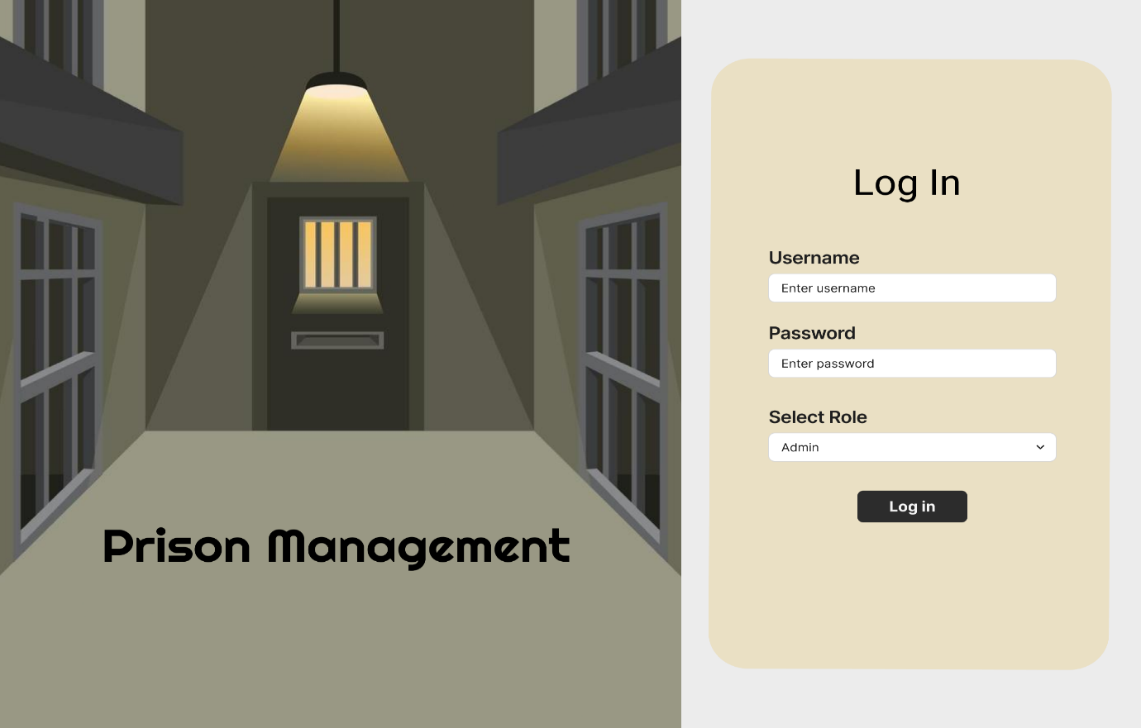

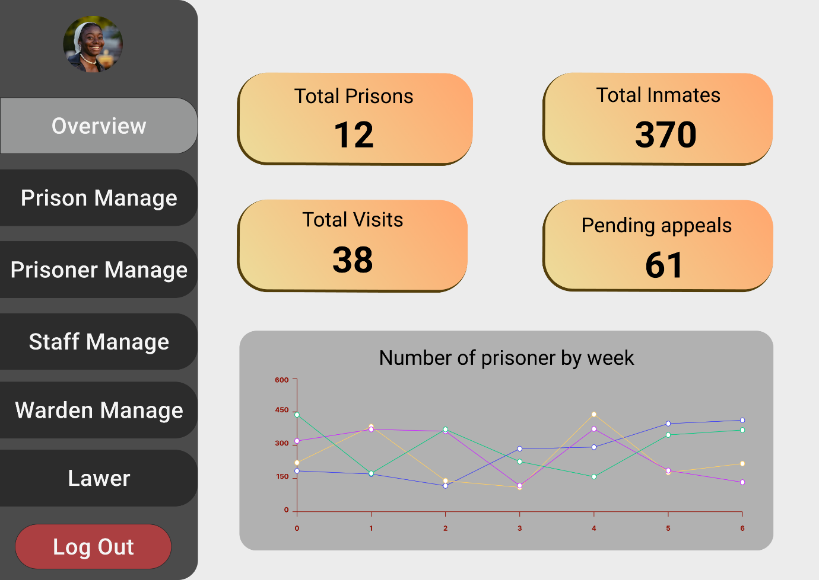

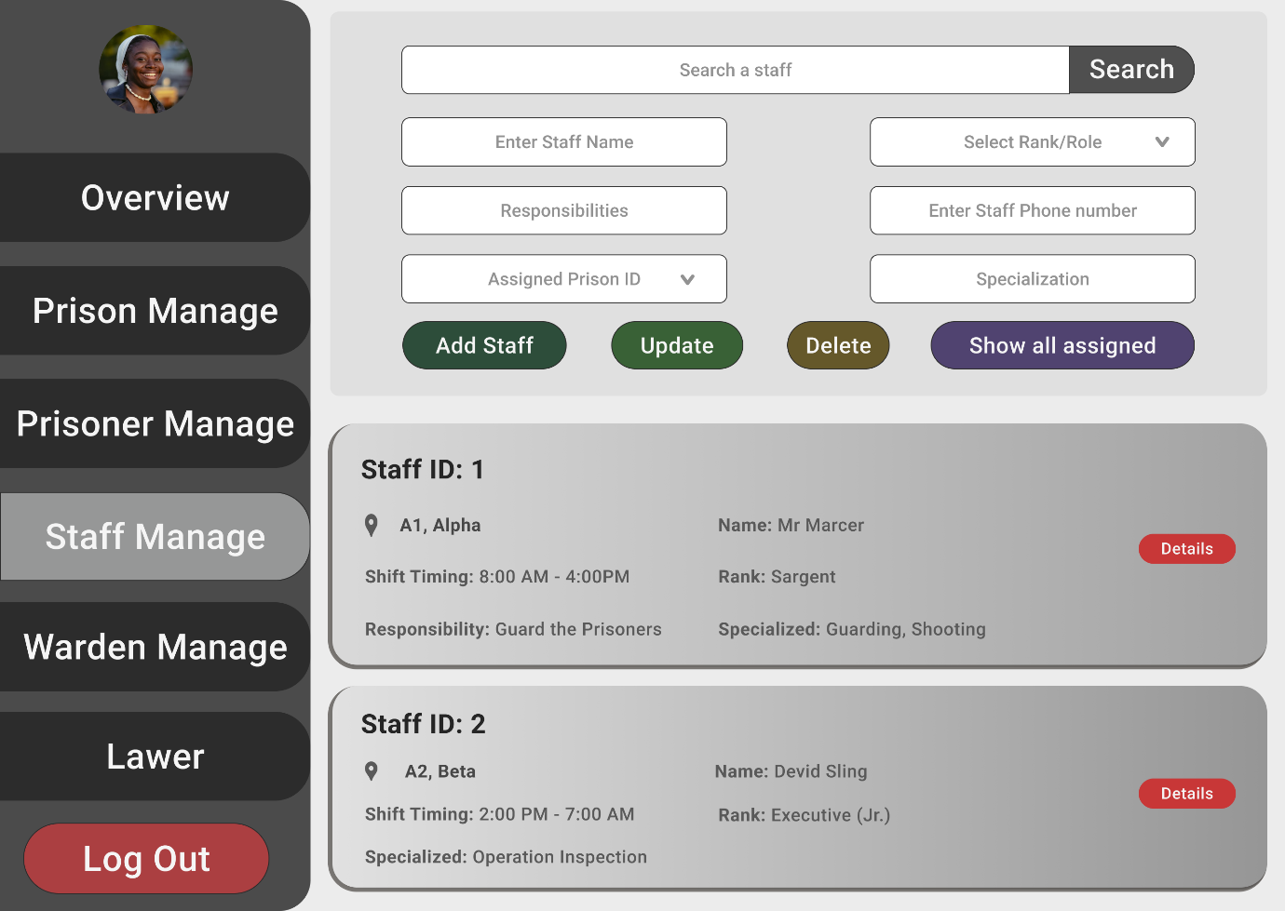

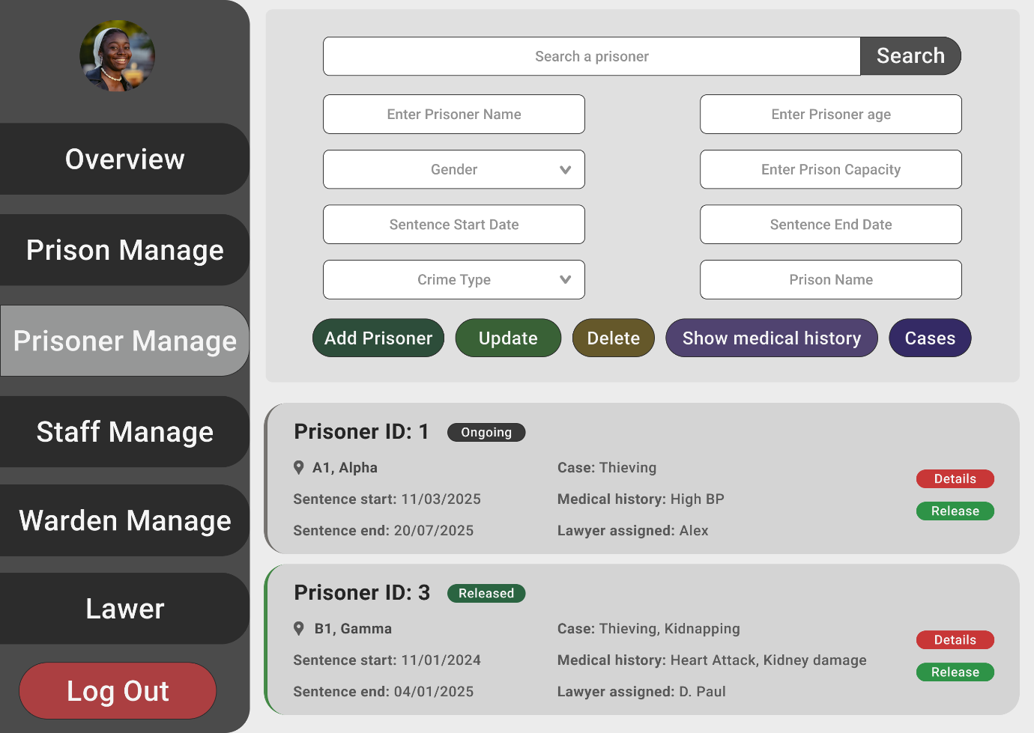

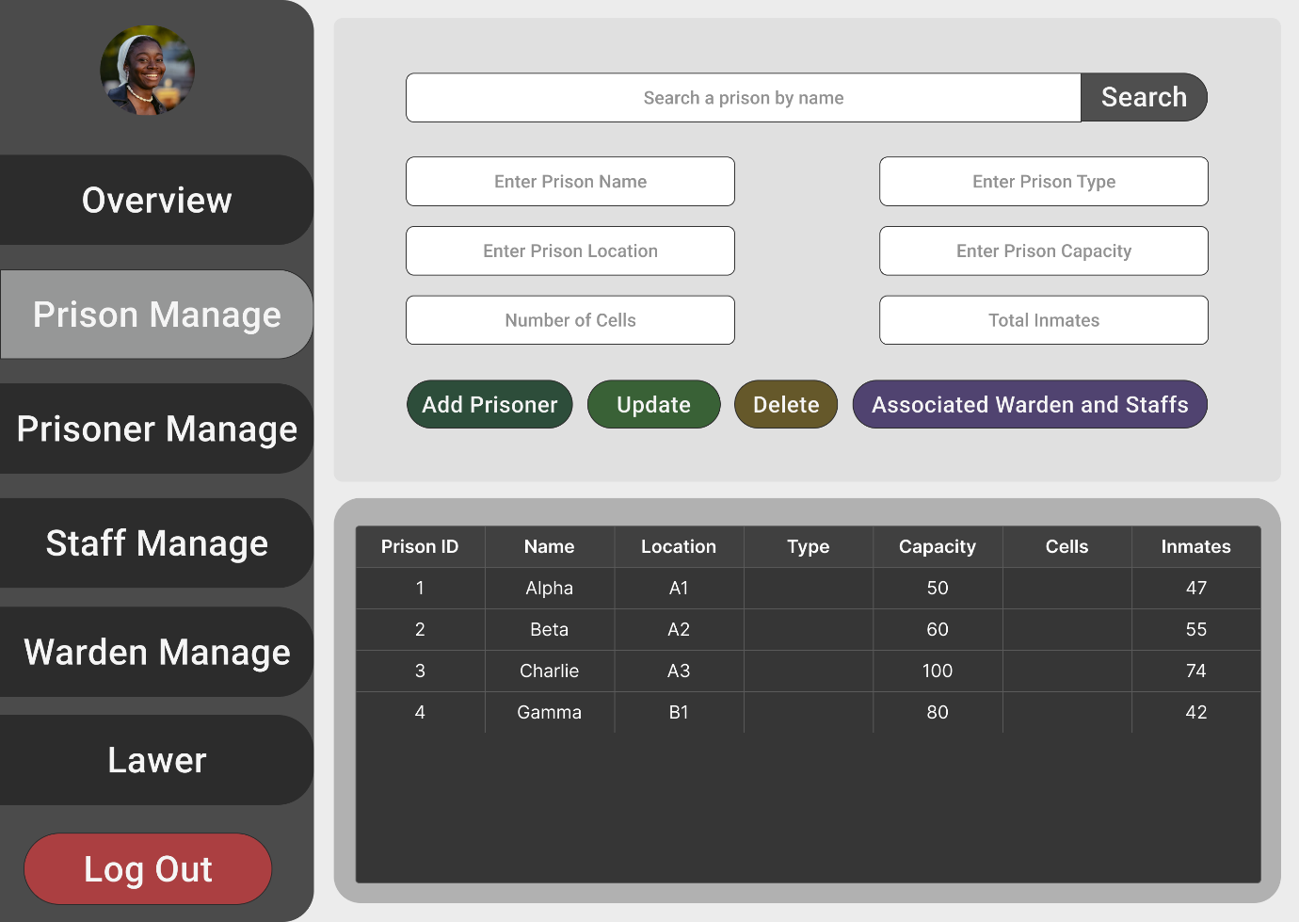

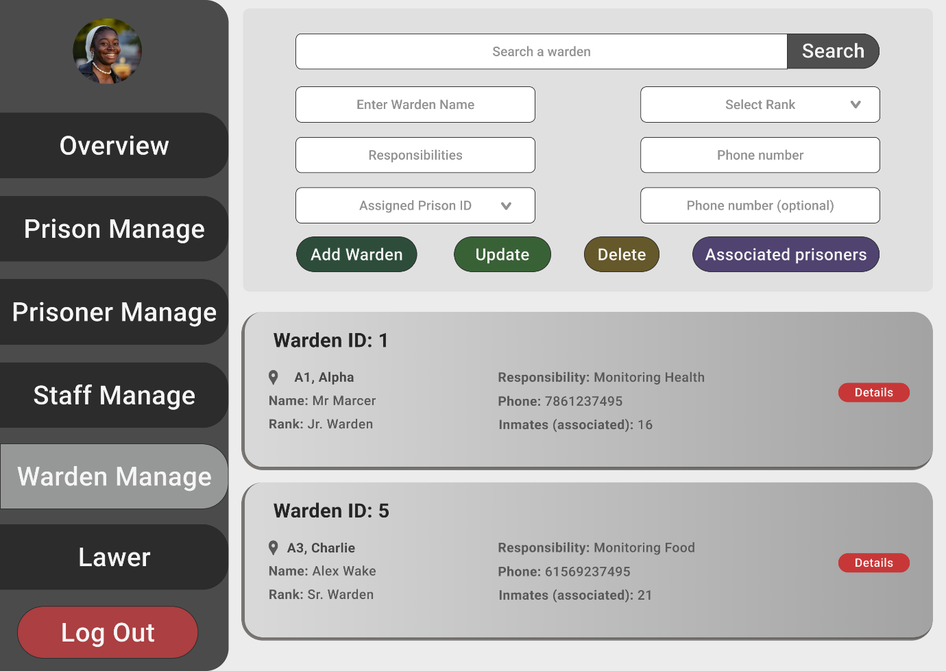

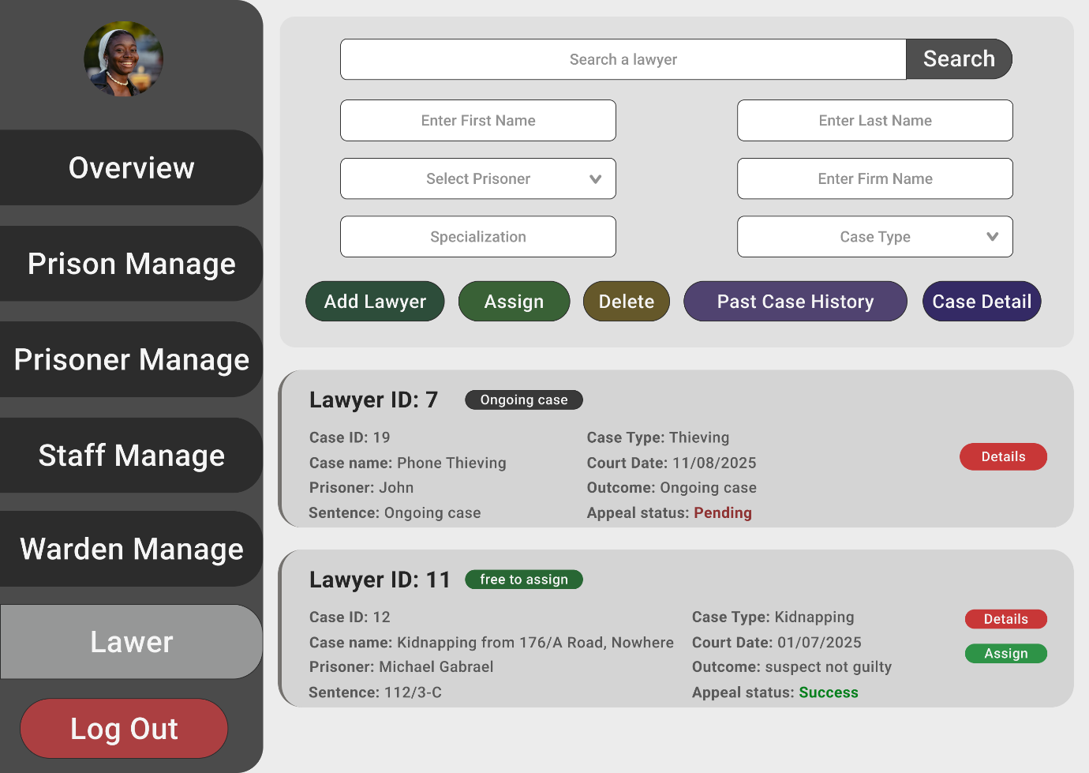

**Scenario Description**

In a Prison Management System, a prison is identified by a Prison ID, and its details such as Prison Name, Location, Type, Capacity, Number_of_Cells, and Total_Inmates are stored. Each prison is managed by exactly one warden, and each warden manages exactly one prison. A warden is identified by a Warden ID, and the system also stores W_Name, W_Rank, W_Phone, and Responsibilities.warden can have more that one phone number . A prison has many officers, and each officer is assigned to exactly one prison. An officer is identified by an Officer ID, and System store O_Name, O_Rank, O_Shift_Timings, Assigned_Block, and O_Phone as well.Oficer can have more than one phone number . A prison contains many prisoners, and each prisoner contain by exactly one prison. A prisoner is identified by a Prisoner ID, and the system keeps details such as P_Name, Age, Gender, Crime_Type, Sentence_Start_Date, Sentence_End_Date, Medical_History, and Status. Each prison hold several cells, and each cell belongs to exactly one prison. A cell is identified by a Cell_ID, and System also store C_Capacity, Cell_Type, and Security_Level are stored. A cell may be assigned to one or more prisoners, and each prisoner is assigned in exactly one cell.Each prisoner is handled by exactly one case manager, and each case manager handle many prisoners. A case manager is identified by a Case Manager ID and includes C_Name, Case_History, and Release_Plan. Each prisoner have multiple lawyers, and each lawyer have multiple prisoners**.** A lawyer is identified by a Lawyer ID, with details such as L_Name, L_Specialization, Firm_Name, and L_Phone.lawyer can have multiple phone number . A prisoner may be treated by several medical workers, and a medical worker may treat several prisoners. A medical worker is identified by a Medical Worker ID, and the system records their M_Name, M_Role, M_Phone, and Medical_Record. A prisoner may receive visits from several visitors, and a visitor may visit several prisoners. A visitor is identified by a Visitor ID, and details such as V_Name, Relationship_to_Prisoner, Visit_Date, and Approval_Status are kept.Each case may involve several prisoners, and each prisoner may be involved in several cases. A case is identified by a Case ID, and information such as Case_Type, Court_Date, Outcome, Sentence, and Appeal_Status is stored. A case may be investigated by several police officers, and a police officer may investigate several cases. A police officer is identified by a Police ID, and the system records their PO_Name, PO_Rank, Department, and PO_Phone. Polic can have multiple phone number A case may include several lawyers, and A lawyer may be included in several cases. A prison keeps many chefs, and each chef is kept by in exactly one prison. A chef is identified by a Chef ID, and attributes such as Ch_Name, Ch_Role, Ch_Shift_Timings, Ch_Phone, and Ch_Specialization are stored. Chefs provide meals to many prisoners, and each prisoner get meals provided by multiple chefs during their stay.chef can have multiple phone number.

**ER diagram:**

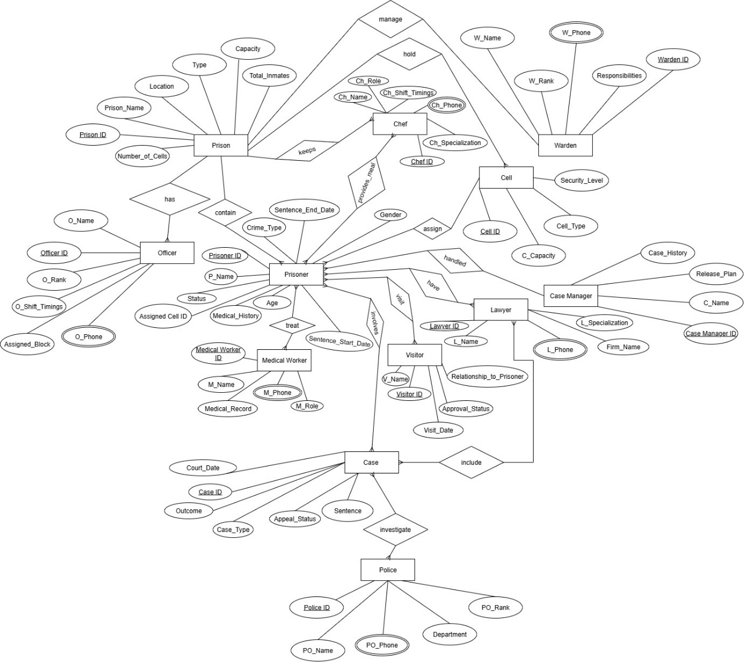

**Prison** – Prison ID, Prison_Name, Location, Type, Capacity , Number_of_Cells, Total_Inmates

Cell ID, C_Capacity, Cell_Type, Security_Level

**Cell** – Prison ID, Prison_Name, Location, Type, Capacity , Number_of_Cells, Total_Inmates

Cell ID, C_Capacity, Cell_Type, Security_Level

**Warden** – Warden ID ,W_Name,W_ Rank, W_phone, Responsibilities

**Officer** – Officer ID, 0_Name,0_Rank, 0_Shift_Timings, Assigned_Block,O_phone

**Prisoner** – Prisoner ID, P_Name, Age, Gender, Sentence_Start Date, Sentence_End_Date, Crime_Type, Status, Medical_History

**Case Manager** – Case Manager ID,C_ Name, Case_History, Release_Plan

**Lawyer** – Lawyer ID, L_Name, L_Specialization, Firm_Name, L_phone

**Medical Worker** – Medical Worker ID, M_Name,M_Role,M_phone, Medical_Record(s)

**Visitor** – Visitor ID,V_ Name, Relationship_to_Prisoner, Visit_Date, Approval_Status

**Police** – Police_ID, PO_Name,PO_Rank, Department,PO_ phone

**Case** – Case ID, Case_Type, Court_Date, Outcome, Sentence, Appeal_Status

**Chefs**– Staff ID,Ch_Name,Ch_Role, Ch_Shift_Timings,Ch_phone,Ch_Specialization

• **Prison – Warden (1:1)** →. **manage**

• **Prison – Officer (1:N)** -> has

• **Prison – Prisoner (1:N)** →.contain

• **Cell- Prisoner (1:N)** → assign

**Prison – cell (1:M)->** hold

**Case Manager (1) - Prisoner (Many)-> handled**

• **Prisoner – Lawyer (M:M)** → have



• **Prisoner – Medical Worker (M:m) → treat**

• **Prisoner – Visitor (M:M)** → visit

• **Case – Prisoner (m:m)** → involves

• **Case – Police (m:m)** → investigate

• **Case – Lawyer (m:m)** → include

• **Prison – chef (1:N)** → keeps

• **chef – Prisoner (m:m)** →( **Provides_meal)**

**Normalization**

**manage**

**Unf**

1. Prison ID, Prison_Name, Location, Type, Capacity , Number_of_Cells, Total_Inmates, Warden ID ,W_Name,W_ Rank, W_phone, Responsibilities

**1nf**

Phone is a multi valued atriibute

1. Prison ID, Prison_Name, Location, Type, Capacity , Number_of_Cells, Total_Inmates, Warden ID ,W_Name,W_ Rank, W_phone, Responsibilities

**2nf**

1. Prison ID, Prison_Name, Location, Type, Capacity , Number_of_Cells, Total_Inmates
2. Warden ID ,W_Name,W_ Rank, W_phone, Responsibilities

**3nf**

1. Prison ID, Prison_Name, Location, Type, Capacity , Number_of_Cells, Total_Inmates
2. Warden ID ,W_Name,W_ Rank, W_phone, Responsibilities

**Table creation**

1. Prison ID, Prison_Name, Location, Type, Capacity , Number_of_Cells, Total_Inmates
2. Warden ID ,W_Name,W_ Rank, W_phone, Responsibilities **Prison_ID**

**has**

**Unf**

1. Prison ID, Prison_Name, Location, Type, Capacity , Number_of_Cells, Total_Inmates, Officer ID, 0_Name,0_Rank, 0_Shift_Timings, Assigned_Block,O_phone.

**1nf**

Phone is a multi valued atriibute

1. Prison ID, Prison_Name, Location, Type, Capacity , Number_of_Cells, Total_Inmates, Officer ID, 0_Name,0_Rank, 0_Shift_Timings, Assigned_Block,O_phone.

**2nf**

1. Prison ID, Prison_Name, Location, Type, Capacity , Number_of_Cells, Total_Inmates,
2. Officer ID, 0_Name,0_Rank, 0_Shift_Timings, Assigned_Block,O_phone.

**3nf**

1. Prison ID, Prison_Name, Location, Type, Capacity , Number_of_Cells, Total_Inmates,
2. Officer ID, 0_Name,0_Rank, 0_Shift_Timings, Assigned_Block,O_phone,

**Table creation :**

1. Prison ID, Prison_Name, Location, Type, Capacity , Number_of_Cells, Total_Inmates,
2. Officer ID, 0_Name,0_Rank, 0_Shift_Timings, Assigned_Block,O_phone, **Prison ID**

**Contain**

**Unf**

1. Prison ID, Prison_Name, Location, Type, Capacity , Number_of_Cells, Total_Inmates, Prisoner ID, P_Name, Age, Gender, Sentence_Start Date, Sentence_End_Date, Crime_Type, Status, Medical_History

**1nf**

1. Prisoner ID, P_Name, Age, Gender, Sentence_Start Date, Sentence_End_Date, Crime_Type, Status, Medical_History, Prison ID, Prison_Name, Location, Type, Capacity , Number_of_Cells, Total_Inmates,

**2nf**

1. Prison ID, Prison_Name, Location, Type, Capacity , Number_of_Cells, Total_Inmates,
2. Prisoner ID, P_Name, Age, Gender, Sentence_Start Date, Sentence_End_Date, Crime_Type, Status, Medical_History,

**3nf**

1. Prison ID, Prison_Name, Location, Type, Capacity , Number_of_Cells, Total_Inmates,
2. Prisoner ID, P_Name, Age, Gender, Sentence_Start Date, Sentence_End_Date, Crime_Type, Status, Medical_History,

**Table creation :**

1. Prison ID, Prison_Name, Location, Type, Capacity , Number_of_Cells, Total_Inmates,
2. Prisoner ID, P_Name, Age, Gender, Sentence_Start Date, Sentence_End_Date, Crime_Type, Status, Medical_History, **Prison ID**

**Asssign**

**Unf**

1. Cell ID, C_Capacity, Cell_Type, Security_LevelPrisoner ID, P_Name, Age, Gender, Sentence_Start ,Date, Sentence_End_Date, Crime_Type, Status, Medical_History

**1nf**

1. Cell ID, C_Capacity, Cell_Type, Security_Level,Prisoner ID, P_Name, Age, Gender, Sentence_Start ,Date, Sentence_End_Date, Crime_Type, Status, Medical_History

**2nf**

1. Cell ID, C_Capacity, Cell_Type, Security_Level
2. Prisoner ID, P_Name, Age, Gender, Sentence_Start ,Date, Sentence_End_Date, Crime_Type, Status, Medical_History

**3nf**

1. Cell ID, C_Capacity, Cell_Type, Security_Level
2. Prisoner ID, P_Name, Age, Gender, Sentence_Start ,Date, Sentence_End_Date, Crime_Type, Status, Medical_History

**Table creation**

1. Cell ID, C_Capacity, Cell_Type, Security_Level
2. Prisoner ID, P_Name, Age, Gender, Sentence_Start ,Date, Sentence_End_Date, Crime_Type, Status, Medical_History**, Cell ID**

**Hold**

**Un f**

Prison ID, Prison_Name, Location, Type, Capacity , Number_of_Cells, Total_Inmates,Cell ID, C_Capacity, Cell_Type, Security_Level

**1nf**

Prison ID, Prison_Name, Location, Type, Capacity , Number_of_Cells, Total_InmatesCell ID, ,C_Capacity, Cell_Type, Security_Level

**2nf**

Prison ID, Prison_Name, Location, Type, Capacity , Number_of_Cells, Total_Inmates

Cell ID, C_Capacity, Cell_Type, Security_Level

**3nf**

Prison ID, Prison_Name, Location, Type, Capacity , Number_of_Cells, Total_Inmates

Cell ID, C_Capacity, Cell_Type, Security_Level

**Table creation :**

Prison ID, Prison_Name, Location, Type, Capacity , Number_of_Cells, Total_Inmates

Cell ID, C_Capacity, Cell_Type, Security_Level, **Prison ID**

**Handle**

**Unf**

1. Prisoner ID, P_Name, Age, Gender, Sentence_Start Date, Sentence_End_Date, Crime_Type, Status, Medical_History, Case Manager ID,C_ Name, Case_History, Release_Plan

**1nf**

1. Prisoner ID, P_Name, Age, Gender, Sentence_Start Date, Sentence_End_Date, Crime_Type, Status, Medical_History, Case Manager ID,C_ Name, Case_History, Release_Plan

**2nf**

1. Prisoner ID, P_Name, Age, Gender, Sentence_Start Date, Sentence_End_Date, Crime_Type, Status, Medical_History,
2. Case Manager ID,C_ Name, Case_History, Release_Plan

**3nf**

1. Prisoner ID, P_Name, Age, Gender, Sentence_Start Date, Sentence_End_Date, Crime_Type, Status, Medical_History,
2. Case Manager ID,C_ Name, Case_History, Release_Plan

**Table creation :**

1. Prisoner ID, P_Name, Age, Gender, Sentence_Start Date, Sentence_End_Date, Crime_Type, Status, Medical_History, **Case Manager ID**
2. Case Manager ID,C_ Name, Case_History, Release_Plan

**Have**

**Unf**

1. Prisoner ID, P_Name, Age, Gender, Sentence_Start Date, Sentence_End_Date, Crime_Type, Status, Medical_History,Lawyer ID, L_Name, L_Specialization, Firm_Name, L_phone

**1nf**

Phone is a multivalued attribute .

1. Prisoner ID, P_Name, Age, Gender, Sentence_Start Date, Sentence_End_Date, Crime_Type, Status, Medical_History,Lawyer ID, L_Name, L_Specialization, Firm_Name, L_phone

2nf

1. Prisoner ID, P_Name, Age, Gender, Sentence_Start Date, Sentence_End_Date, Crime_Type, Status, Medical_History
2. Lawyer ID, L_Name, L_Specialization, Firm_Name, L_phone

**3nf**

1. Prisoner ID, P_Name, Age, Gender, Sentence_Start Date, Sentence_End_Date, Crime_Type, Status, Medical_History
2. Lawyer ID, L_Name, L_Specialization, Firm_Name, L_phone

**Table Creation :**

1. Prisoner ID, P_Name, Age, Gender, Sentence_Start Date, Sentence_End_Date, Crime_Type, Status, Medical_History
2. Lawyer ID, L_Name, L_Specialization, Firm_Name, L_phone
3. **Prisoner ID, Lawyer ID**

**Treat**

**Unf**

1. Prisoner ID, P_Name, Age, Gender, Sentence_Start Date, Sentence_End_Date, Crime_Type, Status, Medical_History,Medical Worker ID, M_Name,M_Role,M_phone, Medical_Record(s)

**1nf**

**M_Phone is multivalued attribute**

1. Prisoner ID, P_Name, Age, Gender, Sentence_Start Date, Sentence_End_Date, Crime_Type, Status, Medical_History,Medical Worker ID, M_Name,M_Role,M_phone, Medical_Record(s)

**2nf**

1. Prisoner ID, P_Name, Age, Gender, Sentence_Start Date, Sentence_End_Date, Crime_Type, Status, Medical_History
2. Medical Worker ID, M_Name,M_Role,M_phone, Medical_Record(s)

**3nf**

1. Prisoner ID, P_Name, Age, Gender, Sentence_Start Date, Sentence_End_Date, Crime_Type, Status, Medical_History
2. Medical Worker ID, M_Name,M_Role,M_phone, Medical_Record(s)

**Table creation :**

1. Prisoner ID, P_Name, Age, Gender, Sentence_Start Date, Sentence_End_Date, Crime_Type, Status, Medical_History
2. Medical Worker ID, M_Name,M_Role,M_phone, Medical_Record(s)
3. **Prisoner ID, Medical Worker ID**

**Visit**

**Unf**

1. Prisoner ID, P_Name, Age, Gender, Sentence_Start Date, Sentence_End_Date, Crime_Type, Status, Medical_History,Visitor ID,V_ Name, Relationship_to_Prisoner, Visit_Date, Approval_Status

**1nf**

1. Prisoner ID, P_Name, Age, Gender, Sentence_Start Date, Sentence_End_Date, Crime_Type, Status, Medical_History,Visitor ID,V_ Name, Relationship_to_Prisoner, Visit_Date, Approval_Status

**2nf**

1. Prisoner ID, P_Name, Age, Gender, Sentence_Start Date, Sentence_End_Date, Crime_Type, Status, Medical_History
2. Visitor ID,V_ Name, Relationship_to_Prisoner, Visit_Date, Approval_Status

**3nf**

1. Prisoner ID, P_Name, Age, Gender, Sentence_Start Date, Sentence_End_Date, Crime_Type, Status, Medical_History
2. Visitor ID,V_ Name, Relationship_to_Prisoner, Visit_Date, Approval_Status

**Table creation :**

1. Prisoner ID, P_Name, Age, Gender, Sentence_Start Date, Sentence_End_Date, Crime_Type, Status, Medical_History
2. Visitor ID,V_ Name, Relationship_to_Prisoner, Visit_Date, Approval_Status

**3. Prisoner ID, Visitor ID**

**involves**

**Unf**

1. Prisoner ID, P_Name, Age, Gender, Sentence_Start Date, Sentence_End_Date, Crime_Type, Status, Medical_History,Case ID, Case_Type, Court_Date, Outcome, Sentence, Appeal_Status

**1nf**

1. Prisoner ID, P_Name, Age, Gender, Sentence_Start Date, Sentence_End_Date, Crime_Type, Status, Medical_History,Case ID, Case_Type, Court_Date, Outcome, Sentence, Appeal_Status

**2nf**

1. Prisoner ID, P_Name, Age, Gender, Sentence_Start Date, Sentence_End_Date, Crime_Type, Status, Medical_History
2. Case ID, Case_Type, Court_Date, Outcome, Sentence, Appeal_Status

**3nf**

1. Prisoner ID, P_Name, Age, Gender, Sentence_Start Date, Sentence_End_Date, Crime_Type, Status, Medical_History
2. Case ID, Case_Type, Court_Date, Outcome, Sentence, Appeal_Status

**Table creation :**

1. Prisoner ID, P_Name, Age, Gender, Sentence_Start Date, Sentence_End_Date, Crime_Type, Status, Medical_History
2. Case ID, Case_Type, Court_Date, Outcome, Sentence, Appeal_Status
3. **Prisoner ID, Case ID**

**Investigate**

**unf**

1. Police_ID, PO_Name,PO_Rank, Department,PO_ phone,Case ID, Case_Type, Court_Date, Outcome, Sentence, Appeal_Status

**1nf**

**PO_Phone is a multivalued attribute .**

1. Police_ID, PO_Name,PO_Rank, Department,PO_ phone,Case ID, Case_Type, Court_Date, Outcome, Sentence, Appeal_Status

**2nf**

1. Police_ID, PO_Name,PO_Rank, Department,PO_ phone
2. Case ID, Case_Type, Court_Date, Outcome, Sentence, Appeal_Status

**3nf**

1. Police_ID, PO_Name,PO_Rank, Department,PO_ phone,
2. Case ID, Case_Type, Court_Date, Outcome, Sentence, Appeal_Status

**Table creation :**

1. Police_ID, PO_Name,PO_Rank, Department,PO_ phone,
2. Case ID, Case_Type, Court_Date, Outcome, Sentence, Appeal_Status
3. **Police_ID, Case ID**

**Include**

**Unf**

1. Lawyer ID, L_Name, L_Specialization, Firm_Name, L_phone,Case ID, Case_Type, Court_Date, Outcome, Sentence, Appeal_Status

**1nf**

1. Lawyer ID, L_Name, L_Specialization, Firm_Name, L_phone,Case ID, Case_Type, Court_Date, Outcome, Sentence, Appeal_Status

**2nf**

1. Lawyer ID, L_Name, L_Specialization, Firm_Name, L_phone
2. Case ID, Case_Type, Court_Date, Outcome, Sentence, Appeal_Status

**3nf**

1. Lawyer ID, L_Name, L_Specialization, Firm_Name, L_phone
2. Case ID, Case_Type, Court_Date, Outcome, Sentence, Appeal_Status

**Table creation :**

1. Lawyer ID, L_Name, L_Specialization, Firm_Name, L_phone
2. Case ID, Case_Type, Court_Date, Outcome, Sentence, Appeal_Status
3. **Lawyer ID, Case ID**

**KEEPS**

**Unf**

1. Prison ID, Prison_Name, Location, Type, Capacity , Number_of_Cells, Total_Inmates,Staff ID,Ch_Name,Ch_Role, Ch_Shift_Timings,Ch_phone,Ch_Specialization

**1nf**

1. Prison ID, Prison_Name, Location, Type, Capacity , Number_of_Cells, Total_Inmates,Staff ID,Ch_Name,Ch_Role, Ch_Shift_Timings,Ch_phone,Ch_Specialization

**2nf**

1. Prison ID, Prison_Name, Location, Type, Capacity , Number_of_Cells, Total_Inmates,
2. Staff ID,Ch_Name,Ch_Role, Ch_Shift_Timings,Ch_phone,Ch_Specialization

**3nf**

1. Prison ID, Prison_Name, Location, Type, Capacity , Number_of_Cells, Total_Inmates,
2. Staff ID,Ch_Name,Ch_Role, Ch_Shift_Timings,Ch_phone,Ch_Specialization

**Table creation :**

1. Prison ID, Prison_Name, Location, Type, Capacity , Number_of_Cells, Total_Inmates,
2. Staff ID,Ch_Name,Ch_Role, Ch_Shift_Timings,Ch_phone,Ch_Specialization, **Prison ID**

**Provides_ meal**

**unf**

1. Prisoner ID, P_Name, Age, Gender, Sentence_Start Date, Sentence_End_Date, Crime_Type, Status, Medical_History, Staff ID,Ch_Name,Ch_Role, Ch_Shift_Timings,Ch_phone,Ch_Specialization

**1nf**

1. Prisoner ID, P_Name, Age, Gender, Sentence_Start Date, Sentence_End_Date, Crime_Type, Status, Medical_History, Staff ID,Ch_Name,Ch_Role, Ch_Shift_Timings,Ch_phone,Ch_Specialization

**2nf**

1. Prisoner ID, P_Name, Age, Gender, Sentence_Start Date, Sentence_End_Date, Crime_Type, Status, Medical_History,
2. Staff ID,Ch_Name,Ch_Role, Ch_Shift_Timings,Ch_phone,Ch_Specialization

**3nf**

1. Prisoner ID, P_Name, Age, Gender, Sentence_Start Date, Sentence_End_Date, Crime_Type, Status, Medical_History,
2. Staff ID,Ch_Name,Ch_Role, Ch_Shift_Timings,Ch_phone,Ch_Specialization

**Table creation :**

1. Prisoner ID, P_Name, Age, Gender, Sentence_Start Date, Sentence_End_Date, Crime_Type, Status, Medical_History,
2. Staff ID,Ch_Name,Ch_Role, Ch_Shift_Timings,Ch_phone,Ch_Specialization
3. **Prisoner ID, Staff ID,**

**Temporary :**

1. Prison ID, Prison_Name, Location, Type, Capacity , Number_of_Cells, Total_Inmates
2. Warden ID ,W_Name,W_ Rank, W_phone, Responsibilities **Prison ID**
3. ~~Prison ID, Prison_Name, Location, Type, Capacity , Number_of_Cells, Total_Inmates,~~
4. Officer ID, 0_Name,0_Rank, 0_Shift_Timings, Assigned_Block,O_phone, **Prison ID**
5. ~~Prison ID, Prison_Name, Location, Type, Capacity , Number_of_Cells, Total_Inmates,~~
6. Prisoner ID, P_Name, Age, Gender, Sentence_Start Date, Sentence_End_Date, Crime_Type, Status, Medical_History, **Prison ID**
7. Cell ID, C_Capacity, Cell_Type, Security_Level
8. Prisoner ID, P_Name, Age, Gender, Sentence_Start ,Date, Sentence_End_Date, Crime_Type, Status, Medical_History**, Cell ID**
9. ~~Prison ID, Prison_Name, Location, Type, Capacity , Number_of_Cells, Total_Inmates~~
10. Cell ID, C_Capacity, Cell_Type, Security_Level, **Prison ID**
11. Prisoner ID, P_Name, Age, Gender, Sentence_Start Date, Sentence_End_Date, Crime_Type, Status, Medical_History, **Case Manager ID**
12. Case Manager ID,C_ Name, Case_History, Release_Plan
13. Prisoner ID, P_Name, Age, Gender, Sentence_Start Date, Sentence_End_Date, Crime_Type, Status, Medical_History
14. Lawyer ID, L_Name, L_Specialization, Firm_Name, L_phone
15. **Prisoner ID, Lawyer ID**
16. ~~Prisoner ID, P_Name, Age, Gender, Sentence_Start Date, Sentence_End_Date, Crime_Type, Status, Medical_History~~
17. Medical Worker ID, M_Name,M_Role,M_phone, Medical_Record(s)
18. **Prisoner ID, Medical Worker ID**
19. ~~Prisoner ID, P_Name, Age, Gender, Sentence_Start Date, Sentence_End_Date, Crime_Type, Status, Medical_History~~
20. Visitor ID,V_ Name, Relationship_to_Prisoner, Visit_Date, Approval_Status
21. **Prisoner ID, Visitor ID**
22. ~~Prisoner ID, P_Name, Age, Gender, Sentence_Start Date, Sentence_End_Date, Crime_Type, Status, Medical_History~~
23. Case ID, Case_Type, Court_Date, Outcome, Sentence, Appeal_Status
24. **Prisoner ID, Case ID**
25. Police_ID, PO_Name,PO_Rank, Department,PO_ phone,
26. ~~Case ID, Case_Type, Court_Date, Outcome, Sentence, Appeal_Status~~
27. **Police_ID, Case ID**
28. ~~Lawyer ID, L_Name, L_Specialization, Firm_Name, L_phone~~
29. ~~Case ID, Case_Type, Court_Date, Outcome, Sentence, Appeal_Status~~
30. **Lawyer ID, Case ID**
31. ~~Prison ID, Prison_Name, Location, Type, Capacity , Number_of_Cells, Total_Inmates,~~
32. Staff ID,Ch_Name,Ch_Role, Ch_Shift_Timings,Ch_phone,Ch_Specialization, **Prison ID**
33. ~~Prisoner ID, P_Name, Age, Gender, Sentence_Start Date, Sentence_End_Date, Crime_Type, Status, Medical_History,~~
34. ~~Staff ID,Ch_Name,Ch_Role, Ch_Shift_Timings,Ch_phone,Ch_Specialization~~
35. **Prisoner ID, Staff ID,**

Final creation :

1. Prison ID, Prison_Name, Location, Type, Capacity , Number_of_Cells, Total_Inmates
2. Warden ID ,W_Name,W_ Rank, W_phone1,W_ phone 2, Responsibilities **Prison ID(FK)**
3. Prisoner ID, P_Name, Age, Gender, Sentence_Start Date, Sentence_End_Date, Crime_Type, Status, Medical_History, **Prison ID(FK) Cell ID(FK), Case Manager ID(FK)**
4. Cell ID, C_Capacity, Cell_Type, Security_Level, **Prison ID(FK)**
5. Case Manager ID,C_ Name, Case_History, Release_Plan
6. Lawyer ID, L_Name, L_Specialization, Firm_Name, L_phone
7. **Prisoner ID, Lawyer ID**
8. Medical Worker ID, M_Name,M_Role,M_phone1, M_phone2, Medical_Record(s)
9. **Prisoner ID, Medical Worker ID**
10. Visitor ID,V_ Name, Relationship_to_Prisoner, Visit_Date, Approval_Status
11. **Prisoner ID, Visitor ID**
12. Case ID, Case_Type, Court_Date, Outcome, Sentence, Appeal_Status
13. **Prisoner ID, Case ID**
14. Police_ID, PO_Name,PO_Rank, Department,PO_ phone1, PO_ phone2,
15. **Police_ID, Case ID**
16. **Lawyer ID, Case ID**
17. Staff ID,Ch_Name,Ch_Role, Ch_Shift_Timings,Ch_phone1, ,Ch_phone2,Ch_Specialization, **Prison ID(FK)**
18. **Prisoner ID, Staff ID,**

**Schema diagram**

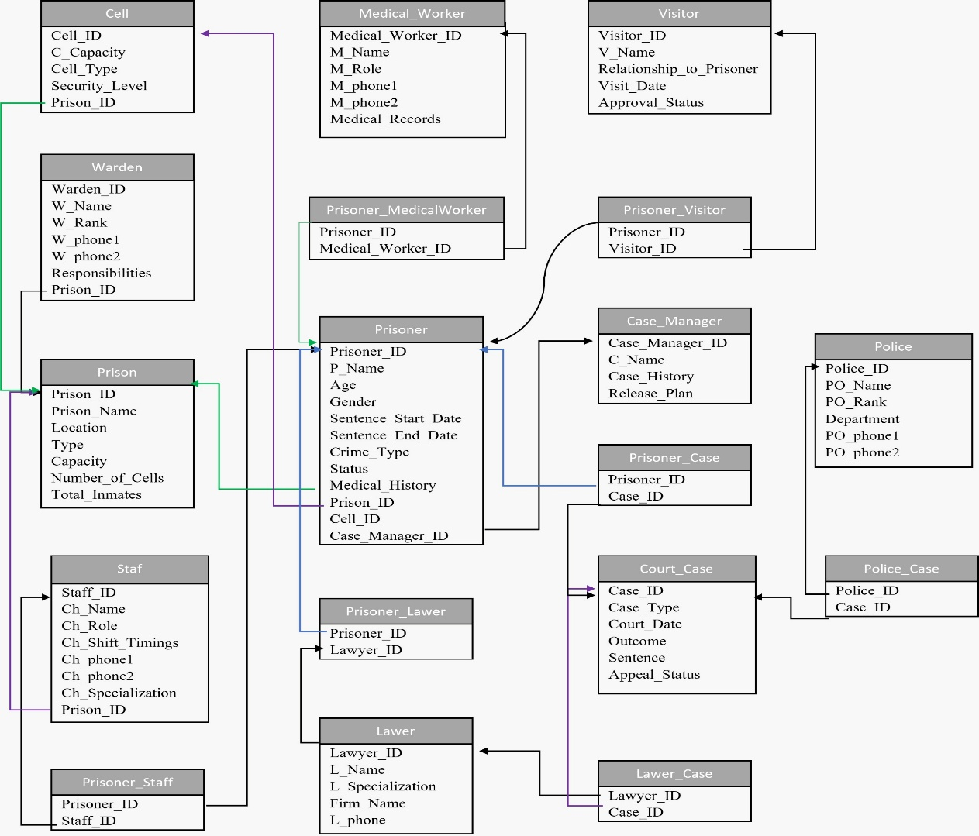

**Create users, assign roles and grant privileges**

CREATE USER noboni IDENTIFIED BY rt23erz;

GRANT UNLIMITED TABLESPACE TO noboni;

CREATE ROLE Prison_INFO;

GRANT CREATE TABLE TO Prison_INFO;

GRANT CREATE VIEW TO Prison_INFO;

GRANT CREATE SEQUENCE TO Prison_INFO;

GRANT CONNECT, RESOURCE, SELECT_CATALOG_ROLE TO noboni;

GRANT Prison_INFO TO noboni;

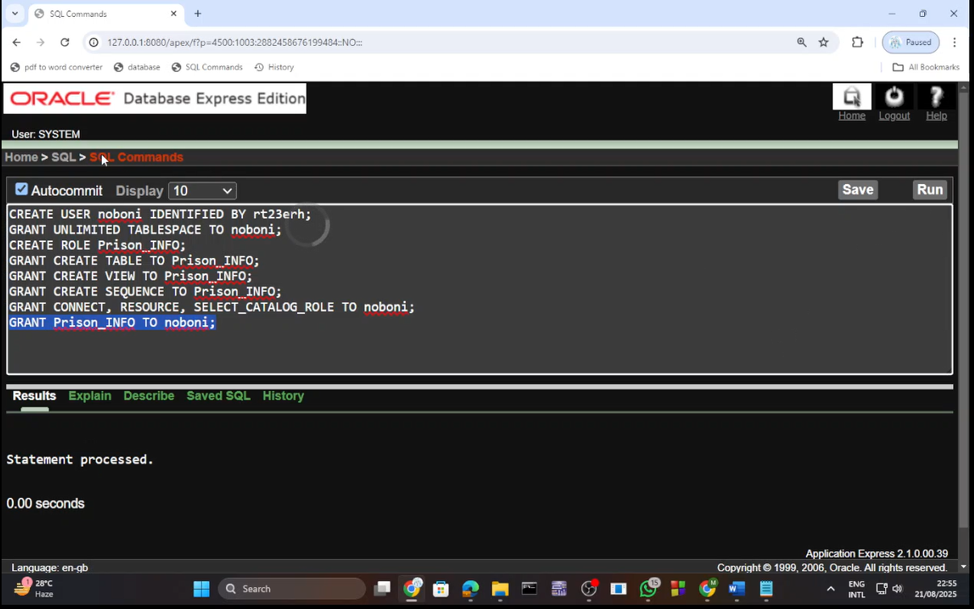

**Table creation code**   
-- 1. Prison

CREATE TABLE Prison (

Prison_ID INT PRIMARY KEY,

Prison_Name VARCHAR(100) NOT NULL,

Location VARCHAR(150),

Type VARCHAR(50),

Capacity INT,

Number_of_Cells INT,

Total_Inmates INT

);

-- 2. Warden

CREATE TABLE Warden (

Warden_ID INT PRIMARY KEY,

W_Name VARCHAR2(100) NOT NULL,

W_Rank VARCHAR2(50),

W_phone1 VARCHAR2(20) NOT NULL,

W_phone2 VARCHAR2(20),

Responsibilities VARCHAR2(4000),

Prison_ID INT,

FOREIGN KEY (Prison_ID) REFERENCES Prison(Prison_ID)

);

-- 3. Cell

CREATE TABLE Cell (

Cell_ID INT PRIMARY KEY,

C_Capacity INT,

Cell_Type VARCHAR(50),

Security_Level VARCHAR(50),

Prison_ID INT,

FOREIGN KEY (Prison_ID) REFERENCES Prison(Prison_ID)

);

-- 4. Case Manager

CREATE TABLE Case_Manager (

Case_Manager_ID INT PRIMARY KEY,

C_Name VARCHAR(100) NOT NULL,

Case_History VARCHAR(600),

Release_Plan VARCHAR(600)

);

-- 5. Prisoner

CREATE TABLE Prisoner (

Prisoner_ID INT PRIMARY KEY,

P_Name VARCHAR(100) NOT NULL,

Age INT,

Gender VARCHAR(10),

Sentence_Start_Date DATE,

Sentence_End_Date DATE,

Crime_Type VARCHAR(100),

Status VARCHAR(50),

Medical_History VARCHAR(4000),

Prison_ID INT,

Cell_ID INT,

Case_Manager_ID INT,

FOREIGN KEY (Prison_ID) REFERENCES Prison(Prison_ID),

FOREIGN KEY (Cell_ID) REFERENCES Cell(Cell_ID),

FOREIGN KEY (Case_Manager_ID) REFERENCES Case_Manager(Case_Manager_ID)

);

-- 6. Lawyer

CREATE TABLE Lawyer (

Lawyer_ID INT PRIMARY KEY,

L_Name VARCHAR(100) NOT NULL,

L_Specialization VARCHAR(100),

Firm_Name VARCHAR(100),

L_phone VARCHAR(20) NOT NULL

);

-- 7. Prisoner-Lawyer (M:N)

CREATE TABLE Prisoner_Lawyer (

Prisoner_ID INT NOT NULL,

Lawyer_ID INT NOT NULL,

PRIMARY KEY (Prisoner_ID, Lawyer_ID),

FOREIGN KEY (Prisoner_ID) REFERENCES Prisoner(Prisoner_ID),

FOREIGN KEY (Lawyer_ID) REFERENCES Lawyer(Lawyer_ID)

);

-- 8. Medical Worker

CREATE TABLE Medical_Worker (

Medical_Worker_ID INT PRIMARY KEY,

M_Name VARCHAR(100) NOT NULL,

M_Role VARCHAR(50),

M_phone1 VARCHAR(20) NOT NULL,

M_phone2 VARCHAR(20),

Medical_Records VARCHAR(4000)

);

-- 9. Prisoner-Medical Worker (M:N)

CREATE TABLE Prisoner_MedicalWorker (

Prisoner_ID INT NOT NULL,

Medical_Worker_ID INT NOT NULL,

PRIMARY KEY (Prisoner_ID, Medical_Worker_ID),

FOREIGN KEY (Prisoner_ID) REFERENCES Prisoner(Prisoner_ID),

FOREIGN KEY (Medical_Worker_ID) REFERENCES Medical_Worker(Medical_Worker_ID)

);

-- 10. Visitor

CREATE TABLE Visitor (

Visitor_ID INT PRIMARY KEY,

V_Name VARCHAR(100) NOT NULL,

Relationship_to_Prisoner VARCHAR(50),

Visit_Date DATE,

Approval_Status VARCHAR(50)

);

-- 11. Prisoner-Visitor (M:N)

CREATE TABLE Prisoner_Visitor (

Prisoner_ID INT NOT NULL,

Visitor_ID INT NOT NULL,

PRIMARY KEY (Prisoner_ID, Visitor_ID),

FOREIGN KEY (Prisoner_ID) REFERENCES Prisoner(Prisoner_ID),

FOREIGN KEY (Visitor_ID) REFERENCES Visitor(Visitor_ID)

);

-- 12. Court Case (renamed from CASE)

CREATE TABLE Court_Case (

Case_ID INT PRIMARY KEY,

Case_Type VARCHAR(100),

Court_Date DATE,

Outcome VARCHAR(100),

Sentence VARCHAR(100),

Appeal_Status VARCHAR(50)

);

-- 13. Prisoner-Case (M:N)

CREATE TABLE Prisoner_Case (

Prisoner_ID INT NOT NULL,

Case_ID INT NOT NULL,

PRIMARY KEY (Prisoner_ID, Case_ID),

FOREIGN KEY (Prisoner_ID) REFERENCES Prisoner(Prisoner_ID),

FOREIGN KEY (Case_ID) REFERENCES Court_Case(Case_ID)

);

-- 14. Police

CREATE TABLE Police (

Police_ID INT PRIMARY KEY,

PO_Name VARCHAR(100) NOT NULL,

PO_Rank VARCHAR(50),

Department VARCHAR(100),

PO_phone1 VARCHAR(20) NOT NULL,

PO_phone2 VARCHAR(20)

);

-- 15. Police-Case (M:N)

CREATE TABLE Police_Case (

Police_ID INT NOT NULL,

Case_ID INT NOT NULL,

PRIMARY KEY (Police_ID, Case_ID),

FOREIGN KEY (Police_ID) REFERENCES Police(Police_ID),

FOREIGN KEY (Case_ID) REFERENCES Court_Case(Case_ID)

);

-- 16. Lawyer-Case (M:N)

CREATE TABLE Lawyer_Case (

Lawyer_ID INT NOT NULL,

Case_ID INT NOT NULL,

PRIMARY KEY (Lawyer_ID, Case_ID),

FOREIGN KEY (Lawyer_ID) REFERENCES Lawyer(Lawyer_ID),

FOREIGN KEY (Case_ID) REFERENCES Court_Case(Case_ID)

);

-- 17. Staff

CREATE TABLE Staff (

Staff_ID INT PRIMARY KEY,

Ch_Name VARCHAR(100) NOT NULL,

Ch_Role VARCHAR(50),

Ch_Shift_Timings VARCHAR(50),

Ch_phone1 VARCHAR(20) NOT NULL,

Ch_phone2 VARCHAR(20),

Ch_Specialization VARCHAR(100),

Prison_ID INT,

FOREIGN KEY (Prison_ID) REFERENCES Prison(Prison_ID)

);

-- 18. Prisoner-Staff (M:N)

CREATE TABLE Prisoner_Staff (

Prisoner_ID INT NOT NULL,

Staff_ID INT NOT NULL,

PRIMARY KEY (Prisoner_ID, Staff_ID),

FOREIGN KEY (Prisoner_ID) REFERENCES Prisoner(Prisoner_ID),

FOREIGN KEY (Staff_ID) REFERENCES Staff(Staff_ID)

);

**Table creation with screenshot**

**1. Prison**

CREATE TABLE Prison (

Prison_ID INT PRIMARY KEY,

Prison_Name VARCHAR(100) NOT NULL,

Location VARCHAR(150),

Type VARCHAR(50),

Capacity INT,

Number_of_Cells INT,

Total_Inmates INT

);

DESC Prison;

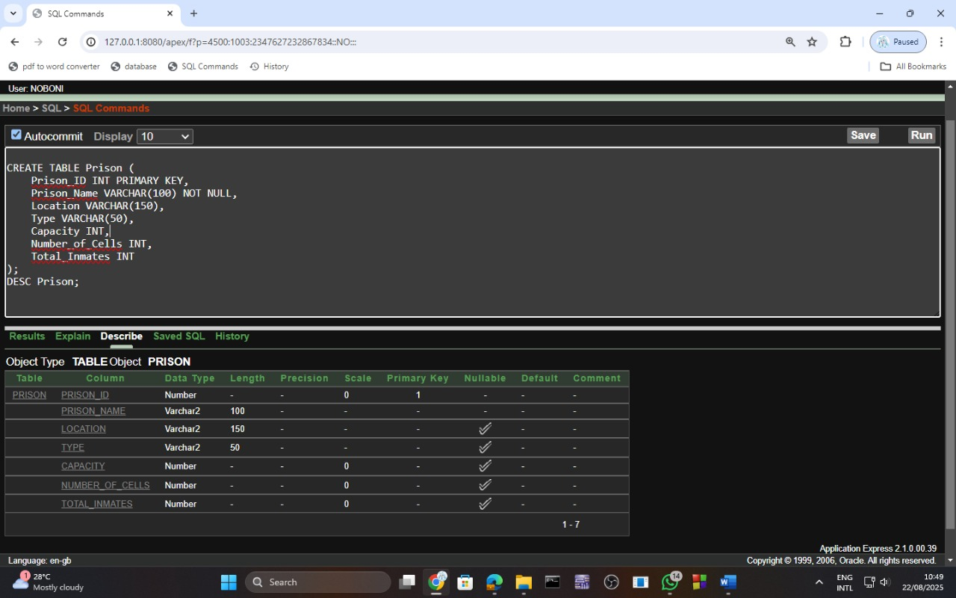

**2. Warden**

CREATE TABLE Warden (

Warden_ID INT PRIMARY KEY,

W_Name VARCHAR2(100) NOT NULL,

W_Rank VARCHAR2(50),

W_phone1 VARCHAR2(20) NOT NULL,

W_phone2 VARCHAR2(20),

Responsibilities VARCHAR2(4000),

Prison_ID INT,

FOREIGN KEY (Prison_ID) REFERENCES Prison(Prison_ID)

);

DESC Warden;

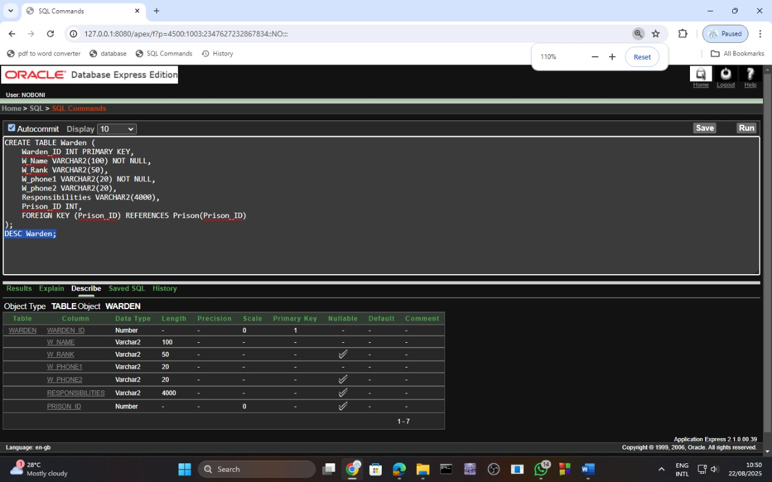

**3. Cell**

CREATE TABLE Cell (

Cell_ID INT PRIMARY KEY,

C_Capacity INT,

Cell_Type VARCHAR(50),

Security_Level VARCHAR(50),

Prison_ID INT,

FOREIGN KEY (Prison_ID) REFERENCES Prison(Prison_ID)

);

DESC Cell;

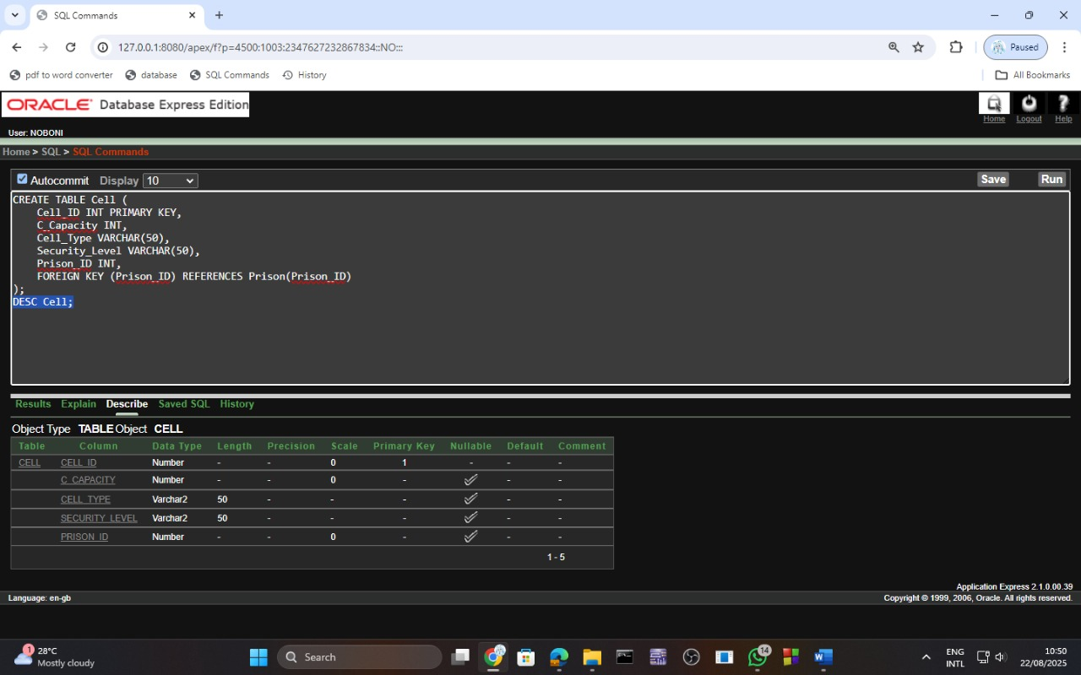

**4. Case Manager**

CREATE TABLE Case_Manager (

Case_Manager_ID INT PRIMARY KEY,

C_Name VARCHAR(100) NOT NULL,

Case_History VARCHAR(600),

Release_Plan VARCHAR(600)

);

DESC Case_Manager;

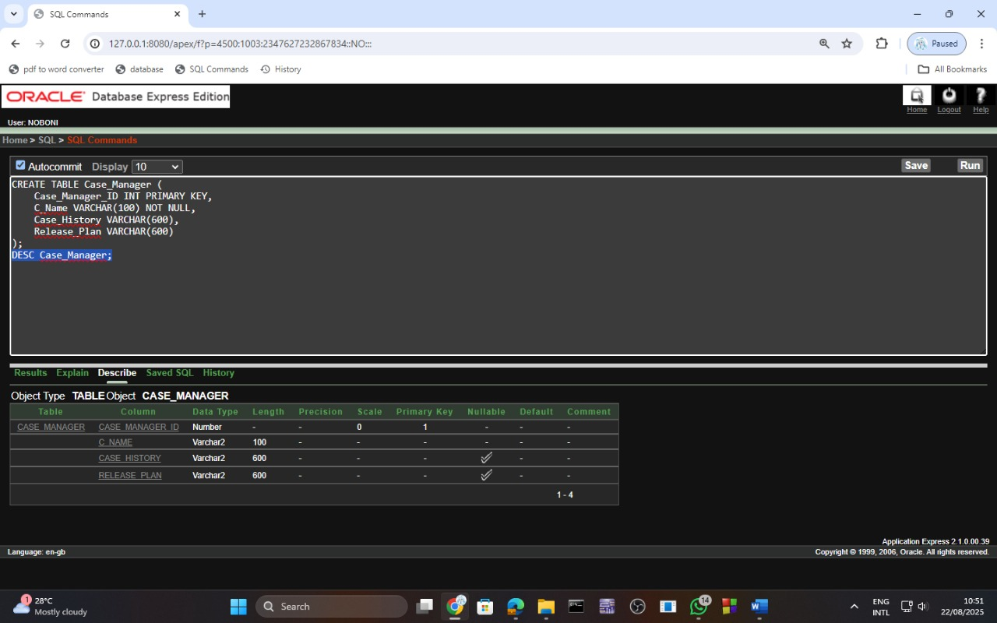

**5. Prisoner**

CREATE TABLE Prisoner (

Prisoner_ID INT PRIMARY KEY,

P_Name VARCHAR(100) NOT NULL,

Age INT,

Gender VARCHAR(10),

Sentence_Start_Date DATE,

Sentence_End_Date DATE,

Crime_Type VARCHAR(100),

Status VARCHAR(50),

Medical_History VARCHAR(4000),

Prison_ID INT,

Cell_ID INT,

Case_Manager_ID INT,

FOREIGN KEY (Prison_ID) REFERENCES Prison(Prison_ID),

FOREIGN KEY (Cell_ID) REFERENCES Cell(Cell_ID),

FOREIGN KEY (Case_Manager_ID) REFERENCES Case_Manager(Case_Manager_ID)

);

DESC Prisoner;

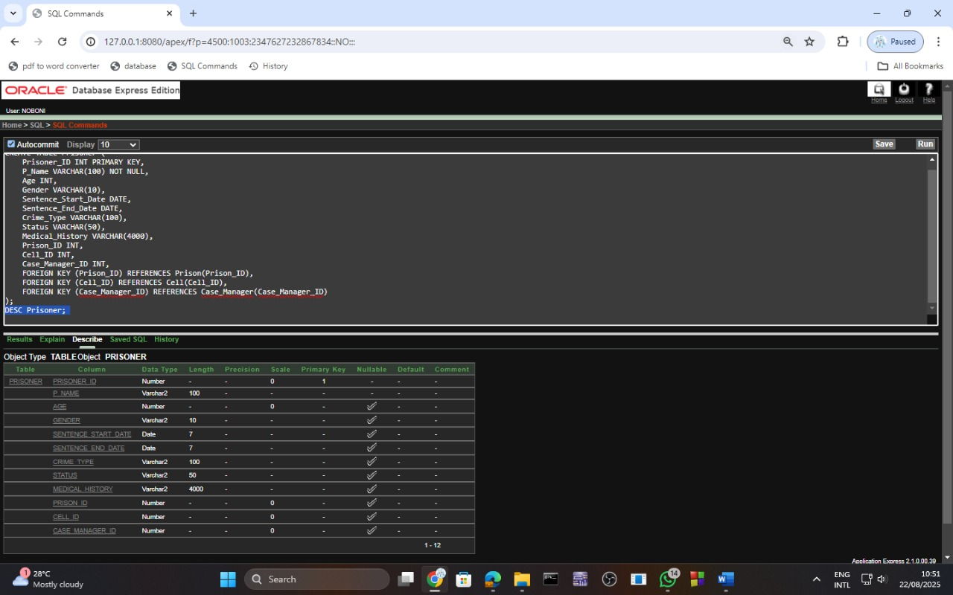

**6. Lawyer**

CREATE TABLE Lawyer (

Lawyer_ID INT PRIMARY KEY,

L_Name VARCHAR(100) NOT NULL,

L_Specialization VARCHAR(100),

Firm_Name VARCHAR(100),

L_phone VARCHAR(20) NOT NULL

);

DESC Lawyer;

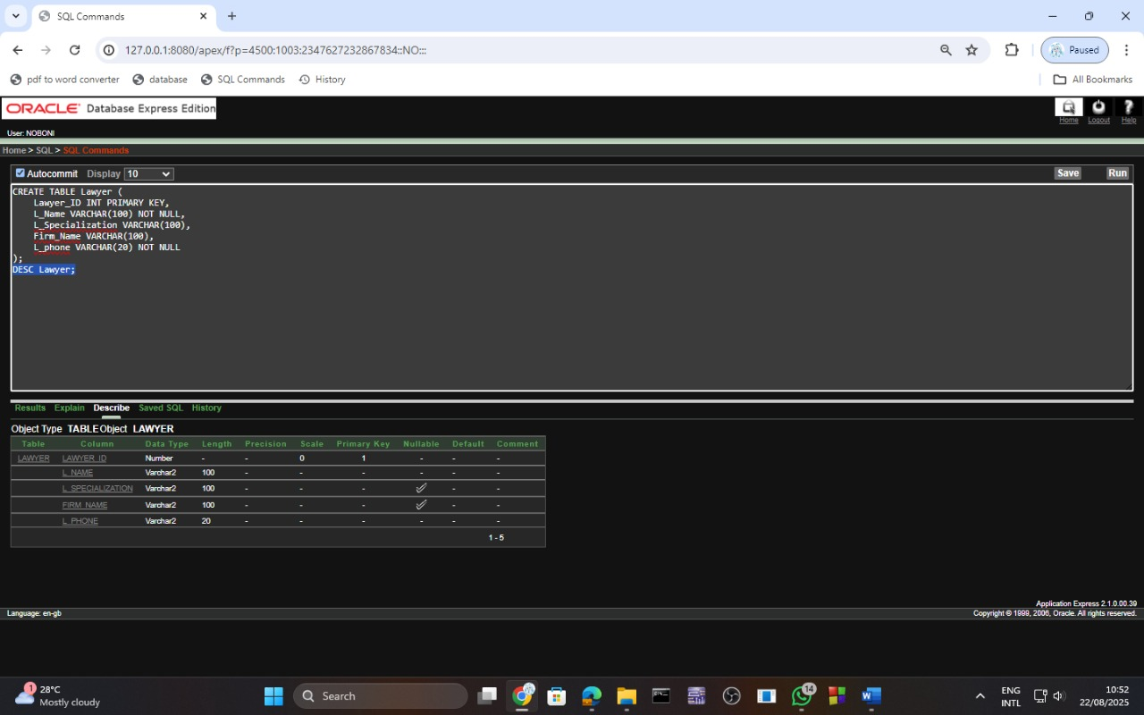

**7. Prisoner-Lawyer (M:N)**

CREATE TABLE Prisoner_Lawyer (

Prisoner_ID INT NOT NULL,

Lawyer_ID INT NOT NULL,

PRIMARY KEY (Prisoner_ID, Lawyer_ID),

FOREIGN KEY (Prisoner_ID) REFERENCES Prisoner(Prisoner_ID),

FOREIGN KEY (Lawyer_ID) REFERENCES Lawyer(Lawyer_ID)

);

DESC Prisoner_Lawyer;

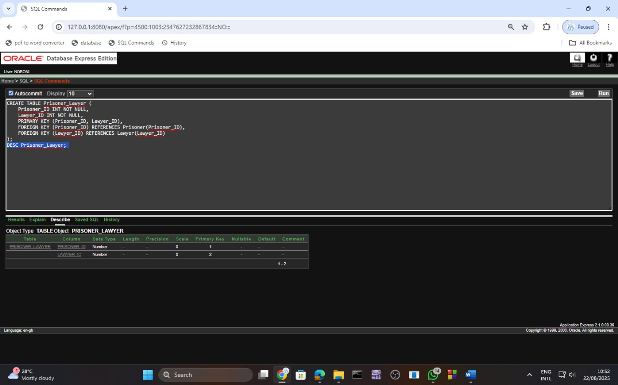

**8. Medical Worker**

CREATE TABLE Medical_Worker (

Medical_Worker_ID INT PRIMARY KEY,

M_Name VARCHAR(100) NOT NULL,

M_Role VARCHAR(50),

M_phone1 VARCHAR(20) NOT NULL,

M_phone2 VARCHAR(20),

Medical_Records VARCHAR(4000)

);

DESC Medical_Worker;

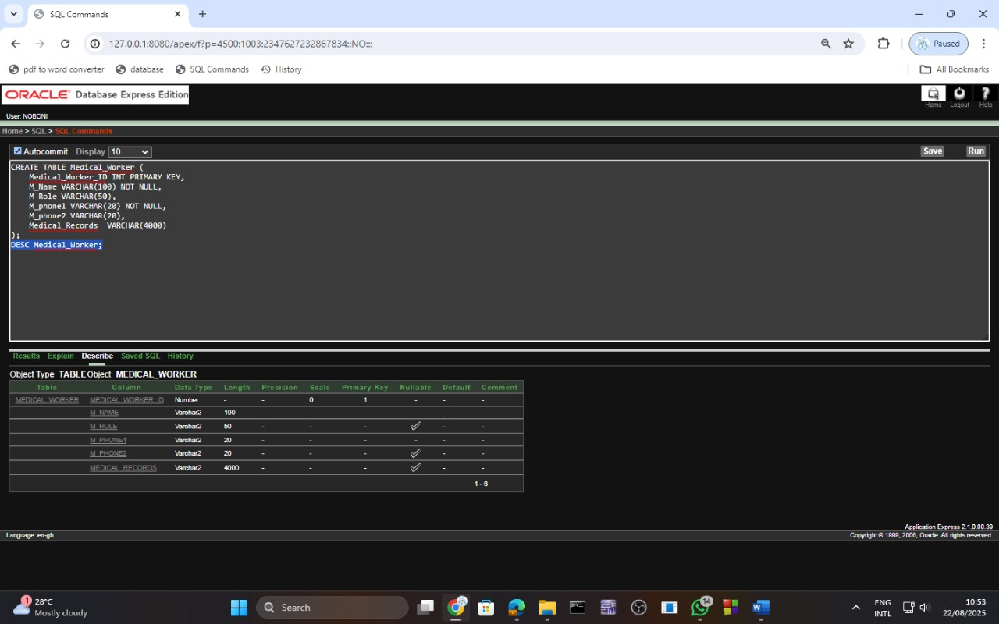

**9. Prisoner-Medical Worker (M:N)**

CREATE TABLE Prisoner_MedicalWorker (

Prisoner_ID INT NOT NULL,

Medical_Worker_ID INT NOT NULL,

PRIMARY KEY (Prisoner_ID, Medical_Worker_ID),

FOREIGN KEY (Prisoner_ID) REFERENCES Prisoner(Prisoner_ID),

FOREIGN KEY (Medical_Worker_ID) REFERENCES Medical_Worker(Medical_Worker_ID)

);

DESC Prisoner_MedicalWorker;

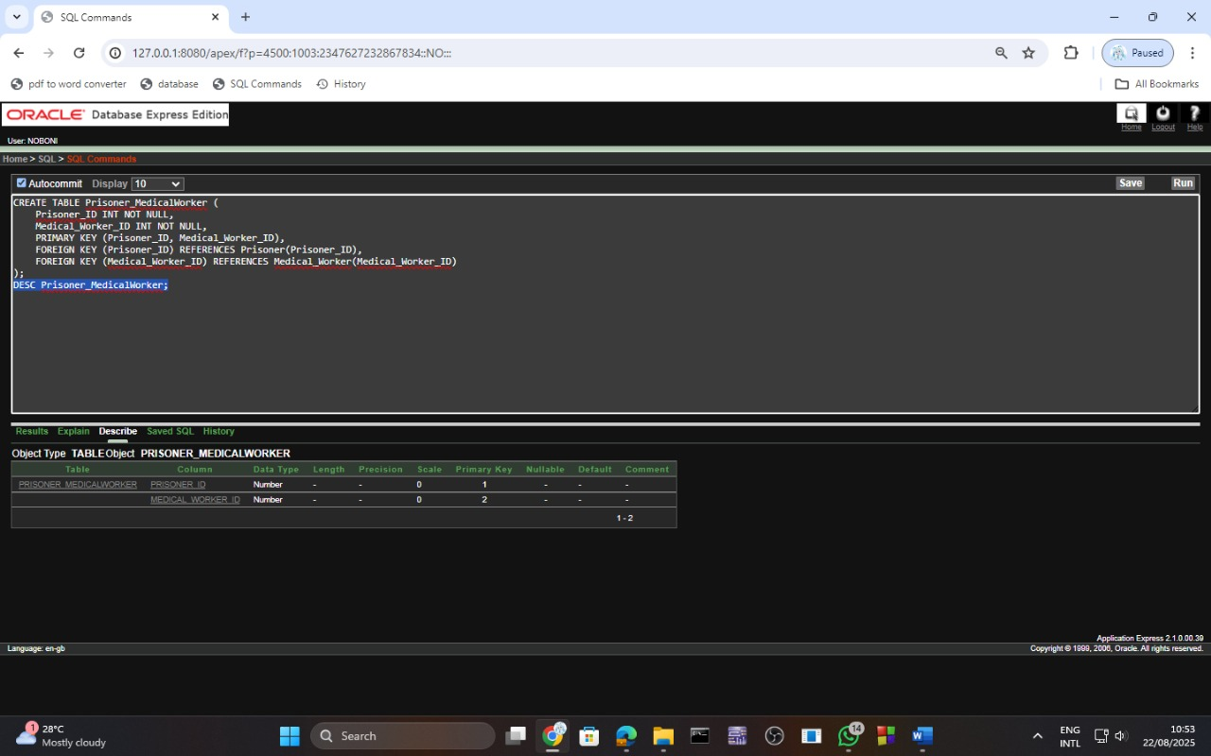

**10. Visitor**

CREATE TABLE Visitor (

Visitor_ID INT PRIMARY KEY,

V_Name VARCHAR(100) NOT NULL,

Relationship_to_Prisoner VARCHAR(50),

Visit_Date DATE,

Approval_Status VARCHAR(50)

);

DESC Visitor;

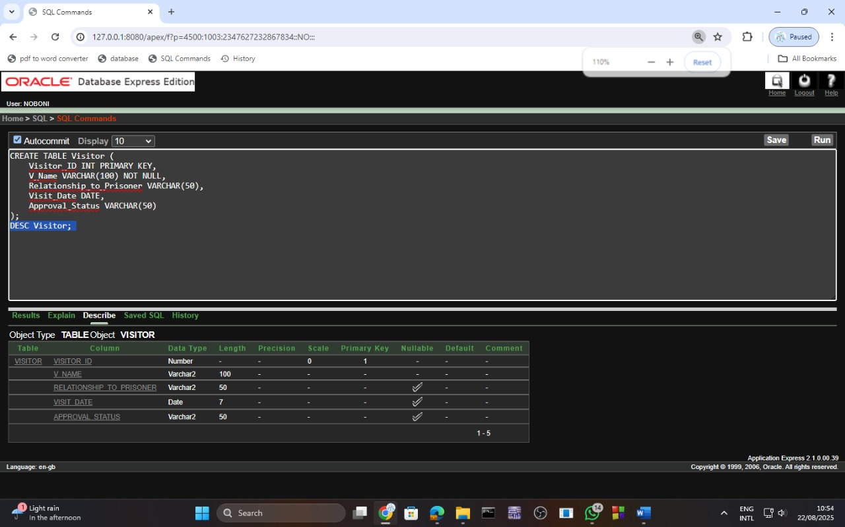

**11. Prisoner-Visitor (M:N)**

CREATE TABLE Prisoner_Visitor (

Prisoner_ID INT NOT NULL,

Visitor_ID INT NOT NULL,

PRIMARY KEY (Prisoner_ID, Visitor_ID),

FOREIGN KEY (Prisoner_ID) REFERENCES Prisoner(Prisoner_ID),

FOREIGN KEY (Visitor_ID) REFERENCES Visitor(Visitor_ID)

);

DESC Prisoner_Visitor;

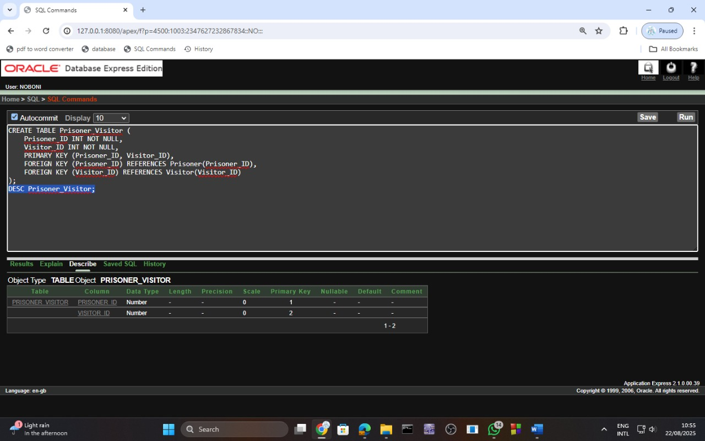

**12. Court Case**

CREATE TABLE Court_Case (

Case_ID INT PRIMARY KEY,

Case_Type VARCHAR(100),

Court_Date DATE,

Outcome VARCHAR(100),

Sentence VARCHAR(100),

Appeal_Status VARCHAR(50)

);

DESC Court_Case;

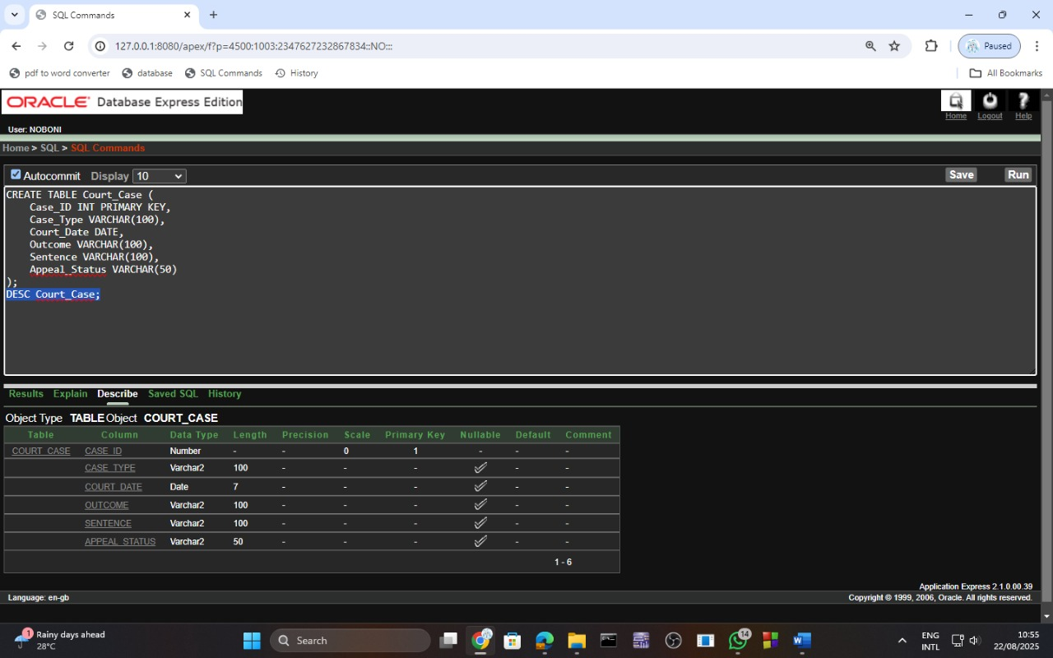

**13. Prisoner-Case (M:N)**

CREATE TABLE Prisoner_Case (

Prisoner_ID INT NOT NULL,

Case_ID INT NOT NULL,

PRIMARY KEY (Prisoner_ID, Case_ID),

FOREIGN KEY (Prisoner_ID) REFERENCES Prisoner(Prisoner_ID),

FOREIGN KEY (Case_ID) REFERENCES Court_Case(Case_ID)

);

DESC Prisoner_Case;

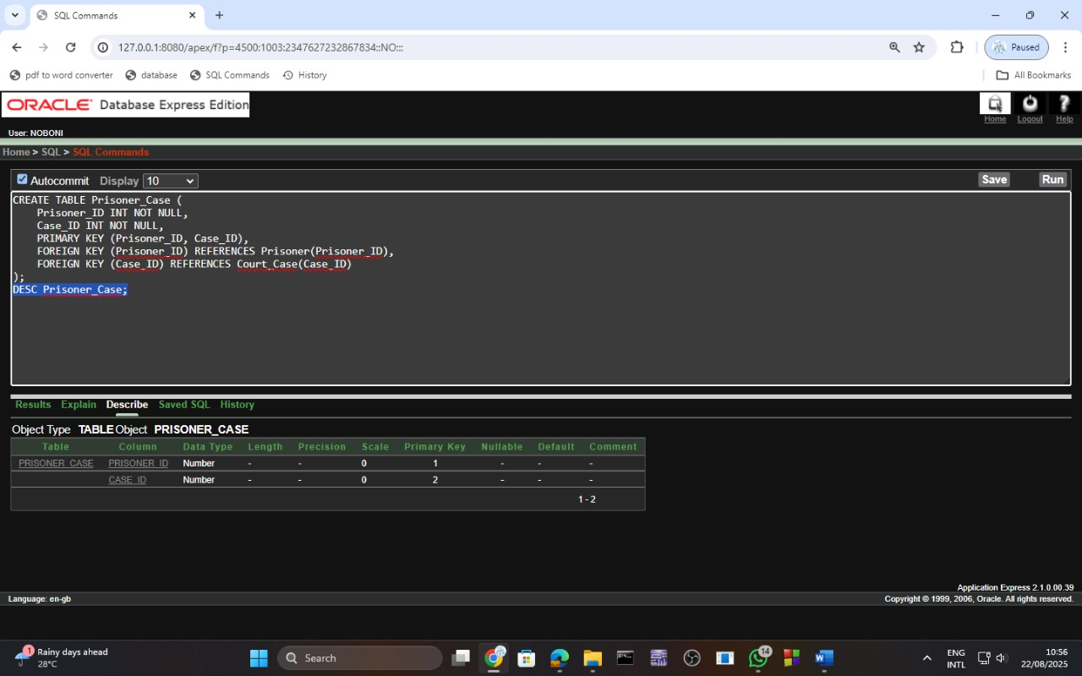

**14. Police**

CREATE TABLE Police (

Police_ID INT PRIMARY KEY,

PO_Name VARCHAR(100) NOT NULL,

PO_Rank VARCHAR(50),

Department VARCHAR(100),

PO_phone1 VARCHAR(20) NOT NULL,

PO_phone2 VARCHAR(20)

);

DESC Police;

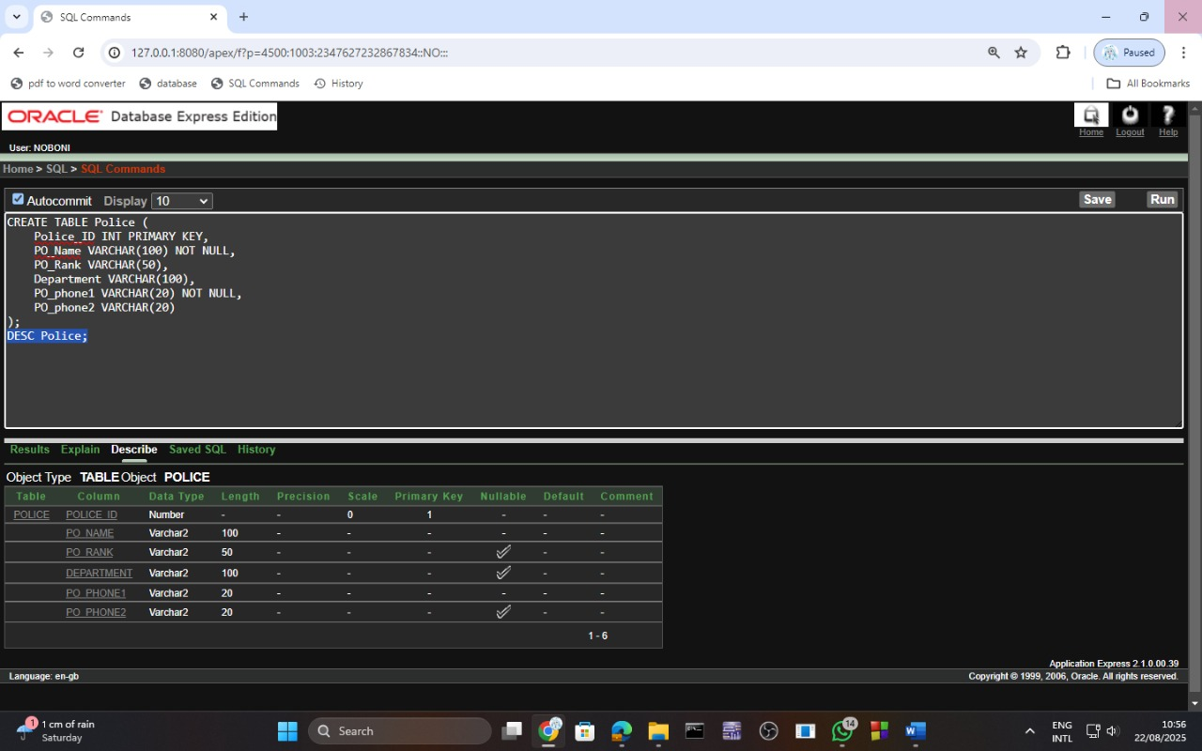

**15. Police-Case (M:N)**

CREATE TABLE Police_Case (

Police_ID INT NOT NULL,

Case_ID INT NOT NULL,

PRIMARY KEY (Police_ID, Case_ID),

FOREIGN KEY (Police_ID) REFERENCES Police(Police_ID),

FOREIGN KEY (Case_ID) REFERENCES Court_Case(Case_ID)

);

DESC Police_Case;

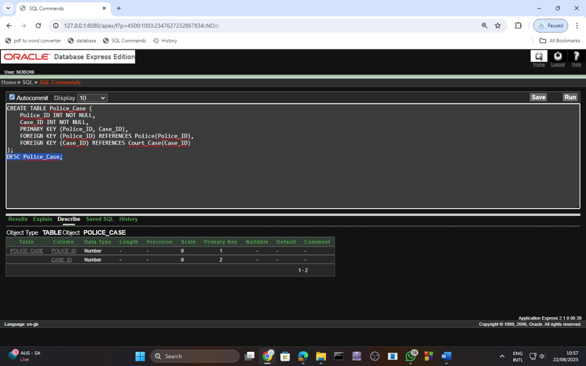

**16. Lawyer-Case (M:N)**

CREATE TABLE Lawyer_Case (

Lawyer_ID INT NOT NULL,

Case_ID INT NOT NULL,

PRIMARY KEY (Lawyer_ID, Case_ID),

FOREIGN KEY (Lawyer_ID) REFERENCES Lawyer(Lawyer_ID),

FOREIGN KEY (Case_ID) REFERENCES Court_Case(Case_ID)

);

DESC Lawyer_Case;

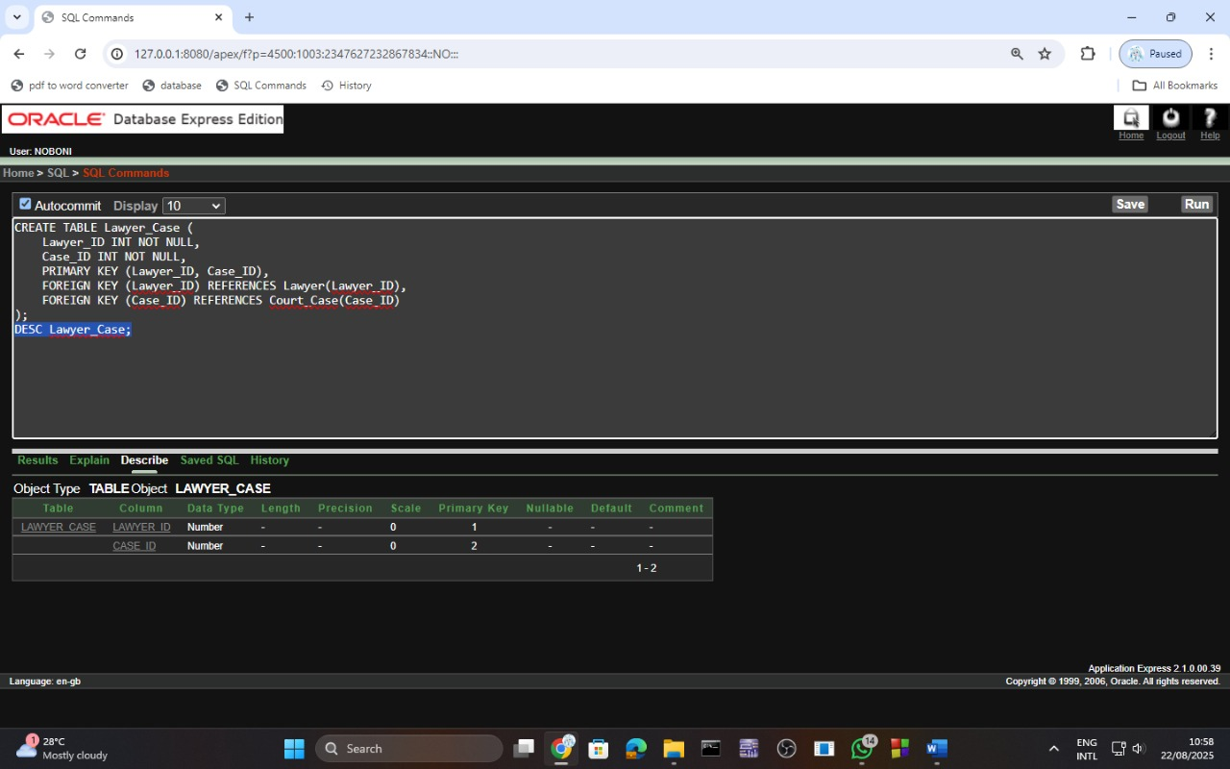

**17. Staff**

CREATE TABLE Staff (

Staff_ID INT PRIMARY KEY,

Ch_Name VARCHAR(100) NOT NULL,

Ch_Role VARCHAR(50),

Ch_Shift_Timings VARCHAR(50),

Ch_phone1 VARCHAR(20) NOT NULL,

Ch_phone2 VARCHAR(20),

Ch_Specialization VARCHAR(100),

Prison_ID INT,

FOREIGN KEY (Prison_ID) REFERENCES Prison(Prison_ID)

);

DESC Staff;

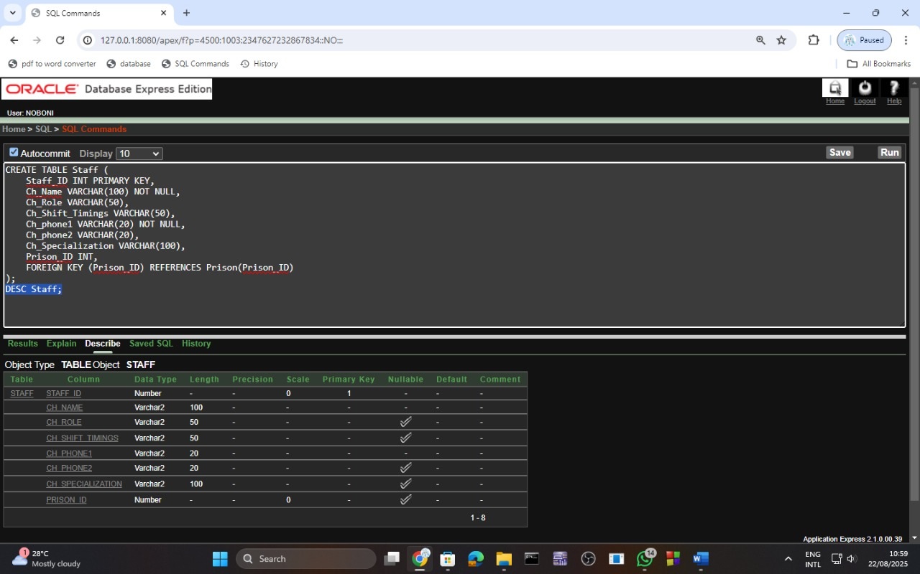

**18. Prisoner-Staff (M:N)**

CREATE TABLE Prisoner_Staff (

Prisoner_ID INT NOT NULL,

Staff_ID INT NOT NULL,

PRIMARY KEY (Prisoner_ID, Staff_ID),

FOREIGN KEY (Prisoner_ID) REFERENCES Prisoner(Prisoner_ID),

FOREIGN KEY (Staff_ID) REFERENCES Staff(Staff_ID)

);

DESC Prisoner_Staff;

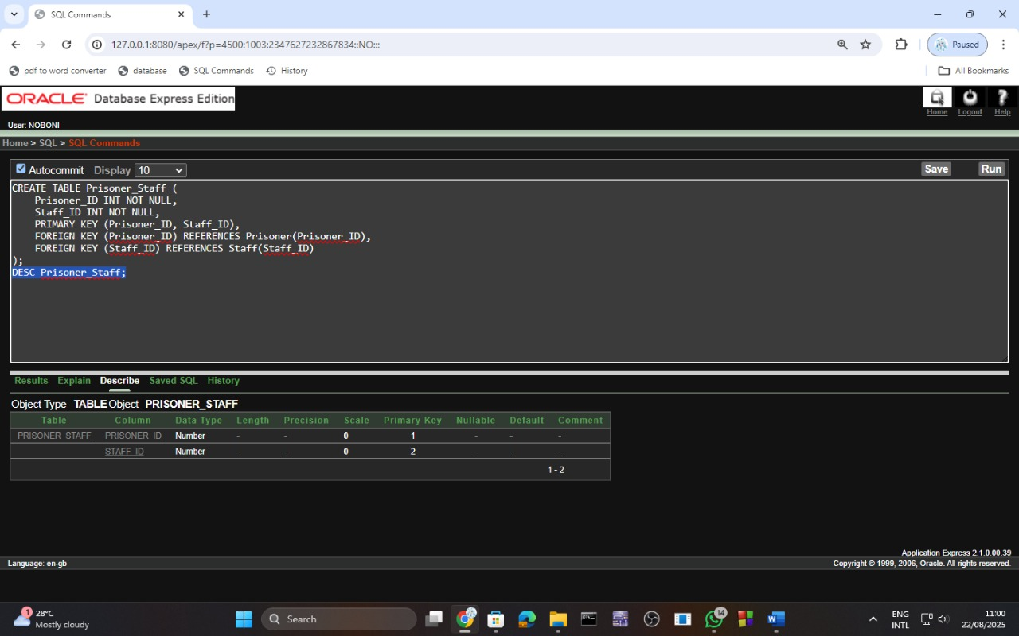

**Sequence**

1. CREATE SEQUENCE prison_id_seq

INCREMENT BY 1

START WITH 1

MAXVALUE 1000

NOCACHE

NOCYCLE;

1. CREATE SEQUENCE warden_id_seq

INCREMENT BY 1

START WITH 1

MAXVALUE 1000

NOCACHE

NOCYCLE;

1. CREATE SEQUENCE cell_id_seq

INCREMENT BY 1

START WITH 1

MAXVALUE 1000

NOCACHE

NOCYCLE;

1. CREATE SEQUENCE case_manager_id_seq

INCREMENT BY 1

START WITH 1

MAXVALUE 1000

NOCACHE

NOCYCLE;

1. CREATE SEQUENCE prisoner_id_seq

INCREMENT BY 1

START WITH 1

MAXVALUE 1000

NOCACHE

NOCYCLE;

1. CREATE SEQUENCE lawyer_id_seq

INCREMENT BY 1

START WITH 1

MAXVALUE 1000

NOCACHE

NOCYCLE;

1. CREATE SEQUENCE prisoner_lawyer_id_seq

INCREMENT BY 1

START WITH 1

MAXVALUE 1000

NOCACHE

NOCYCLE;

1. CREATE SEQUENCE medical_worker_id_seq

INCREMENT BY 1

START WITH 1

MAXVALUE 1000

NOCACHE

NOCYCLE;

1. CREATE SEQUENCE prisoner_medical_worker_id_seq

INCREMENT BY 1

START WITH 1

MAXVALUE 1000

NOCACHE

NOCYCLE;

1. CREATE SEQUENCE visitor_id_seq

INCREMENT BY 1

START WITH 1

MAXVALUE 1000

NOCACHE

NOCYCLE;

1. CREATE SEQUENCE prisoner_visitor_id_seq

INCREMENT BY 1

START WITH 1

MAXVALUE 1000

NOCACHE

NOCYCLE;

1. CREATE SEQUENCE court_case_id_seq

INCREMENT BY 1

START WITH 1

MAXVALUE 1000

NOCACHE

NOCYCLE;

1. CREATE SEQUENCE prisoner_case_id_seq

INCREMENT BY 1

START WITH 1

MAXVALUE 1000

NOCACHE

NOCYCLE;

1. CREATE SEQUENCE police_id_seq

INCREMENT BY 1

START WITH 1

MAXVALUE 1000

NOCACHE

NOCYCLE;

1. CREATE SEQUENCE police_case_id_seq

INCREMENT BY 1

START WITH 1

MAXVALUE 1000

NOCACHE

NOCYCLE;

1. CREATE SEQUENCE lawyer_case_id_seq

INCREMENT BY 1

START WITH 1

MAXVALUE 1000

NOCACHE

NOCYCLE;

1. CREATE SEQUENCE staff_id_seq

INCREMENT BY 1

START WITH 1

MAXVALUE 1000

NOCACHE

NOCYCLE;

1. CREATE SEQUENCE prisoner_staff_id_seq

INCREMENT BY 1

START WITH 1

MAXVALUE 1000

NOCACHE

NOCYCLE;

**Table Insertion:**

1. INSERT INTO Prison VALUES (prison_id_seq.NEXTVAL, 'Central Prison', 'Dhaka', 'Maximum Security', 500, 100, 450);

INSERT INTO Prison VALUES (prison_id_seq.NEXTVAL, 'Women’s Prison', 'Chittagong', 'Medium Security', 200, 50, 150);

INSERT INTO Prison VALUES (prison_id_seq.NEXTVAL, 'Juvenile Prison', 'Rajshahi', 'Low Security', 100, 25, 80);

INSERT INTO Prison VALUES (prison_id_seq.NEXTVAL, 'Maximum Security Prison', 'Khulna', 'Maximum Security', 1000, 250, 800);

INSERT INTO Prison VALUES (prison_id_seq.NEXTVAL, 'Minimum Security Prison', 'Sylhet', 'Minimum Security', 300, 75, 250);

SELECT * FROM Prison

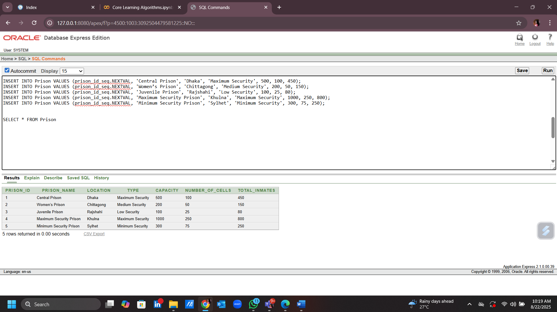

1. INSERT INTO Warden VALUES (warden_id_seq.NEXTVAL, 'Ariful Islam', 'Senior Warden', '01712345678', '01787654321', 'Oversees all prison operations', 1);

INSERT INTO Warden VALUES (warden_id_seq.NEXTVAL, 'Nusrat Jahan', 'Assistant Warden', '01723456789', '01798765432', 'Assists with prison security', 2);

INSERT INTO Warden VALUES (warden_id_seq.NEXTVAL, 'Mahbubur Rahman', 'Chief Warden', '01734567890', '01719876543', 'Manages security and staff', 3);

INSERT INTO Warden VALUES (warden_id_seq.NEXTVAL, 'Sharmin Akter', 'Warden', '01745678901', '01710987654', 'Responsible for prisoner welfare', 4);

INSERT INTO Warden VALUES (warden_id_seq.NEXTVAL, 'Imran Hossain', 'Deputy Warden', '01756789012', '01720123456', 'Supervises guards and staff', 5);

SELECT * FROM Warden  
  
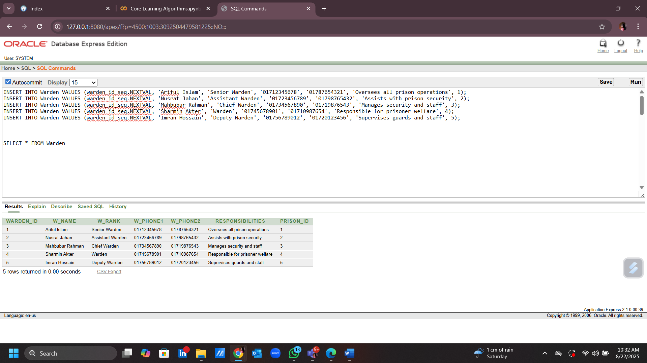

1. INSERT INTO Cell VALUES (cell_id_seq.NEXTVAL, 20, 'Single', 'High', 1);

INSERT INTO Cell VALUES (cell_id_seq.NEXTVAL, 30, 'Double', 'Medium', 2);

INSERT INTO Cell VALUES (cell_id_seq.NEXTVAL, 25, 'Single', 'Low', 3);

INSERT INTO Cell VALUES (cell_id_seq.NEXTVAL, 50, 'Double', 'High', 4);

INSERT INTO Cell VALUES (cell_id_seq.NEXTVAL, 40, 'Single', 'Medium', 5);

SELECT * FROM Cell

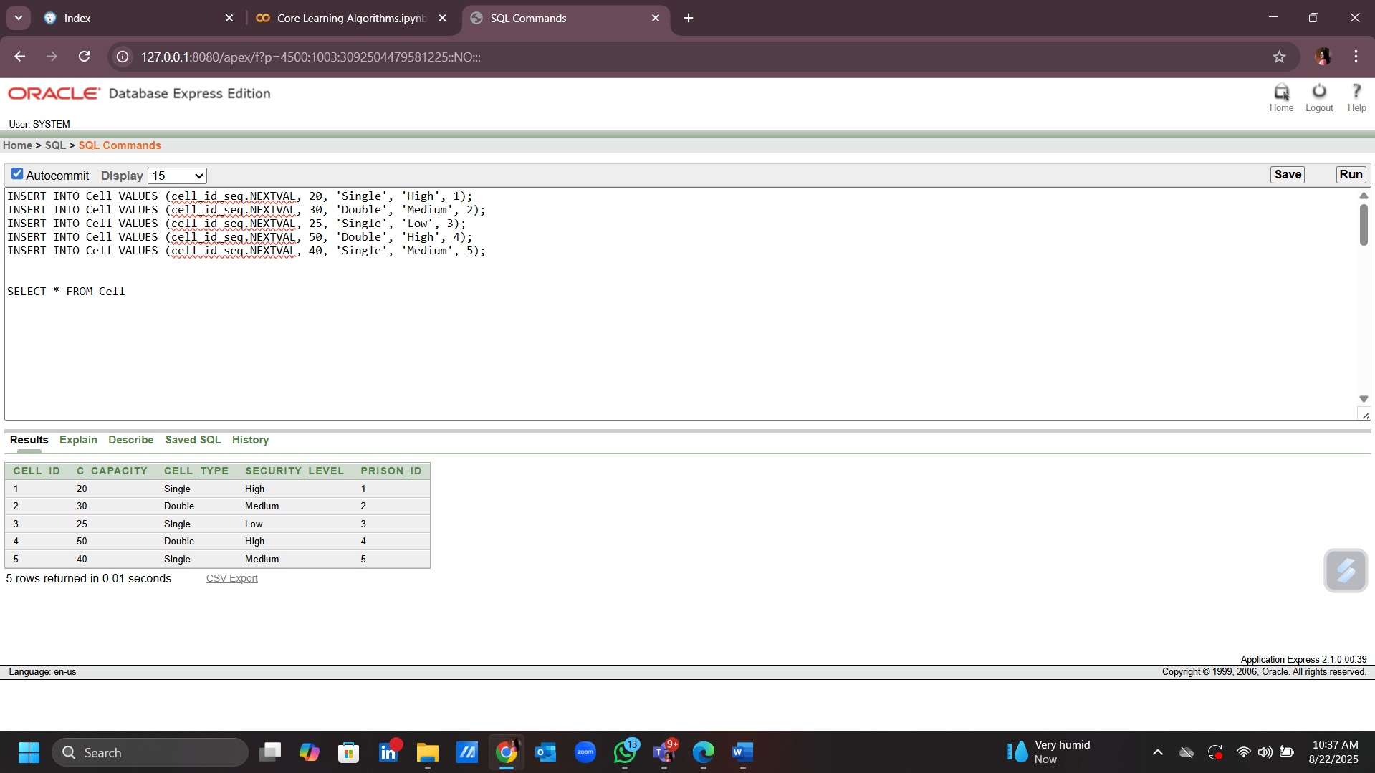

1. INSERT INTO Case_Manager VALUES (case_manager_id_seq.NEXTVAL, 'Mohammad Rafiqul', 'Assists prisoners with case management', 'Plans release and rehabilitation');

INSERT INTO Case_Manager VALUES (case_manager_id_seq.NEXTVAL, 'Sultana Begum', 'Handles juvenile cases', 'Rehabilitates minors');

INSERT INTO Case_Manager VALUES (case_manager_id_seq.NEXTVAL, 'Jahirul Islam', 'Supervises violent criminal cases', 'Reintegrates violent offenders');

INSERT INTO Case_Manager VALUES (case_manager_id_seq.NEXTVAL, 'Lutfur Rahman', 'Works with inmates on death row', 'Ensures legal rights and review processes');

INSERT INTO Case_Manager VALUES (case_manager_id_seq.NEXTVAL, 'Rumana Akter', 'Coordinates with lawyers and judges', 'Handles parole cases');

SELECT * FROM Case_Manager

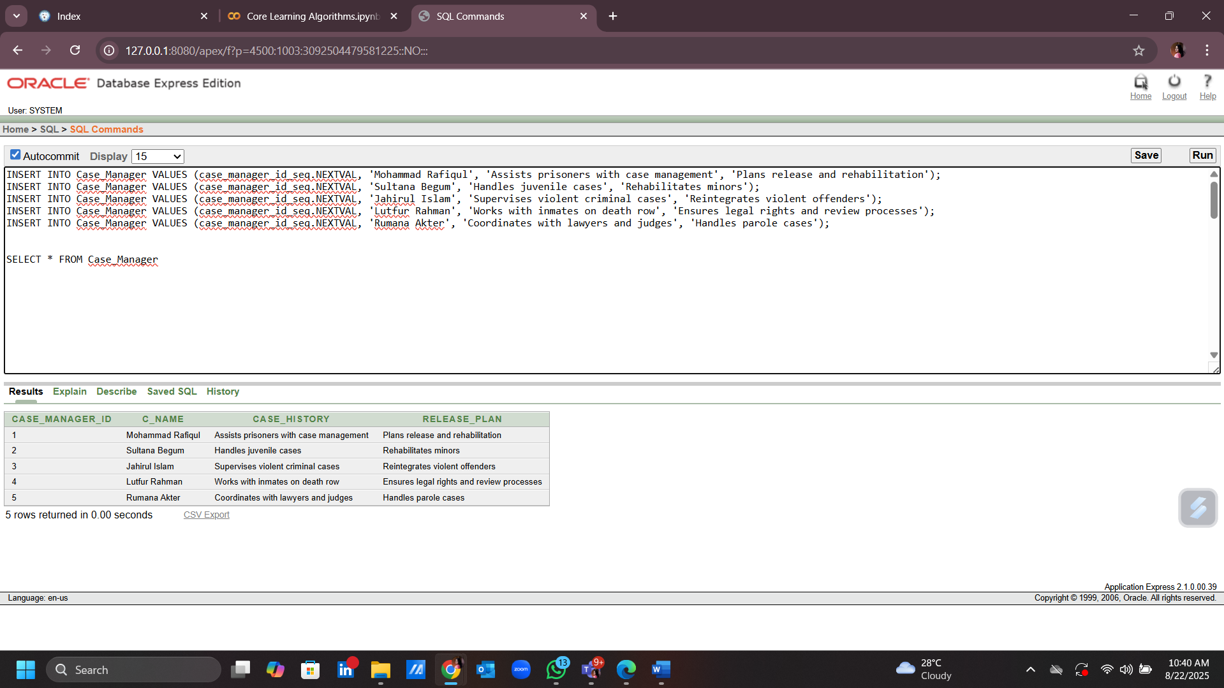

1. INSERT INTO Prisoner VALUES (prisoner_id_seq.NEXTVAL, 'Md. Hasan', 34, 'Male', TO_DATE('2015-01-01', 'YYYY-MM-DD'), TO_DATE('2025-01-01', 'YYYY-MM-DD'), 'Robbery', 'Active', 'No medical issues', 1, 1, 1);

INSERT INTO Prisoner VALUES (prisoner_id_seq.NEXTVAL, 'Rupa Sultana', 29, 'Female', TO_DATE('2018-03-15', 'YYYY-MM-DD'), TO_DATE('2028-03-15', 'YYYY-MM-DD'), 'Fraud', 'Active', 'Asthma', 2, 2, 2);

INSERT INTO Prisoner VALUES (prisoner_id_seq.NEXTVAL, 'Tanvir Ahmed', 40, 'Male', TO_DATE('2010-05-20', 'YYYY-MM-DD'), TO_DATE('2020-05-20', 'YYYY-MM-DD'), 'Murder', 'Inactive', 'No medical issues', 3, 3, 3);

INSERT INTO Prisoner VALUES (prisoner_id_seq.NEXTVAL, 'Fatema Naz', 22, 'Female', TO_DATE('2017-07-30', 'YYYY-MM-DD'), TO_DATE('2027-07-30', 'YYYY-MM-DD'), 'Drug Possession', 'Active', 'Diabetes', 4, 4, 4);

INSERT INTO Prisoner VALUES (prisoner_id_seq.NEXTVAL, 'Jahangir Alam', 55, 'Male', TO_DATE('2000-11-10', 'YYYY-MM-DD'), TO_DATE('2025-11-10', 'YYYY-MM-DD'), 'Theft', 'Active', 'Heart Disease', 5, 5, 5);

SELECT * FROM Prisoner

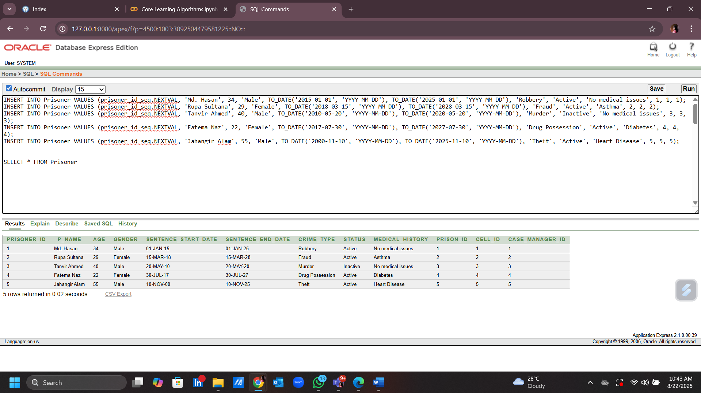

1. INSERT INTO Lawyer VALUES (lawyer_id_seq.NEXTVAL, 'Tariq Mahmud', 'Criminal Defense', 'Mahmud Law Associates', '01765432100');

INSERT INTO Lawyer VALUES (lawyer_id_seq.NEXTVAL, 'Shahnaz Begum', 'Corporate Law', 'Begum Legal Associates', '01776543210');

INSERT INTO Lawyer VALUES (lawyer_id_seq.NEXTVAL, 'Rakibul Islam', 'Family Law', 'Islam & Partners', '01787654321');

INSERT INTO Lawyer VALUES (lawyer_id_seq.NEXTVAL, 'Khaled Hossain', 'Immigration Law', 'Hossain Legal Services', '01798765432');

INSERT INTO Lawyer VALUES (lawyer_id_seq.NEXTVAL, 'Saira Zaman', 'Personal Injury', 'Zaman Law Firm', '01812345678');

SELECT * FROM Lawyer

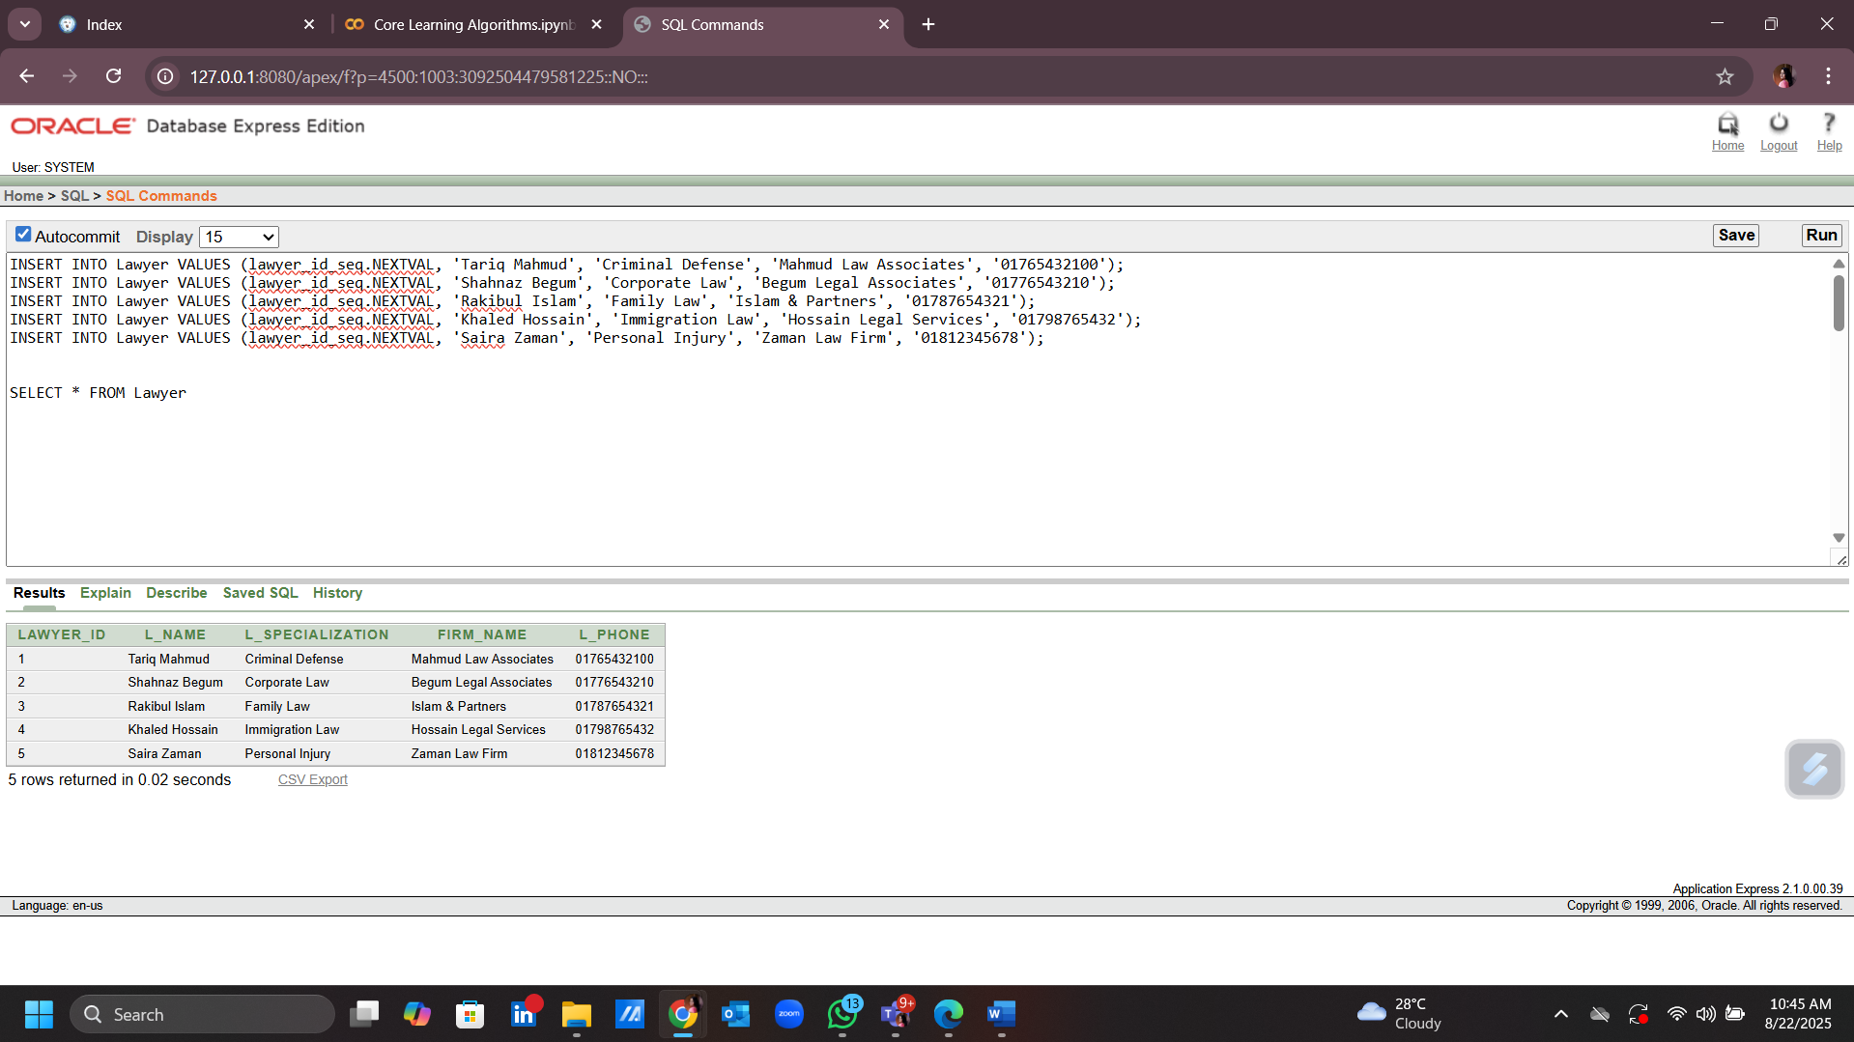

1. INSERT INTO Prisoner_Lawyer VALUES (1, 1);

INSERT INTO Prisoner_Lawyer VALUES (2, 2);

INSERT INTO Prisoner_Lawyer VALUES (3, 3);

INSERT INTO Prisoner_Lawyer VALUES (4, 4);

INSERT INTO Prisoner_Lawyer VALUES (5, 5);

SELECT * FROM Prisoner_Lawyer

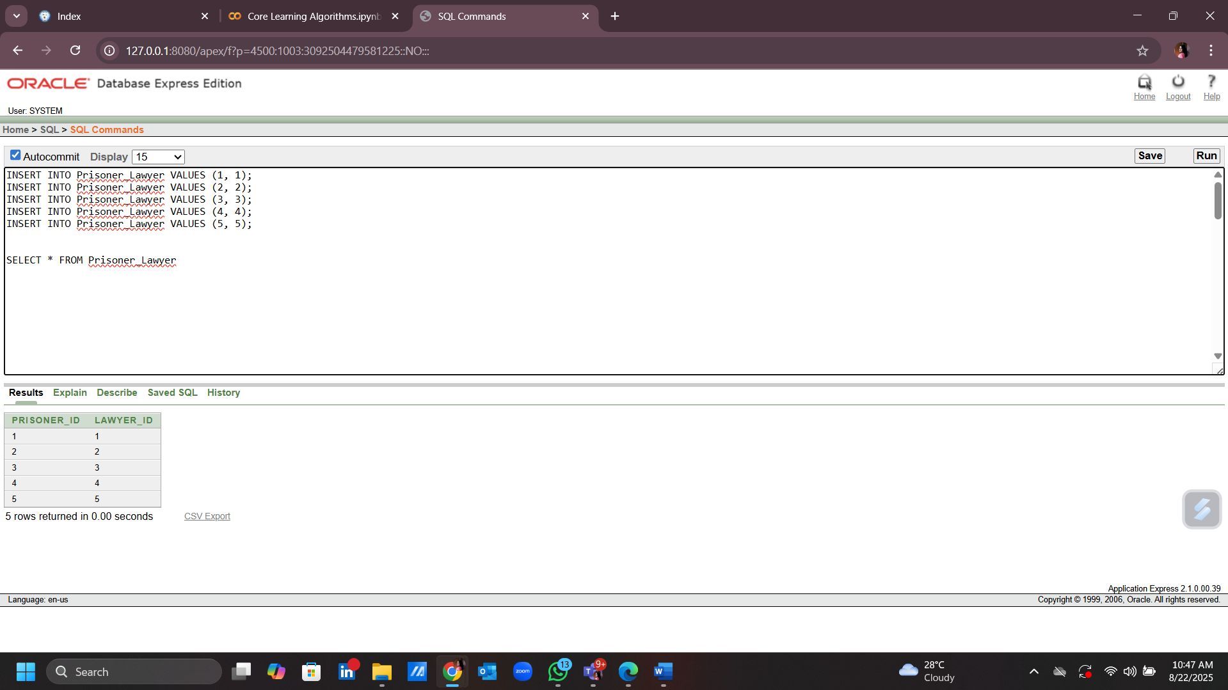

1. INSERT INTO Medical_Worker VALUES (medical_worker_id_seq.NEXTVAL, 'Dr. Rahim Uddin', 'Physician', '01798765432', '01787654321', 'No major medical records');

INSERT INTO Medical_Worker VALUES (medical_worker_id_seq.NEXTVAL, 'Dr. Rifat Zaman', 'Psychiatrist', '01787654321', '01776543210', 'Treats mental health disorders');

INSERT INTO Medical_Worker VALUES (medical_worker_id_seq.NEXTVAL, 'Dr. Anwar Hossain', 'Surgeon', '01776543210', '01765432100', 'Performed surgeries on inmates');

INSERT INTO Medical_Worker VALUES (medical_worker_id_seq.NEXTVAL, 'Nurse Tamanna Islam', 'Nurse', '01765432100', '01754321000', 'Administers daily medications');

INSERT INTO Medical_Worker VALUES (medical_worker_id_seq.NEXTVAL, 'Dr. Sultana Zohra', 'Dentist', '01754321000', '01743210999', 'Dental care and hygiene');

SELECT * FROM Medical_Worker

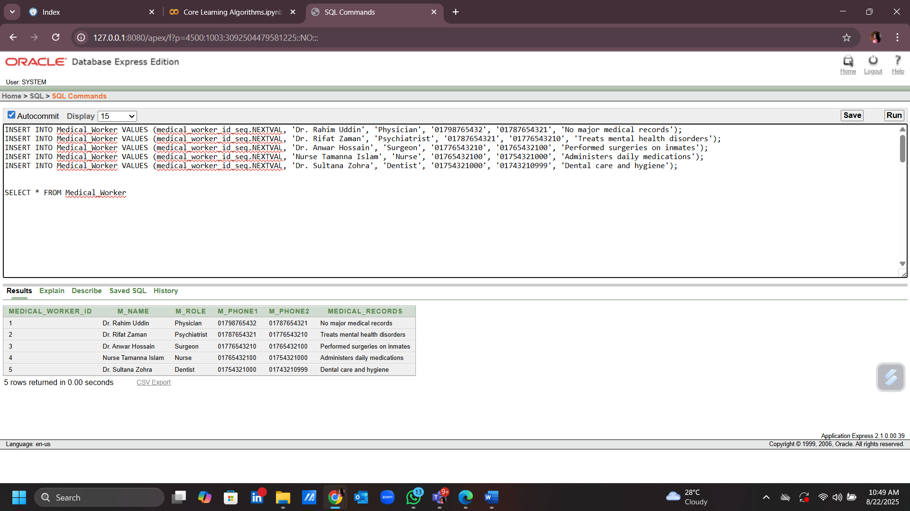

1. INSERT INTO Prisoner_MedicalWorker VALUES (1, 1);

INSERT INTO Prisoner_MedicalWorker VALUES (2, 2);

INSERT INTO Prisoner_MedicalWorker VALUES (3, 3);

INSERT INTO Prisoner_MedicalWorker VALUES (4, 4);

INSERT INTO Prisoner_MedicalWorker VALUES (5, 5);

SELECT * FROM Prisoner_MedicalWorker

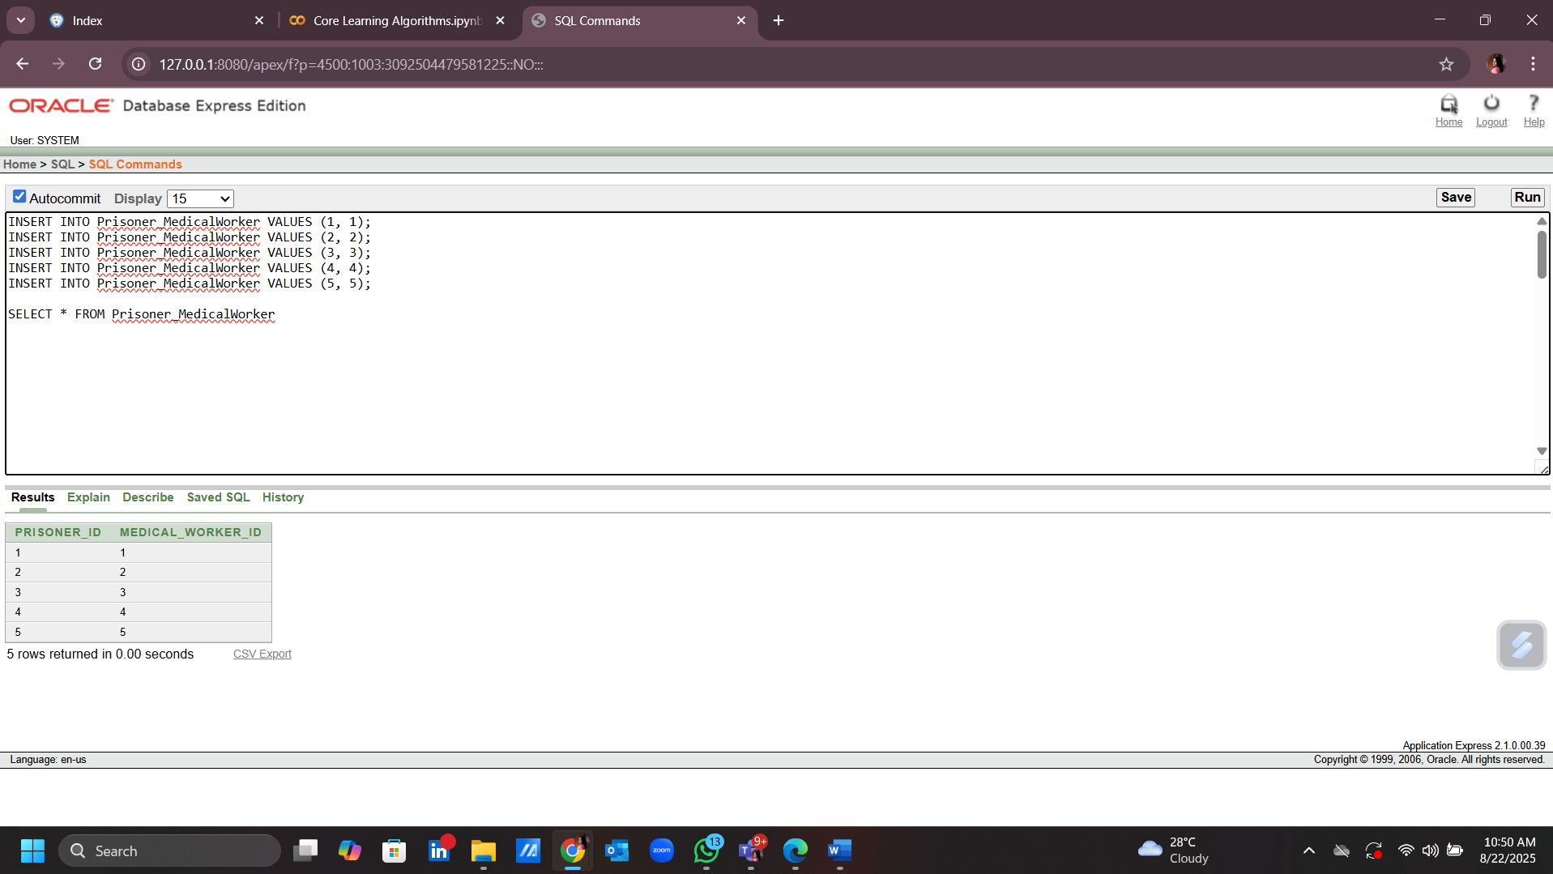

1. INSERT INTO Visitor VALUES (visitor_id_seq.NEXTVAL, 'Momena Khatun', 'Mother', TO_DATE('2023-07-01', 'YYYY-MM-DD'), 'Approved');

INSERT INTO Visitor VALUES (visitor_id_seq.NEXTVAL, 'Shahinur Rahman', 'Father', TO_DATE('2023-07-02', 'YYYY-MM-DD'), 'Approved');

INSERT INTO Visitor VALUES (visitor_id_seq.NEXTVAL, 'Fariha Sultana', 'Friend', TO_DATE('2023-07-03', 'YYYY-MM-DD'), 'Pending');

INSERT INTO Visitor VALUES (visitor_id_seq.NEXTVAL, 'Rafiqul Islam', 'Brother', TO_DATE('2023-07-04', 'YYYY-MM-DD'), 'Rejected');

INSERT INTO Visitor VALUES (visitor_id_seq.NEXTVAL, 'Morsheda Begum', 'Sister', TO_DATE('2023-07-05', 'YYYY-MM-DD'), 'Approved');

SELECT * FROM Visitor

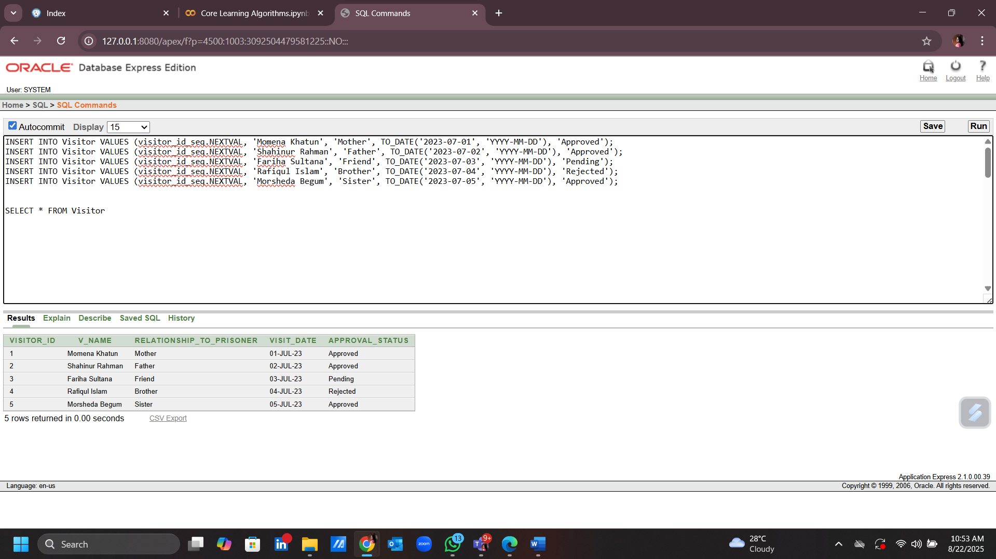

1. INSERT INTO Prisoner_Visitor VALUES (1, 1);

INSERT INTO Prisoner_Visitor VALUES (2, 2);

INSERT INTO Prisoner_Visitor VALUES (3, 3);

INSERT INTO Prisoner_Visitor VALUES (4, 4);

INSERT INTO Prisoner_Visitor VALUES (5, 5);

SELECT * FROM Prisoner_Visitor

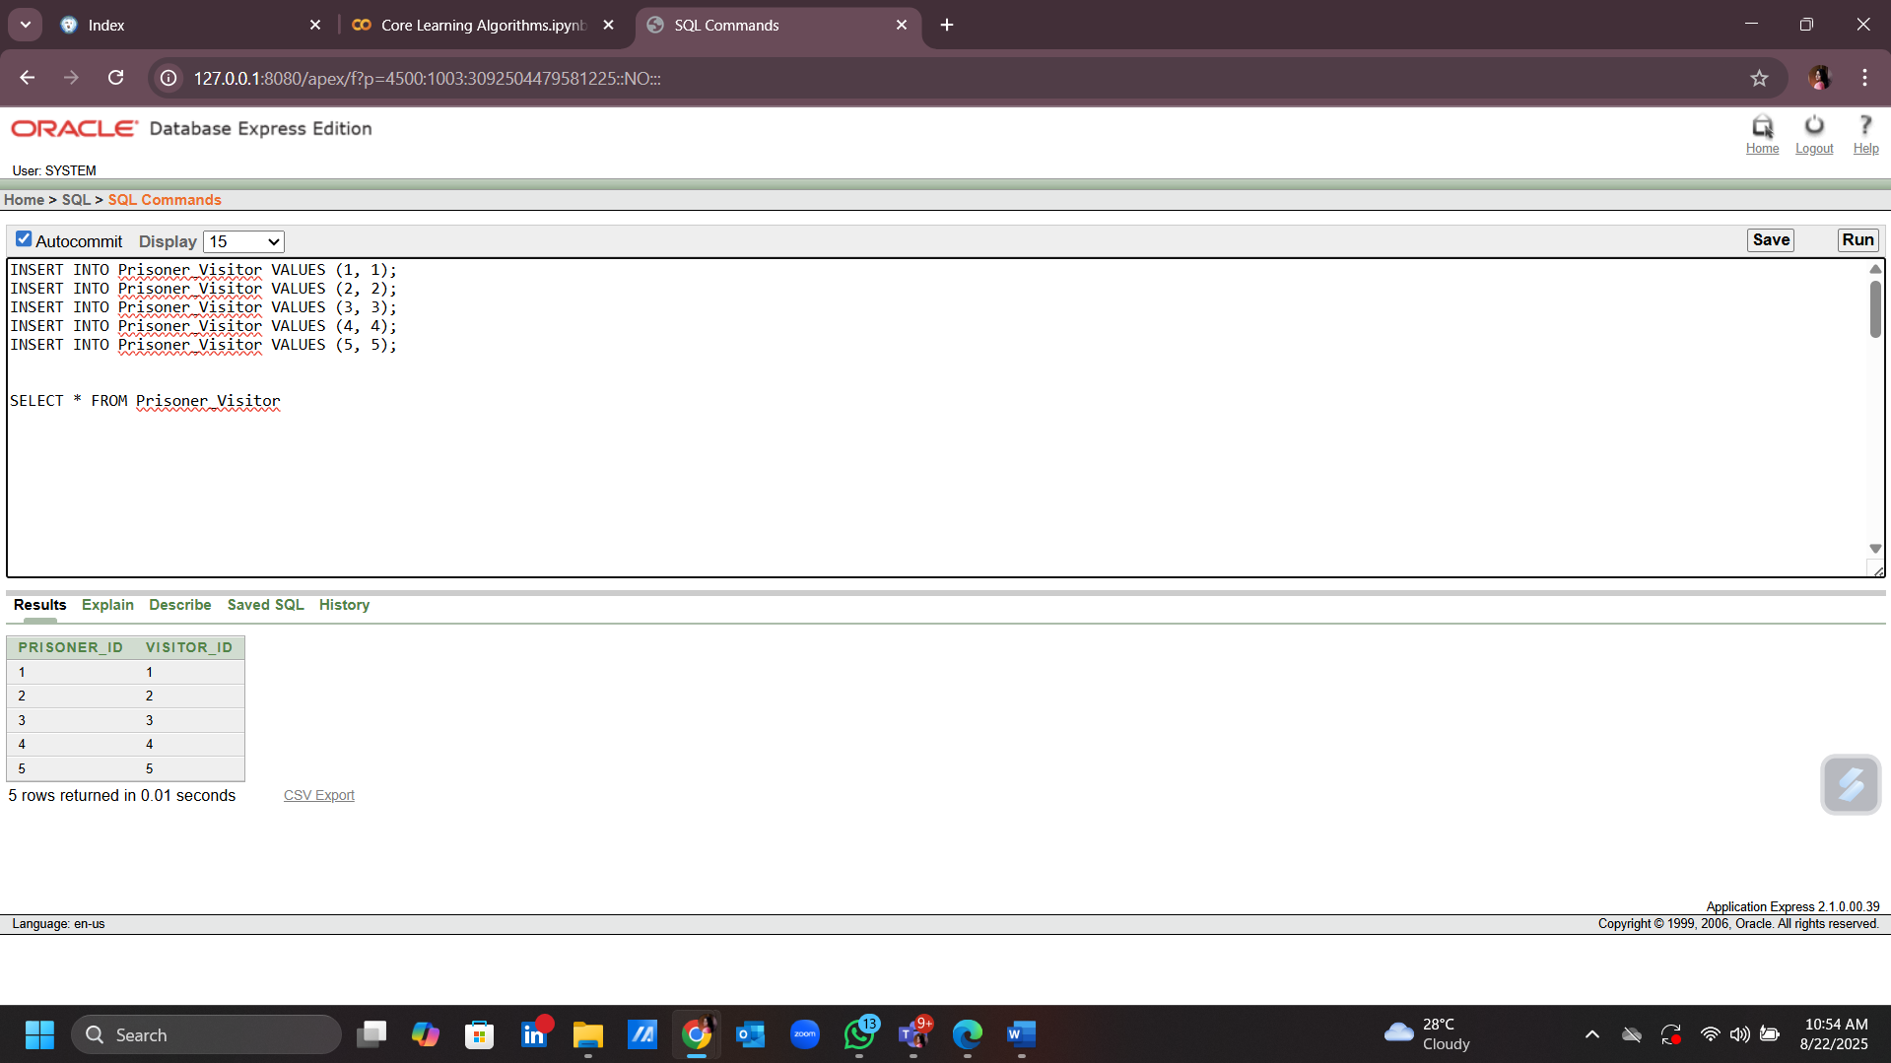

1. INSERT INTO Court_Case VALUES (court_case_id_seq.NEXTVAL, 'Robbery', TO_DATE('2016-05-15', 'YYYY-MM-DD'), 'Guilty', '10 years', 'No Appeal');

INSERT INTO Court_Case VALUES (court_case_id_seq.NEXTVAL, 'Fraud', TO_DATE('2018-03-01', 'YYYY-MM-DD'), 'Guilty', '5 years', 'Appealed');

INSERT INTO Court_Case VALUES (court_case_id_seq.NEXTVAL, 'Murder', TO_DATE('2010-10-20', 'YYYY-MM-DD'), 'Guilty', 'Life Sentence', 'No Appeal');

INSERT INTO Court_Case VALUES (court_case_id_seq.NEXTVAL, 'Drug Possession', TO_DATE('2017-11-10', 'YYYY-MM-DD'), 'Guilty', '3 years', 'Appealed');

INSERT INTO Court_Case VALUES (court_case_id_seq.NEXTVAL, 'Theft', TO_DATE('2005-06-15', 'YYYY-MM-DD'), 'Guilty', '2 years', 'No Appeal');

SELECT * FROM Court_Case

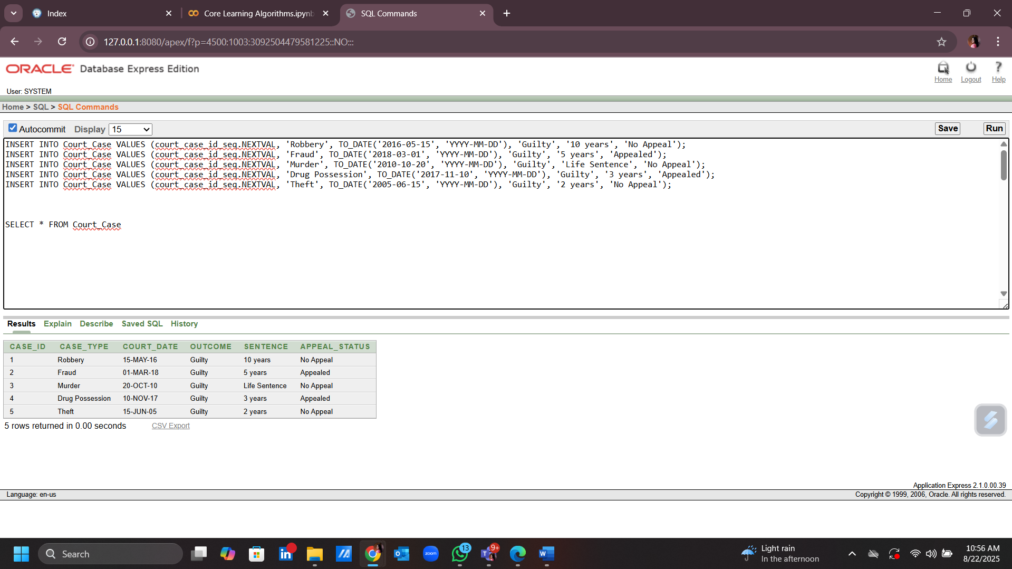

1. INSERT INTO Prisoner_Case VALUES (1, 1);

INSERT INTO Prisoner_Case VALUES (2, 2);

INSERT INTO Prisoner_Case VALUES (3, 3);

INSERT INTO Prisoner_Case VALUES (4, 4);

INSERT INTO Prisoner_Case VALUES (5, 5);

SELECT * FROM Prisoner_Case

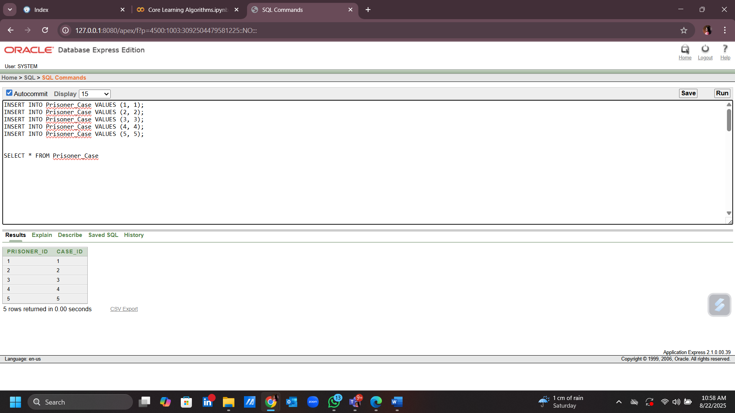

1. INSERT INTO Police VALUES (police_id_seq.NEXTVAL, 'Abdul Kadir', 'Inspector', 'Dhaka Metropolitan Police', '01765432100', '01787654321');

INSERT INTO Police VALUES (police_id_seq.NEXTVAL, 'Lutfur Rahman', 'Sub-Inspector', 'Rajshahi Police', '01776543210', '01798765432');

INSERT INTO Police VALUES (police_id_seq.NEXTVAL, 'Rashidul Islam', 'Constable', 'Chattogram Police', '01787654321', '01776543210');

INSERT INTO Police VALUES (police_id_seq.NEXTVAL, 'Shafiqul Alam', 'Senior Constable', 'Sylhet Police', '01798765432', '01787654321');

INSERT INTO Police VALUES (police_id_seq.NEXTVAL, 'Farhana Begum', 'Inspector', 'Khulna Metropolitan Police', '01812345678', '01876543210');

SELECT * FROM Police

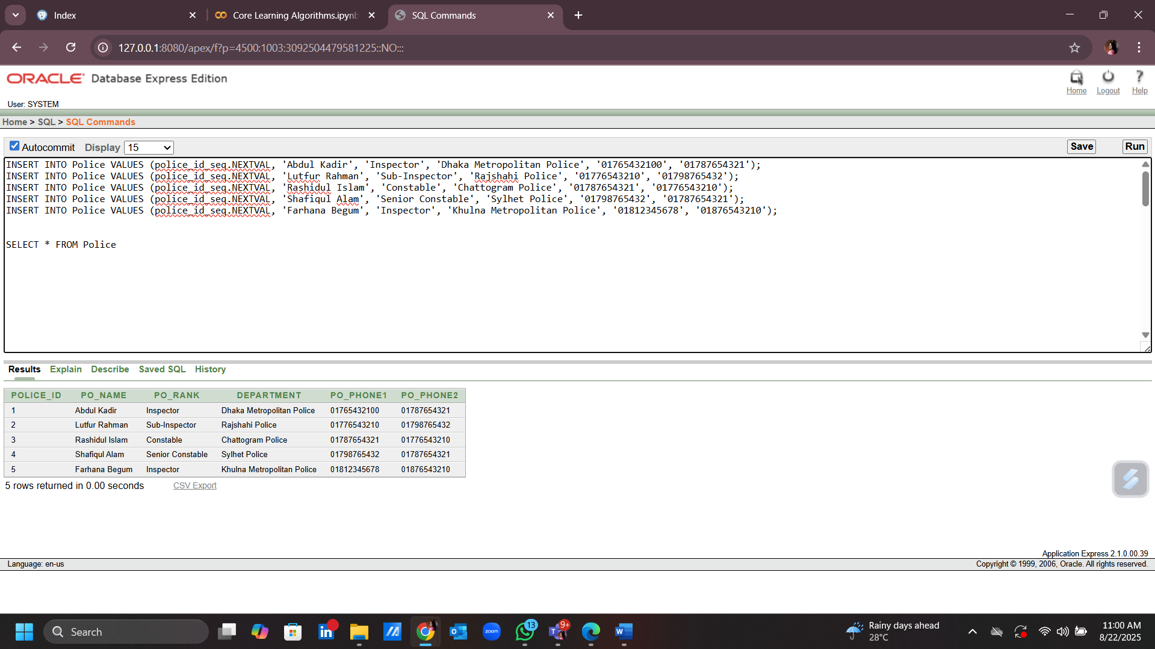

1. INSERT INTO Police_Case VALUES (1, 1);

INSERT INTO Police_Case VALUES (2, 2);

INSERT INTO Police_Case VALUES (3, 3);

INSERT INTO Police_Case VALUES (4, 4);

INSERT INTO Police_Case VALUES (5, 5);

SELECT * FROM Police_Case

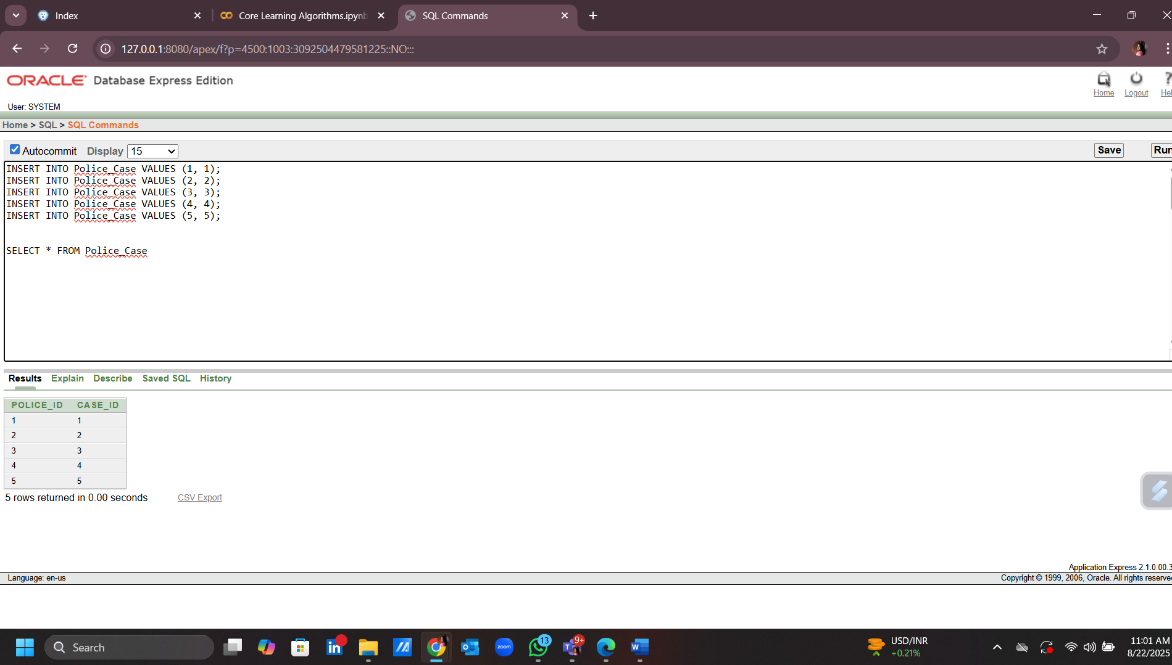

1. INSERT INTO Lawyer_Case VALUES (1, 1);

INSERT INTO Lawyer_Case VALUES (2, 2);

INSERT INTO Lawyer_Case VALUES (3, 3);

INSERT INTO Lawyer_Case VALUES (4, 4);

INSERT INTO Lawyer_Case VALUES (5, 5);

SELECT * FROM Lawyer_Case

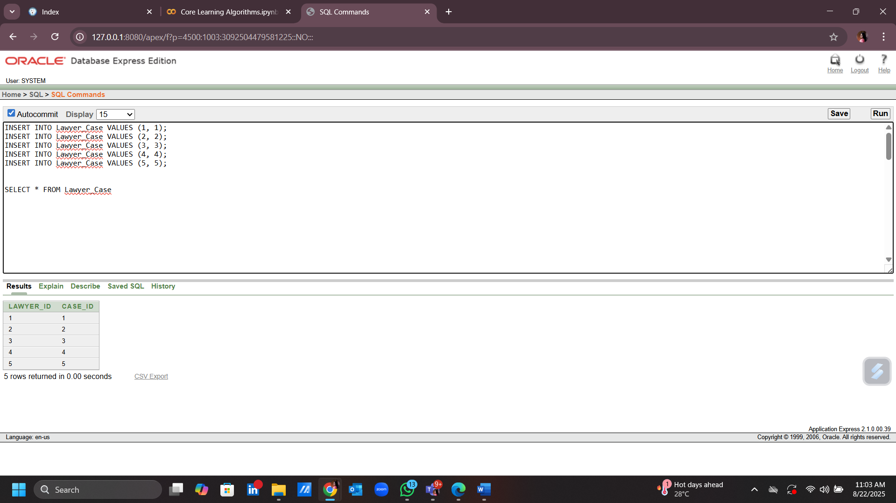

1. INSERT INTO Staff VALUES (staff_id_seq.NEXTVAL, 'Mohammad Ali', 'Guard', 'Night Shift', '01765432100', '01787654321', 'Security', 1);

INSERT INTO Staff VALUES (staff_id_seq.NEXTVAL, 'Rahima Begum', 'Nurse', 'Day Shift', '01776543210', '01798765432', 'Healthcare', 2);

INSERT INTO Staff VALUES (staff_id_seq.NEXTVAL, 'Shamsul Alam', 'Janitor', 'Morning Shift', '01787654321', '01776543210', 'Cleaning', 3);

INSERT INTO Staff VALUES (staff_id_seq.NEXTVAL, 'Mofizul Islam', 'Cook', 'Evening Shift', '01798765432', '01787654321', 'Kitchen', 4);

INSERT INTO Staff VALUES (staff_id_seq.NEXTVAL, 'Sumaya Akter', 'Admin Assistant', 'Day Shift', '01812345678', '01876543210', 'Administration', 5);

SELECT * FROM Staff

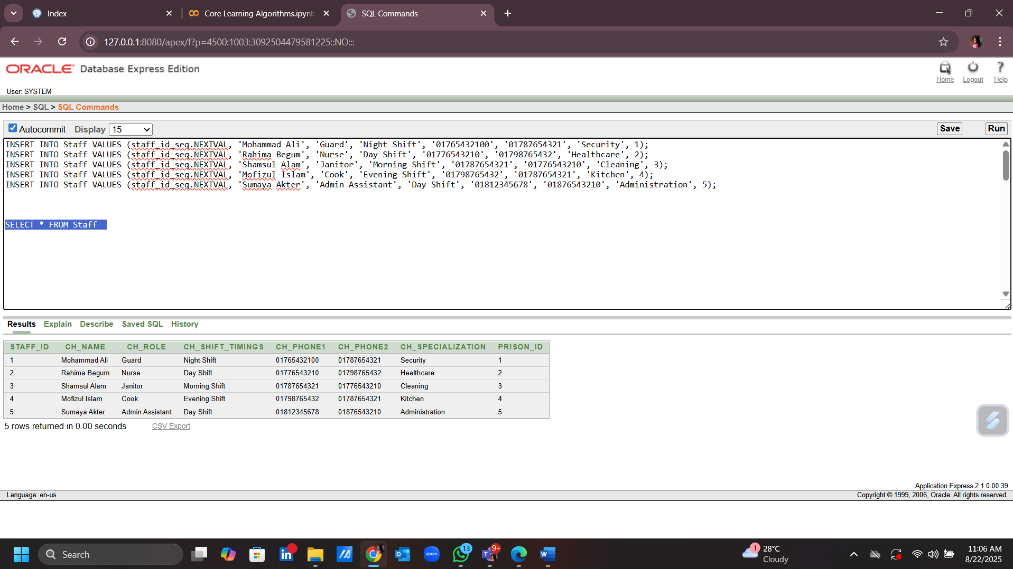

1. INSERT INTO Prisoner_Staff VALUES (1, 1);

INSERT INTO Prisoner_Staff VALUES (2, 2);

INSERT INTO Prisoner_Staff VALUES (3, 3);

INSERT INTO Prisoner_Staff VALUES (4, 4);

INSERT INTO Prisoner_Staff VALUES (5, 5);

SELECT * FROM Prisoner_Staff

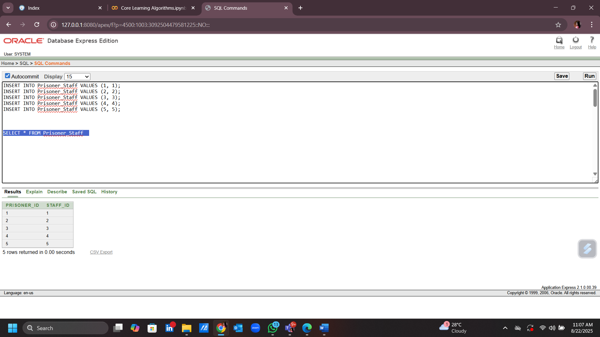

**Basic PL/SQL**

**Variables:**

1. **Calculate how many prisoners are in a specific cell.**

-- Project Name : Prison Management System

-- Semester : SUMMER 2024-2025

-- Course Name : ADVANCED DATABASE MANAGEMENT SYSTEM

-- Section : A

DECLARE

v_cell Cell.Cell_ID%TYPE := 5;

v_count NUMBER;

BEGIN

SELECT COUNT(*)

INTO v_count

FROM Prisoner

WHERE Cell_ID = v_cell;

DBMS_OUTPUT.PUT_LINE('Cell '||v_cell||' has '||v_count||' prisoners.');

END;

/

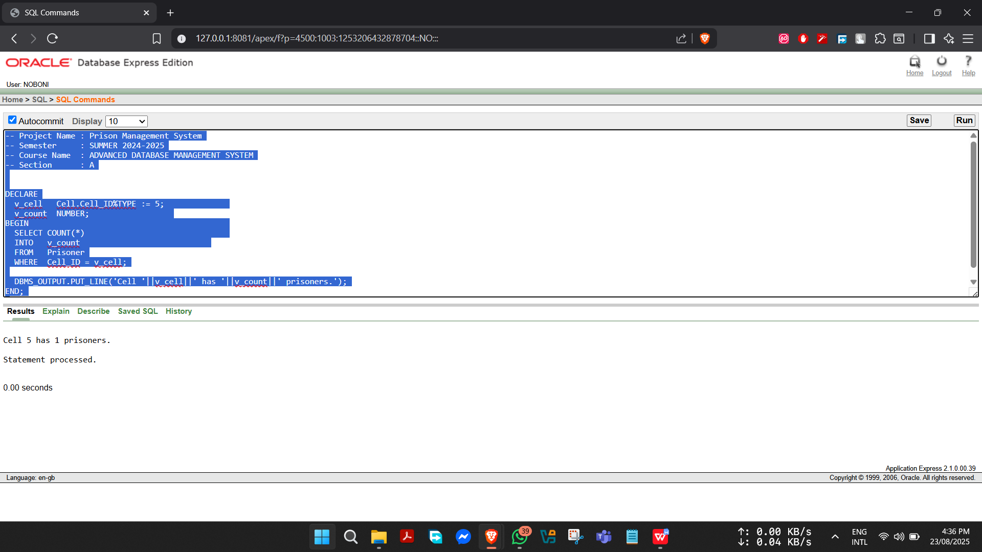

1. **Calculate sentence length (days) for a given :prisoner_id.**

-- Project Name : Prison Management System

-- Semester : SUMMER 2024-2025

-- Course Name : ADVANCED DATABASE MANAGEMENT SYSTEM

-- Section : A

DECLARE

v_pid Prisoner.Prisoner_ID%TYPE := :prisoner_id;

v_days NUMBER;

BEGIN

SELECT (Sentence_End_Date - Sentence_Start_Date)

INTO v_days

FROM Prisoner

WHERE Prisoner_ID = v_pid;

DBMS_OUTPUT.PUT_LINE('Sentence length (days): '||v_days);

END;

/

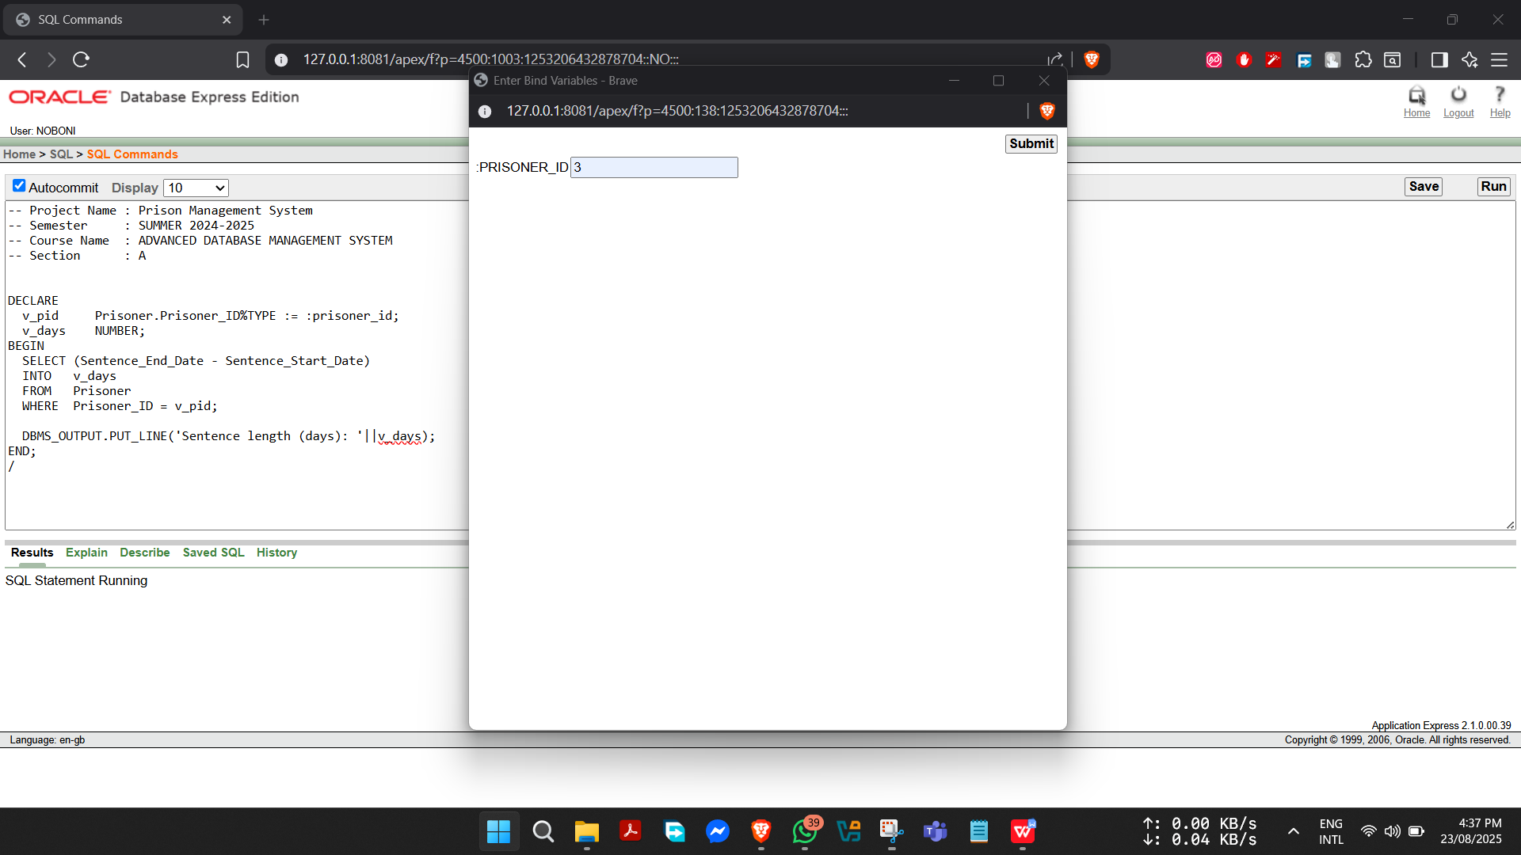

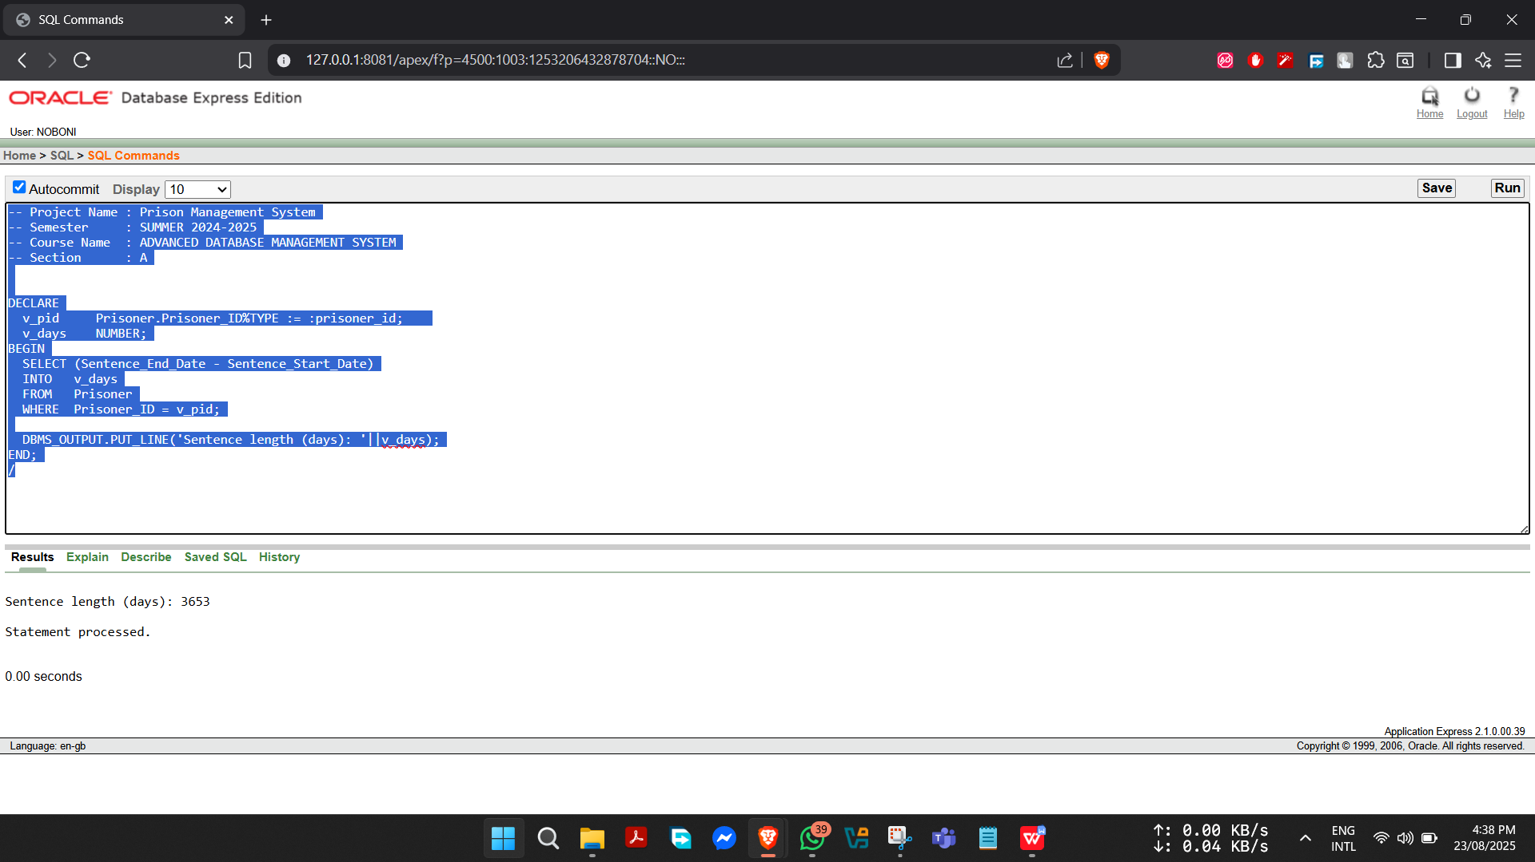

**Operators:**

1. **Duty planning needs to check if planned releases free enough beds for a new intake today.**

-- Project: Prison Management System

-- Semester: Summer 2024-2025

-- Course: Advance Database Management System

-- Section: A

DECLARE

today_releases NUMBER := 8;

today_new_intake NUMBER := 10;

current_free_beds NUMBER := 5;

projected_free NUMBER;

BEGIN

projected_free := (current_free_beds + today_releases) - today_new_intake; -- +, - operators

IF projected_free >= 0 THEN -- comparison operator

DBMS_OUTPUT.PUT_LINE('Sufficient beds after releases. Free: ' || projected_free);

ELSE

DBMS_OUTPUT.PUT_LINE('Insufficient beds. Short by: ' || ABS(projected_free));

END IF;

END;

/

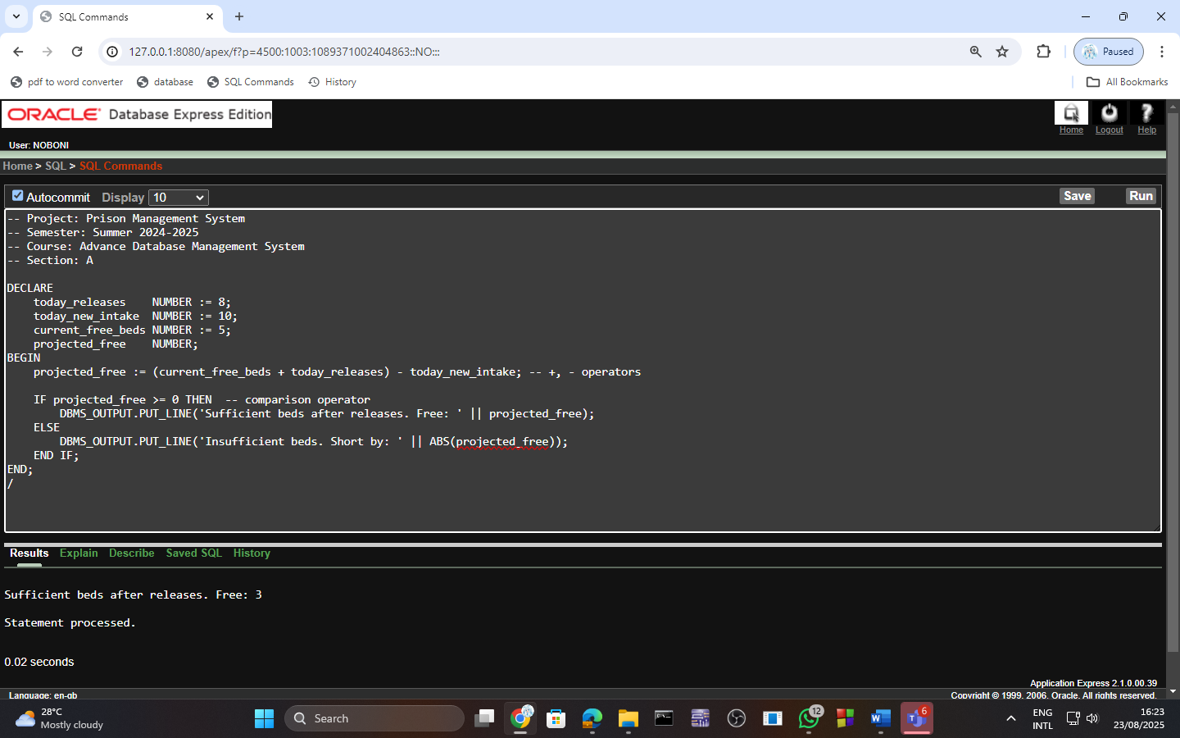

1. **If security completes a round, which round comes next in a 3-round cycle?**

-- Project: Prison Management System

-- Semester: Summer 2024-2025

-- Course: Advance Database Management System

-- Section: A

DECLARE

last_round NUMBER := 5; -- last round completed

next_round NUMBER;

BEGIN

-- Cycles 1..3 using MOD

next_round := MOD(last_round, 3) + 1;

DBMS_OUTPUT.PUT_LINE('Next headcount round: ' || next_round);

END;

/

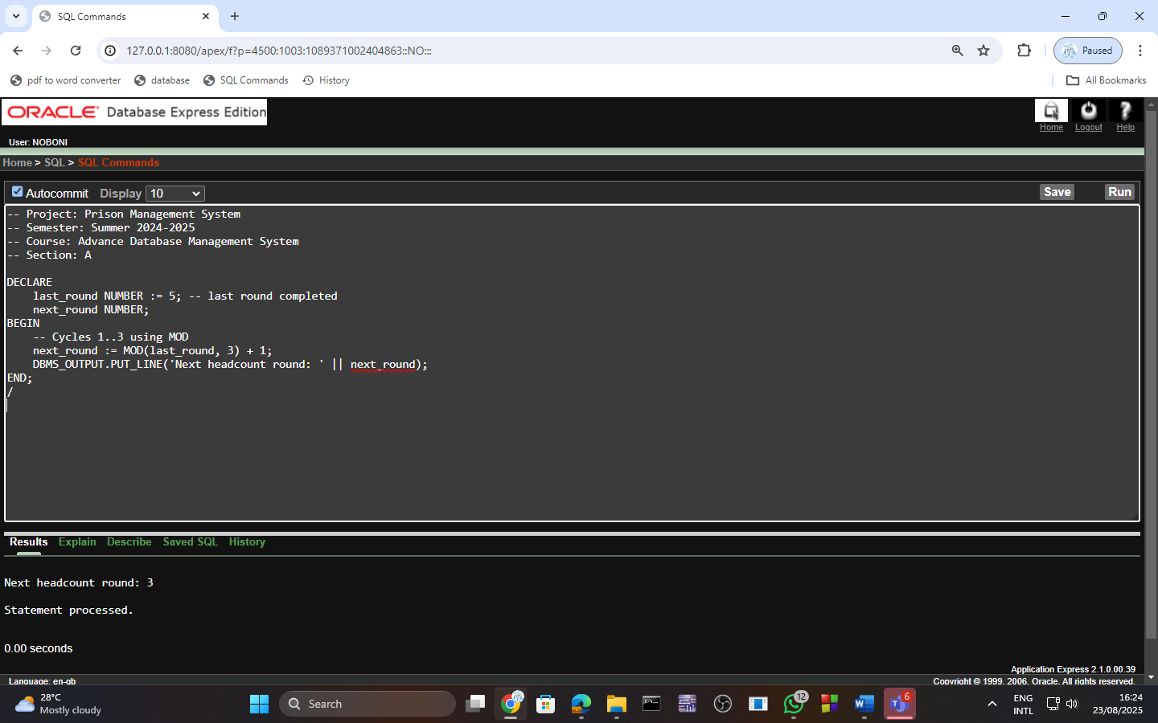

**Single-Row Function:**

1. **Display all prisoner names in uppercase.**

-- Project Name : Prison Management System

-- Semester : SUMMER 2024-2025

-- Course Name : ADVANCED DATABASE MANAGEMENT SYSTEM

-- Section : A

SELECT Prisoner_ID, UPPER(P_Name) AS NAME_UPPER

FROM Prisoner;

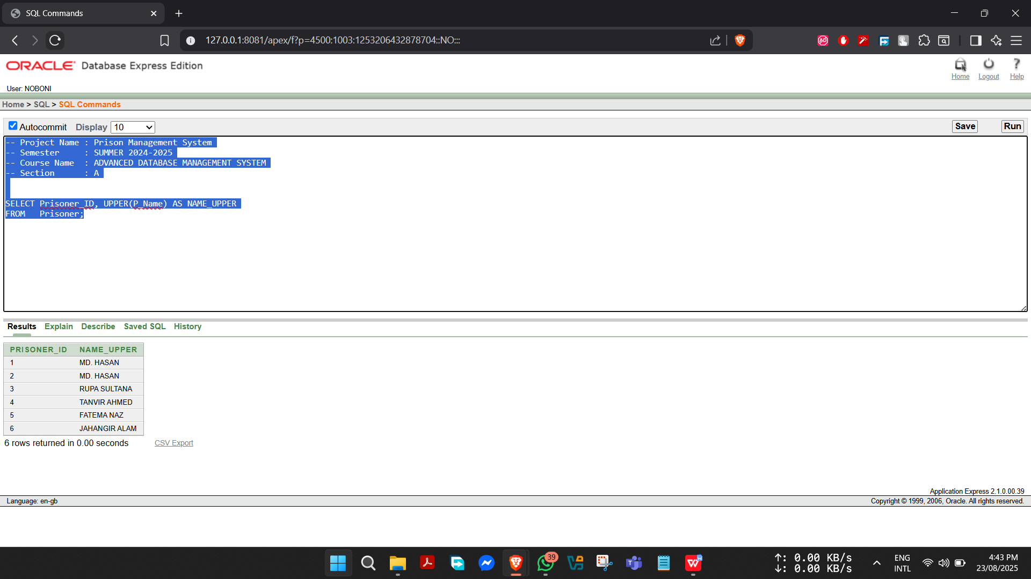

1. **Show formatted sentence end date of each prisoner.**

-- Project Name : Prison Management System

-- Semester : SUMMER 2024-2025

-- Course Name : ADVANCED DATABASE MANAGEMENT SYSTEM

-- Section : A

SELECT Prisoner_ID,

TO_CHAR(Sentence_End_Date,'DD-MON-YYYY') AS END_DATE

FROM Prisoner;

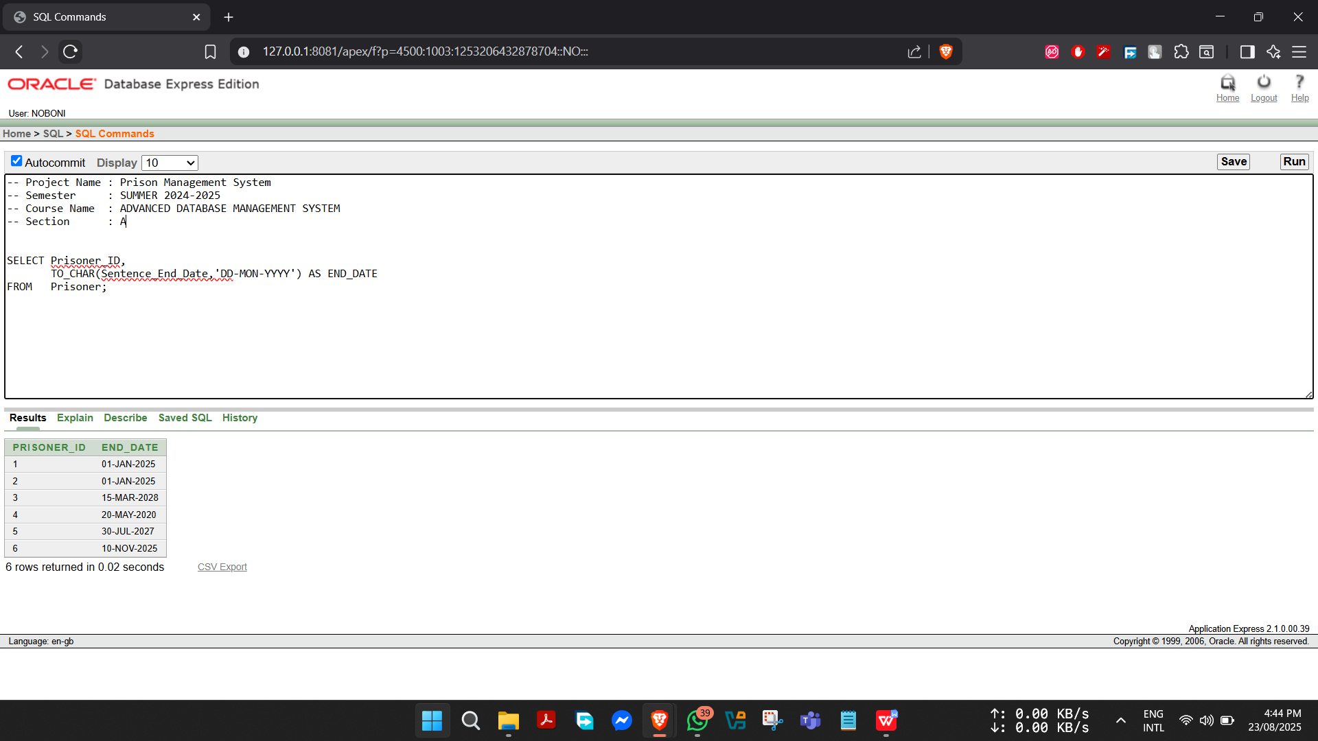

**Group Function:**

**1) Administrators want to see total inmates and average age per prison for resource allocation.**

-- Project Name: Prison Management System

-- Semester: SUMMER 2024-2025

-- Course Name: ADVANCED DATABASE MANAGEMENT SYSTEM

-- Section: A

SELECT pr.Prison_Name,

COUNT(p.Prisoner_ID) AS Total_Inmates,

AVG(p.Age) AS Average_Age

FROM Prisoner p

JOIN Prison pr ON p.Prison_ID = pr.Prison_ID

GROUP BY pr.Prison_Name

ORDER BY pr.Prison_Name;

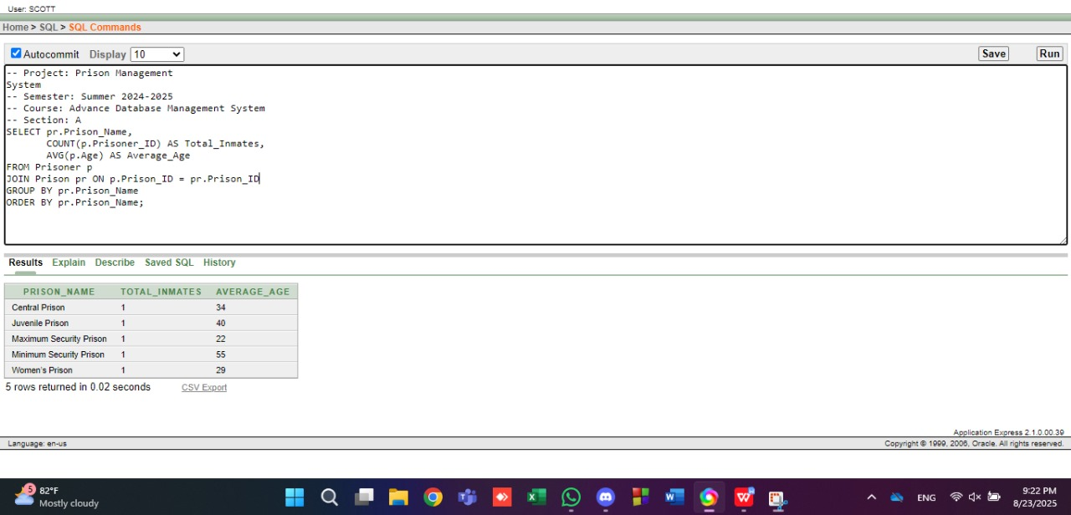

**2) Lawyers want to see total cases and appealed count per case type for trend analysis**.

-- Project Name: Prison Management System

-- Semester: SUMMER 2024-2025

-- Course Name: ADVANCED DATABASE MANAGEMENT SYSTEM

-- Section: A

SELECT Case_Type,

COUNT(Case_ID) AS Total_Cases,

SUM(CASE WHEN Appeal_Status = 'Appealed' THEN 1 ELSE 0 END) AS Appealed

FROM Court_Case

GROUP BY Case_Type

ORDER BY Total_Cases DESC;

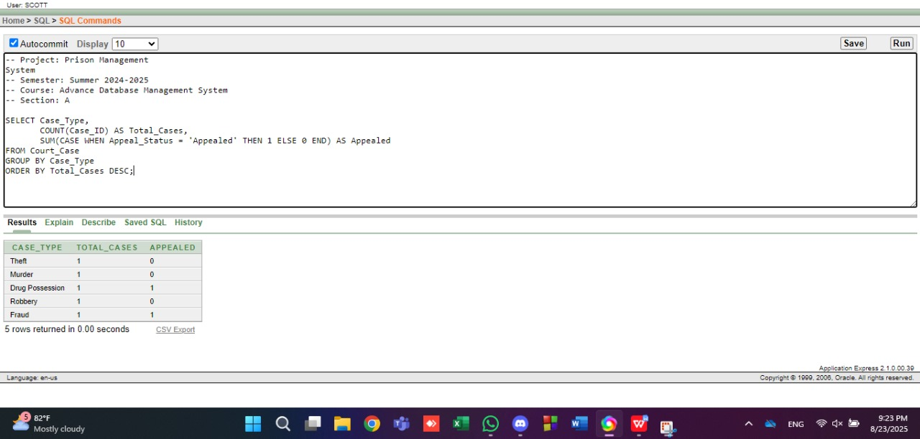

**Loop:**

1. **Wardens want to display a sequence of shift hours from 1 to 12 for reporting.**

-- Project Name: Prison Management System

-- Semester: SUMMER 2024-2025

-- Course Name: ADVANCED DATABASE MANAGEMENT SYSTEM

-- Section: A.

DECLARE

v_hour NUMBER := 1;

BEGIN

WHILE v_hour <= 12 LOOP

DBMS_OUTPUT.PUT_LINE('Shift hour: ' || v_hour);

v_hour := v_hour + 1;

END LOOP;

END;

/

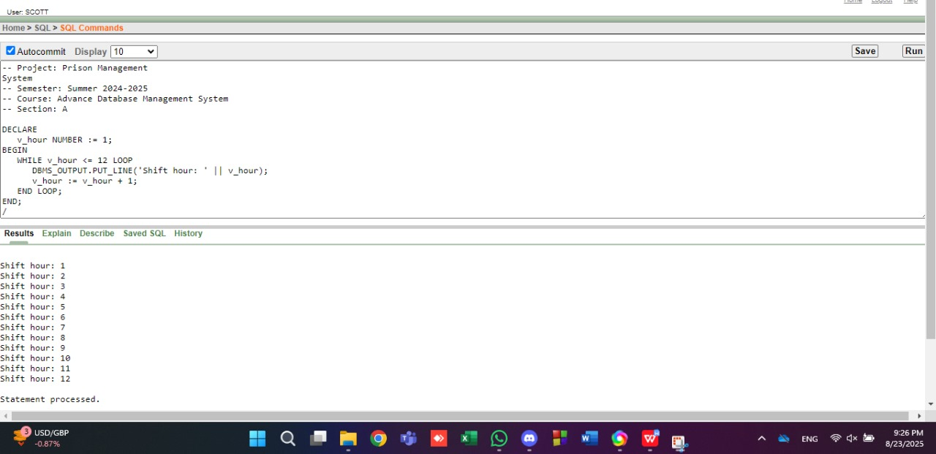

1. **Administrators want to calculate and display incremental occupancy rates for planning.**

-- Project Name: Prison Management System

-- Semester: SUMMER 2024-2025

-- Course Name: ADVANCED DATABASE MANAGEMENT SYSTEM

-- Section: A

DECLARE

v_rate NUMBER := 0;

BEGIN

LOOP

DBMS_OUTPUT.PUT_LINE('Rate: ' || v_rate);

v_rate := v_rate + 10;

EXIT WHEN v_rate > 90;

END LOOP;

END;

/

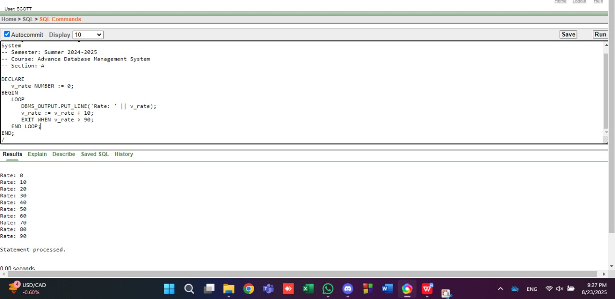

**Conditional Statements:**

1. **Check for Active Prisoners with Medical Issues.**

-- Project Name: Prison Management System

-- Semester: SUMMER 2024-2025

-- Course Name: ADVANCED DATABASE MANAGEMENT SYSTEM

-- Section: A

DECLARE

prisoner_name Prisoner.P_Name%TYPE;

prisoner_medical_history Prisoner.Medical_History%TYPE;

BEGIN

FOR prisoner IN

(SELECT P_Name, Medical_History

FROM Prisoner

WHERE Status = 'Active')

LOOP

prisoner_name := prisoner.P_Name;

prisoner_medical_history := prisoner.Medical_History;

IF prisoner_medical_history IS NULL OR prisoner_medical_history = 'No medical issues' THEN

DBMS_OUTPUT.PUT_LINE('Prisoner ' || prisoner_name || ' has no medical issues.');

ELSE

DBMS_OUTPUT.PUT_LINE('Prisoner ' || prisoner_name || ' has medical issues: ' || prisoner_medical_history);

END IF;

END LOOP;

END;

/

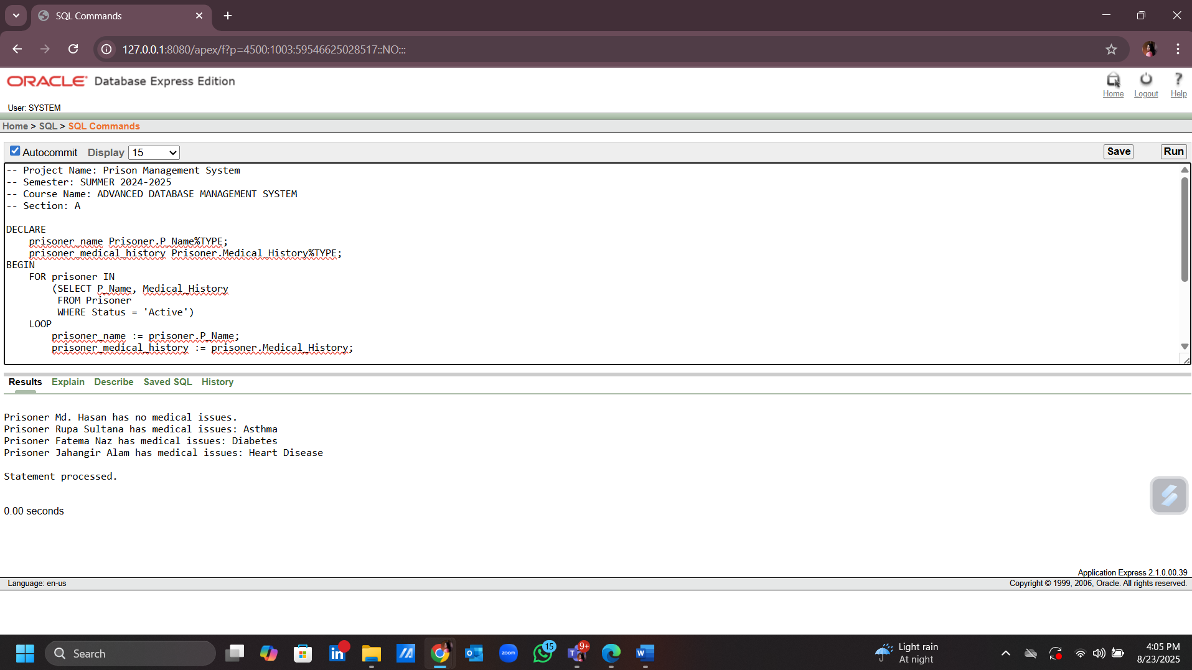

1. **Verify Warden's Responsibilities for a Specific Prison.**

-- Project Name: Prison Management System

-- Semester: SUMMER 2024-2025

-- Course Name: ADVANCED DATABASE MANAGEMENT SYSTEM

-- Section: A

DECLARE

warden_name Warden.W_Name%TYPE;

warden_responsibilities Warden.Responsibilities%TYPE;

BEGIN

SELECT W_Name, Responsibilities

INTO warden_name, warden_responsibilities

FROM Warden

WHERE Warden_ID = 1;

IF warden_responsibilities = 'Oversees all prison operations' THEN

DBMS_OUTPUT.PUT_LINE('Warden ' || warden_name || ' is responsible for overseeing all prison operations.');

ELSE

DBMS_OUTPUT.PUT_LINE('Warden ' || warden_name || ' has other responsibilities.');

END IF;

END;

/

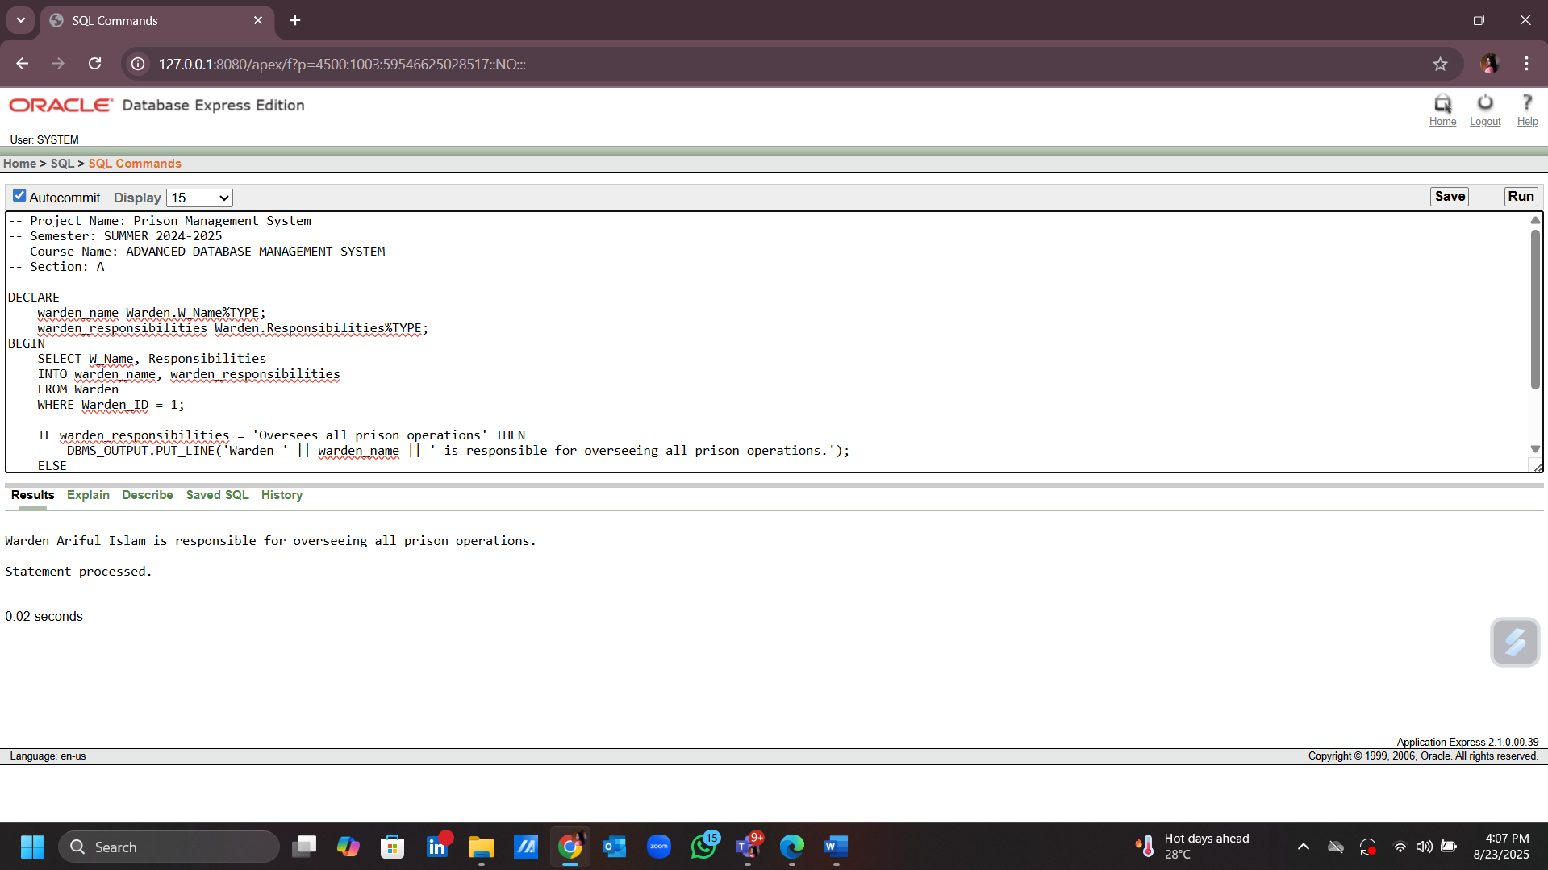

**Subquery:**

1. **Find Prisoners with Higher Sentences than "Robbery".**

-- Project Name: Prison Management System

-- Semester: SUMMER 2024-2025

-- Course Name: ADVANCED DATABASE MANAGEMENT SYSTEM

-- Section: A

SELECT P_Name

FROM Prisoner

WHERE Sentence_End_Date >

(SELECT Sentence_End_Date

FROM Prisoner

WHERE Crime_Type = 'Robbery'

AND Prisoner_ID = 1);

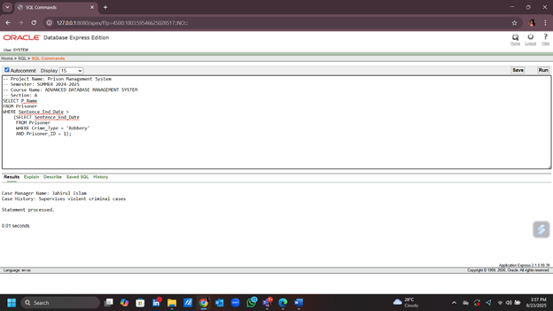

1. **Subquery to Find Prisoners in Prisons with Capacity Greater than 500.**

-- Project Name: Prison Management System

-- Semester: SUMMER 2024-2025

-- Course Name: ADVANCED DATABASE MANAGEMENT SYSTEM

-- Section: A

SELECT P_Name

FROM Prisoner

WHERE Prison_ID IN

(SELECT Prison_ID

FROM Prison

WHERE Capacity > 500);

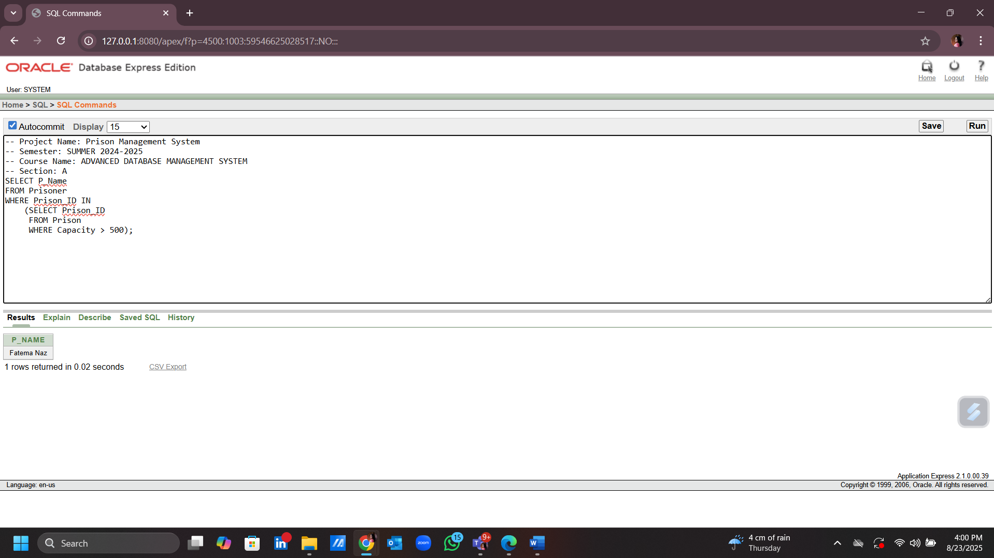

**Joining:**

1. **Auditors want to see which prisoner is in which prison, and in which cell.**

-- Project: Prison Management System

-- Semester: Summer 2024-2025

-- Course: Advance Database Management System

-- Section: A

SELECT pr.Prisoner_ID,

pr.P_Name,

p.Prison_Name,

c.Cell_ID,

c.Cell_Type

FROM Prisoner pr

JOIN Prison p ON p.Prison_ID = pr.Prison_ID

JOIN Cell c ON c.Cell_ID = pr.Cell_ID

ORDER BY pr.Prisoner_ID;

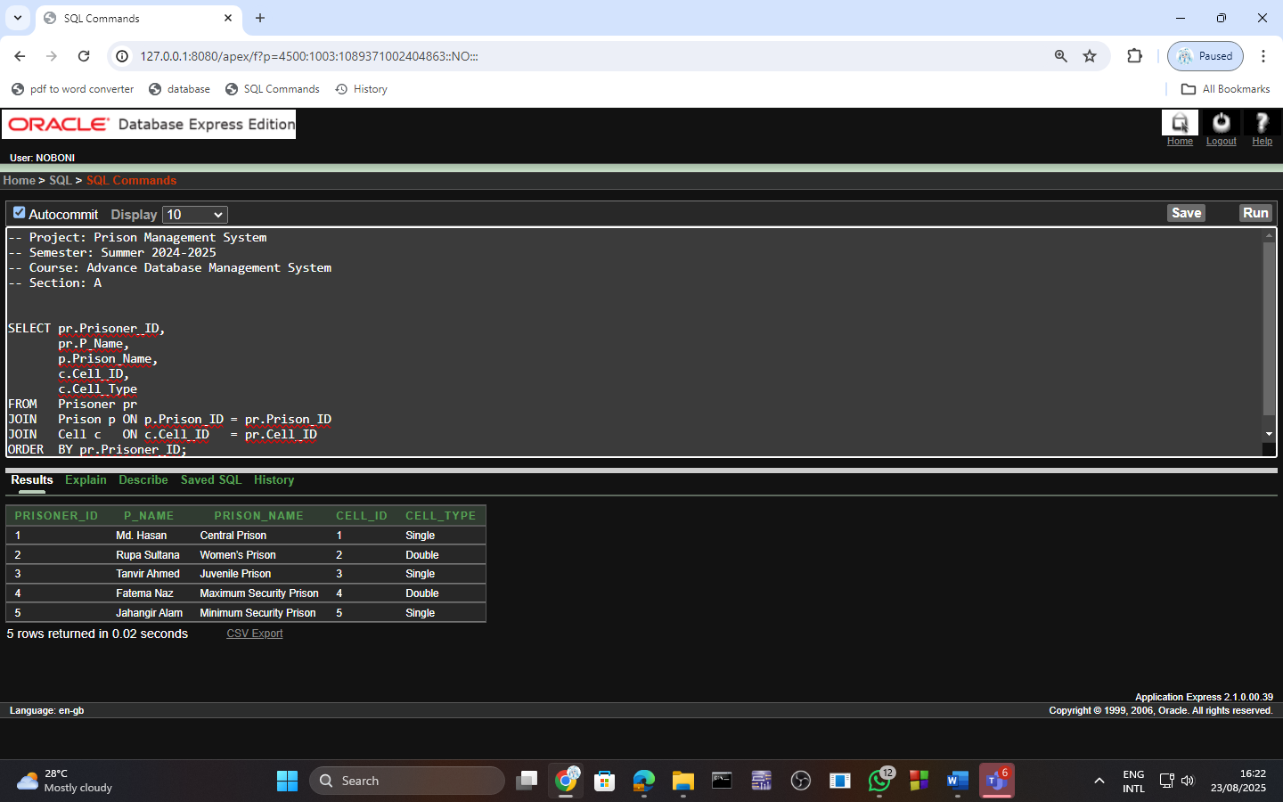

1. **List all prisoners along with their lawyers for court coordination.**

-- Project: Prison Management System

-- Semester: Summer 2024-2025

-- Course: Advance Database Management System

-- Section: A

SELECT pr.Prisoner_ID,

pr.P_Name,

l.Lawyer_ID,

l.L_Name

FROM Prisoner pr

JOIN Prisoner_Lawyer pl ON pl.Prisoner_ID = pr.Prisoner_ID

JOIN Lawyer l ON l.Lawyer_ID = pl.Lawyer_ID

ORDER BY pr.Prisoner_ID, l.Lawyer_ID;

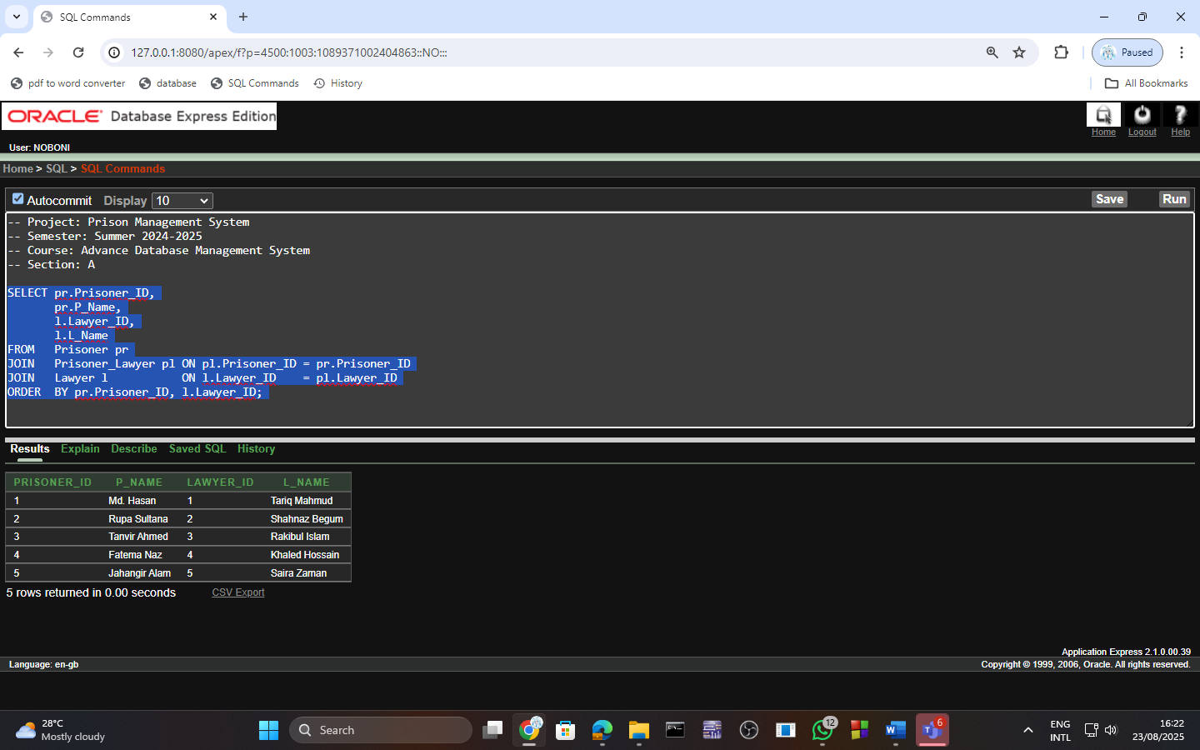

**Advance PL/SQL**

**Stored Function:**

1. **Parole officers want a quick function to return how many days a prisoner is sentenced for.**

-- Project: Prison Management System

-- Semester: Summer 2024-2025

-- Course: Advance Database Management System

-- Section: A

CREATE OR REPLACE FUNCTION sentence_length(p_pid Prisoner.Prisoner_ID%TYPE)

RETURN NUMBER

IS

v_days NUMBER;

BEGIN

SELECT (Sentence_End_Date - Sentence_Start_Date)

INTO v_days

FROM Prisoner

WHERE Prisoner_ID = p_pid;

RETURN v_days;

END;

/

SELECT P_Name, sentence_length(Prisoner_ID) AS length_days

FROM Prisoner;

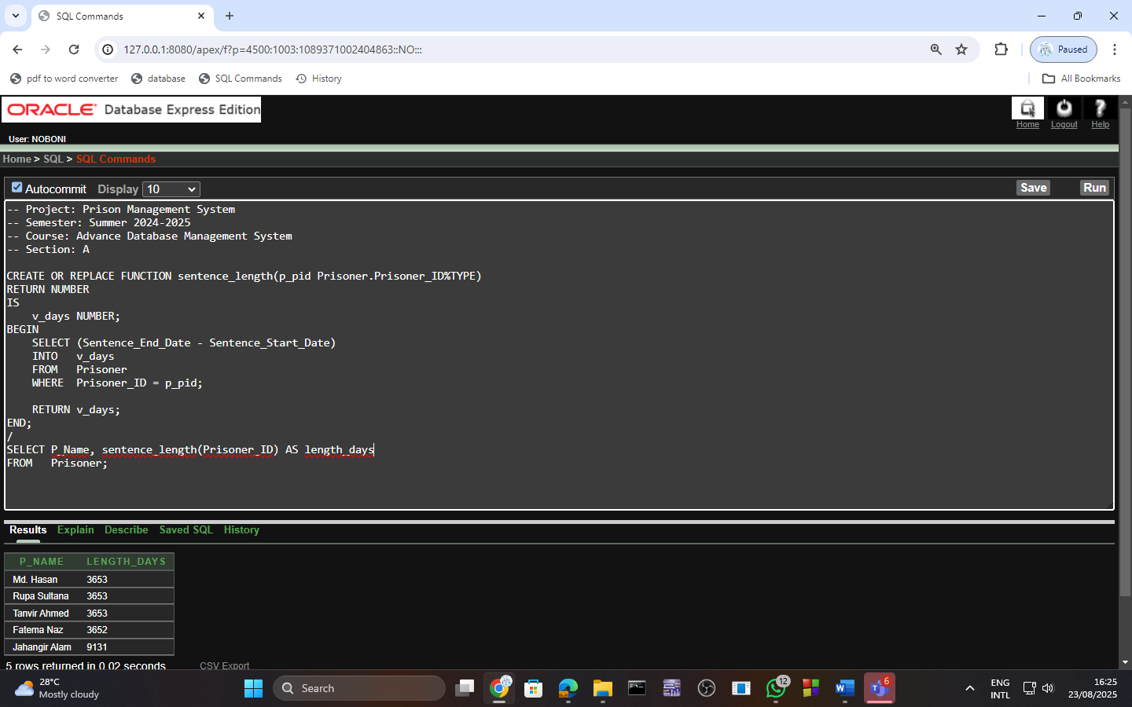

1. **Legal team needs to know which prisoners are involved in which court cases.**

-- Project: Prison Management System

-- Semester: Summer 2024-2025

-- Course: Advance Database Management System

-- Section: A

SELECT pr.Prisoner_ID,

pr.P_Name,

cc.Case_ID,

cc.Case_Type

FROM Prisoner pr

JOIN Prisoner_Case pc ON pc.Prisoner_ID = pr.Prisoner_ID

JOIN Court_Case cc ON cc.Case_ID = pc.Case_ID

ORDER BY pr.Prisoner_ID, cc.Case_ID;

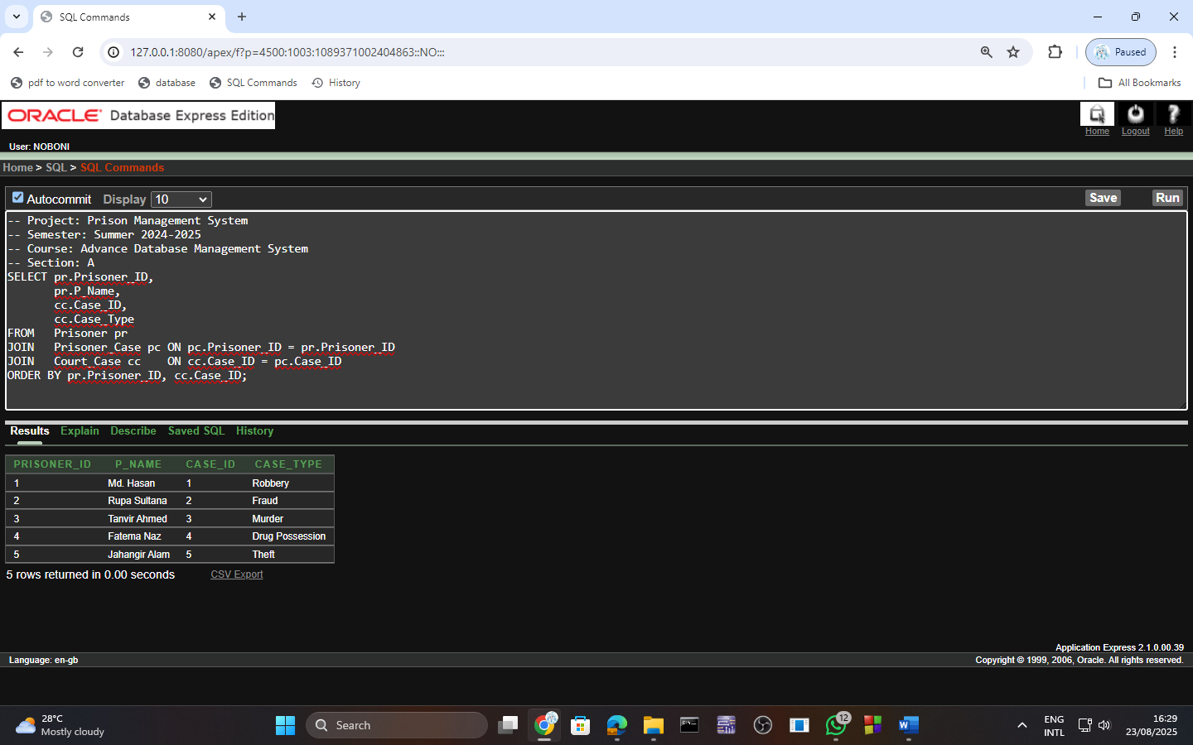

**Stored Procedures:**

1. **Create a procedure that updates a prisoner’s status to ‘RELEASED’ when they are freed and confirms the action with a message.**

-- Project: Prison Management System

-- Semester: Summer 2024-2025

-- Course: Advance Database Management System

-- Section: A

CREATE OR REPLACE PROCEDURE release_prisoner(p_pid Prisoner.Prisoner_ID%TYPE)

IS

BEGIN

UPDATE Prisoner

SET Status = 'RELEASED'

WHERE Prisoner_ID = p_pid;

DBMS_OUTPUT.PUT_LINE('Prisoner ' || p_pid || ' marked as RELEASED.');

END;

/

BEGIN

release_prisoner(1001);

END;

/

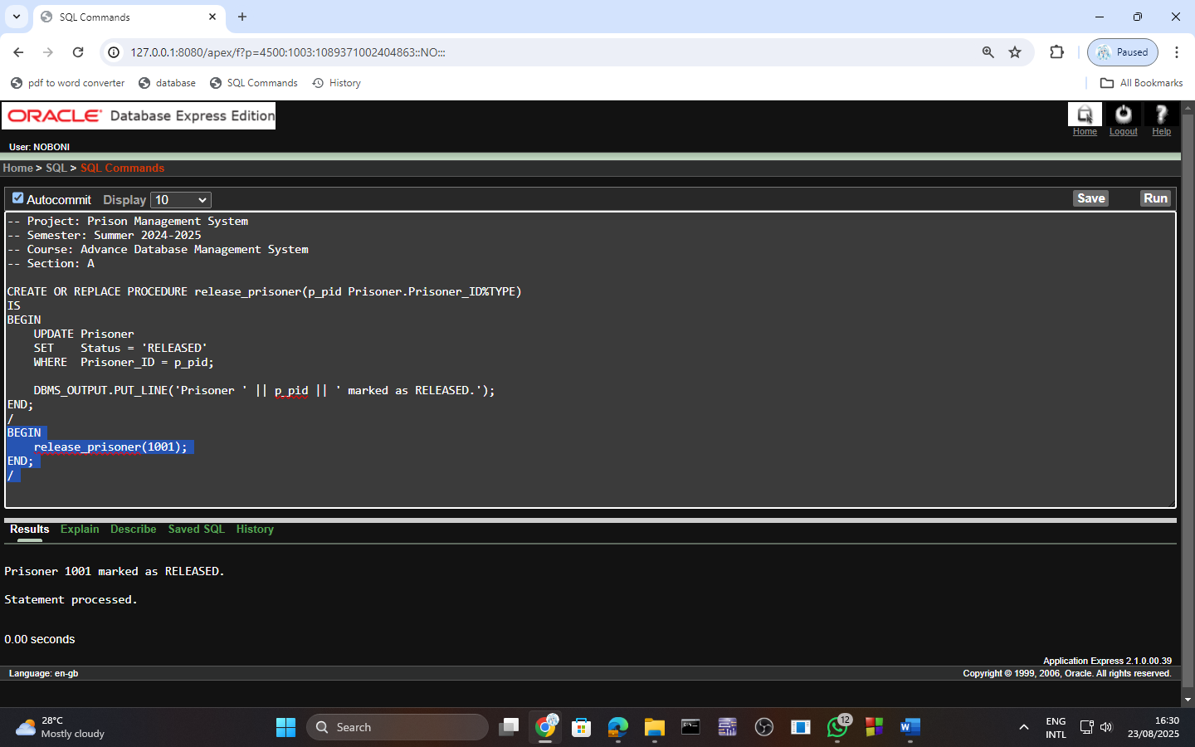

1. **When a prisoner is freed, staff need one command to update status.**

-- Project: Prison Management System

-- Semester: Summer 2024-2025

-- Course: Advance Database Management System

-- Section: A

CREATE OR REPLACE PROCEDURE increase_capacity(p_cid Cell.Cell_ID%TYPE)

IS

BEGIN

UPDATE Cell

SET C_Capacity = C_Capacity + 1

WHERE Cell_ID = p_cid;

DBMS_OUTPUT.PUT_LINE('Cell ' || p_cid || ' capacity increased.');

END;

/

BEGIN

increase_capacity(201);

END;

/

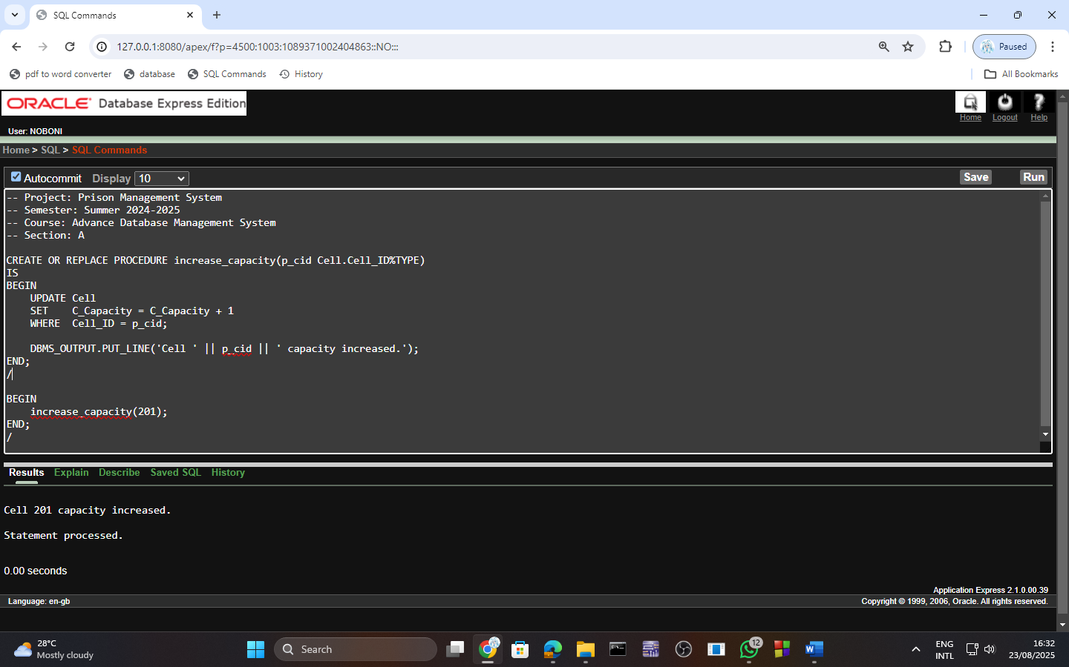

**Table-Based Record:**

1. **To select a row into the record from the Prison table where Prison_ID = 1**

-- Project Name: Prison Management System

-- Semester: SUMMER 2024-2025

-- Course Name: ADVANCED DATABASE MANAGEMENT SYSTEM

-- Section: A

DECLARE

prison_rec Prison%ROWTYPE;

BEGIN

SELECT * INTO prison_rec

FROM Prison

WHERE Prison_ID = 1;

DBMS_OUTPUT.PUT_LINE('Prison Name: ' || prison_rec.Prison_Name);

DBMS_OUTPUT.PUT_LINE('Location: ' || prison_rec.Location);

DBMS_OUTPUT.PUT_LINE('Type: ' || prison_rec.Type);

DBMS_OUTPUT.PUT_LINE('Capacity: ' || prison_rec.Capacity);

DBMS_OUTPUT.PUT_LINE('Number of Cells: ' || prison_rec.Number_of_Cells);

DBMS_OUTPUT.PUT_LINE('Total Inmates: ' || prison_rec.Total_Inmates);

END;

/

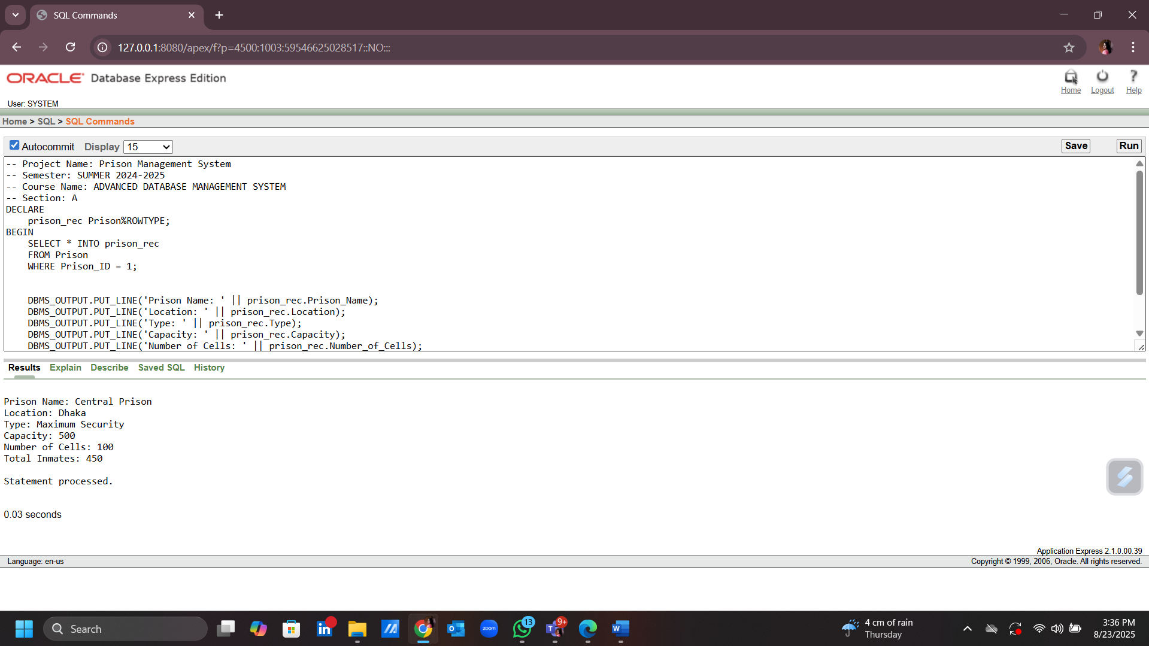

1. **To select a row into the record from the Warden table where Warden_ID = 1:**

-- Project Name: Prison Management System

-- Semester: SUMMER 2024-2025

-- Course Name: ADVANCED DATABASE MANAGEMENT SYSTEM

-- Section: A

DECLARE

warden_rec Warden%ROWTYPE;

BEGIN

SELECT * INTO warden_rec

FROM Warden

WHERE Warden_ID = 1;

DBMS_OUTPUT.PUT_LINE('Warden Name: ' || warden_rec.W_Name);

DBMS_OUTPUT.PUT_LINE('Rank: ' || warden_rec.W_Rank);

DBMS_OUTPUT.PUT_LINE('Phone 1: ' || warden_rec.W_phone1);

DBMS_OUTPUT.PUT_LINE('Phone 2: ' || warden_rec.W_phone2);

DBMS_OUTPUT.PUT_LINE('Responsibilities: ' || warden_rec.Responsibilities);

DBMS_OUTPUT.PUT_LINE('Prison ID: ' || warden_rec.Prison_ID);

END;

/

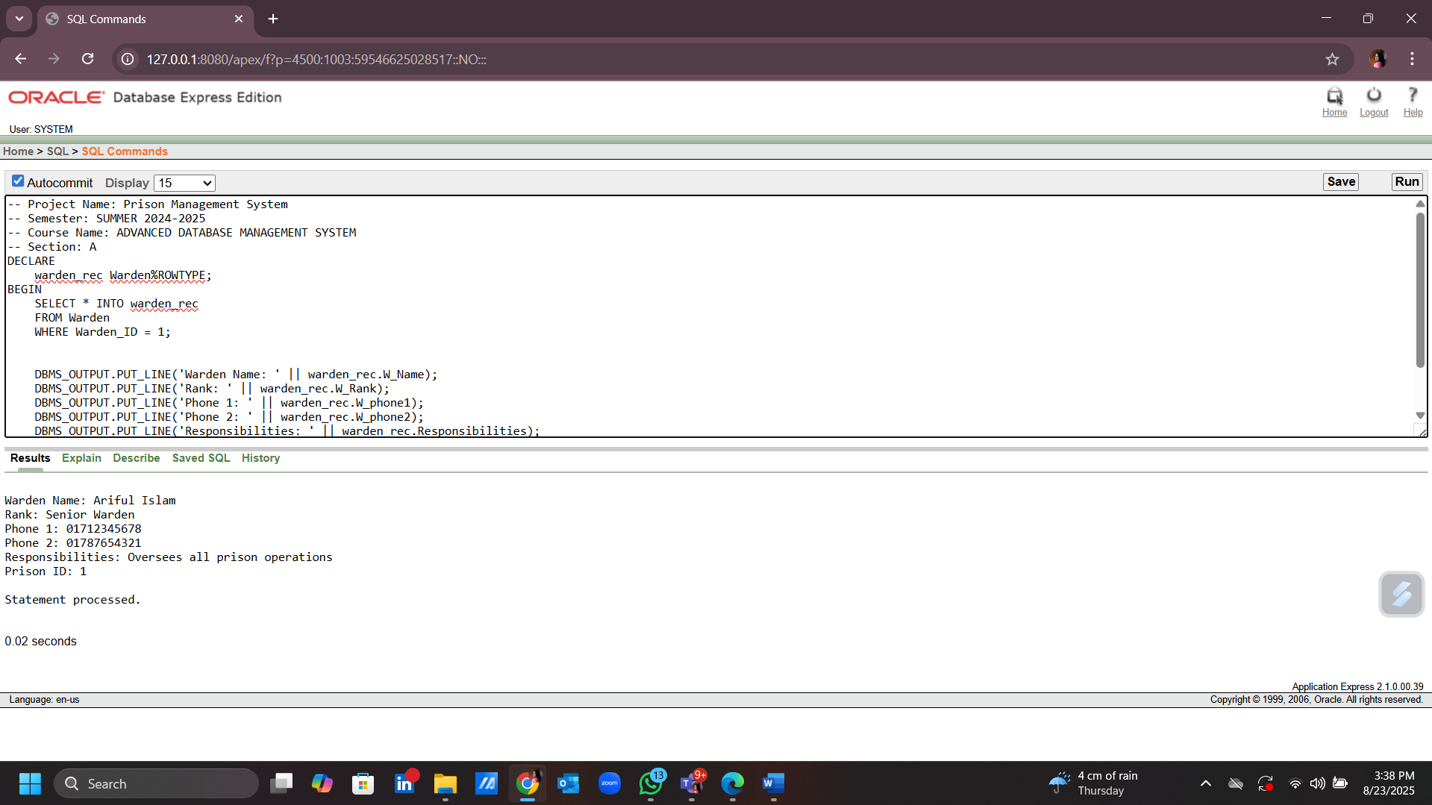

**Explicit** **Cursor:**

1. **To select prisoners who have an active status:**

-- Project Name: Prison Management System

-- Semester: SUMMER 2024-2025

-- Course Name: ADVANCED DATABASE MANAGEMENT SYSTEM

-- Section: A

DECLARE

prisoner_name Prisoner.P_Name%TYPE;

prisoner_age Prisoner.Age%TYPE;

CURSOR c_prisoner IS

SELECT P_Name, Age

FROM Prisoner

WHERE Status = 'Active';

BEGIN

OPEN c_prisoner;

LOOP

FETCH c_prisoner INTO prisoner_name, prisoner_age;

EXIT WHEN c_prisoner%NOTFOUND;

DBMS_OUTPUT.PUT_LINE('Prisoner Name: ' || prisoner_name || ', Age: ' || prisoner_age);

END LOOP;

CLOSE c_prisoner;

END;

/

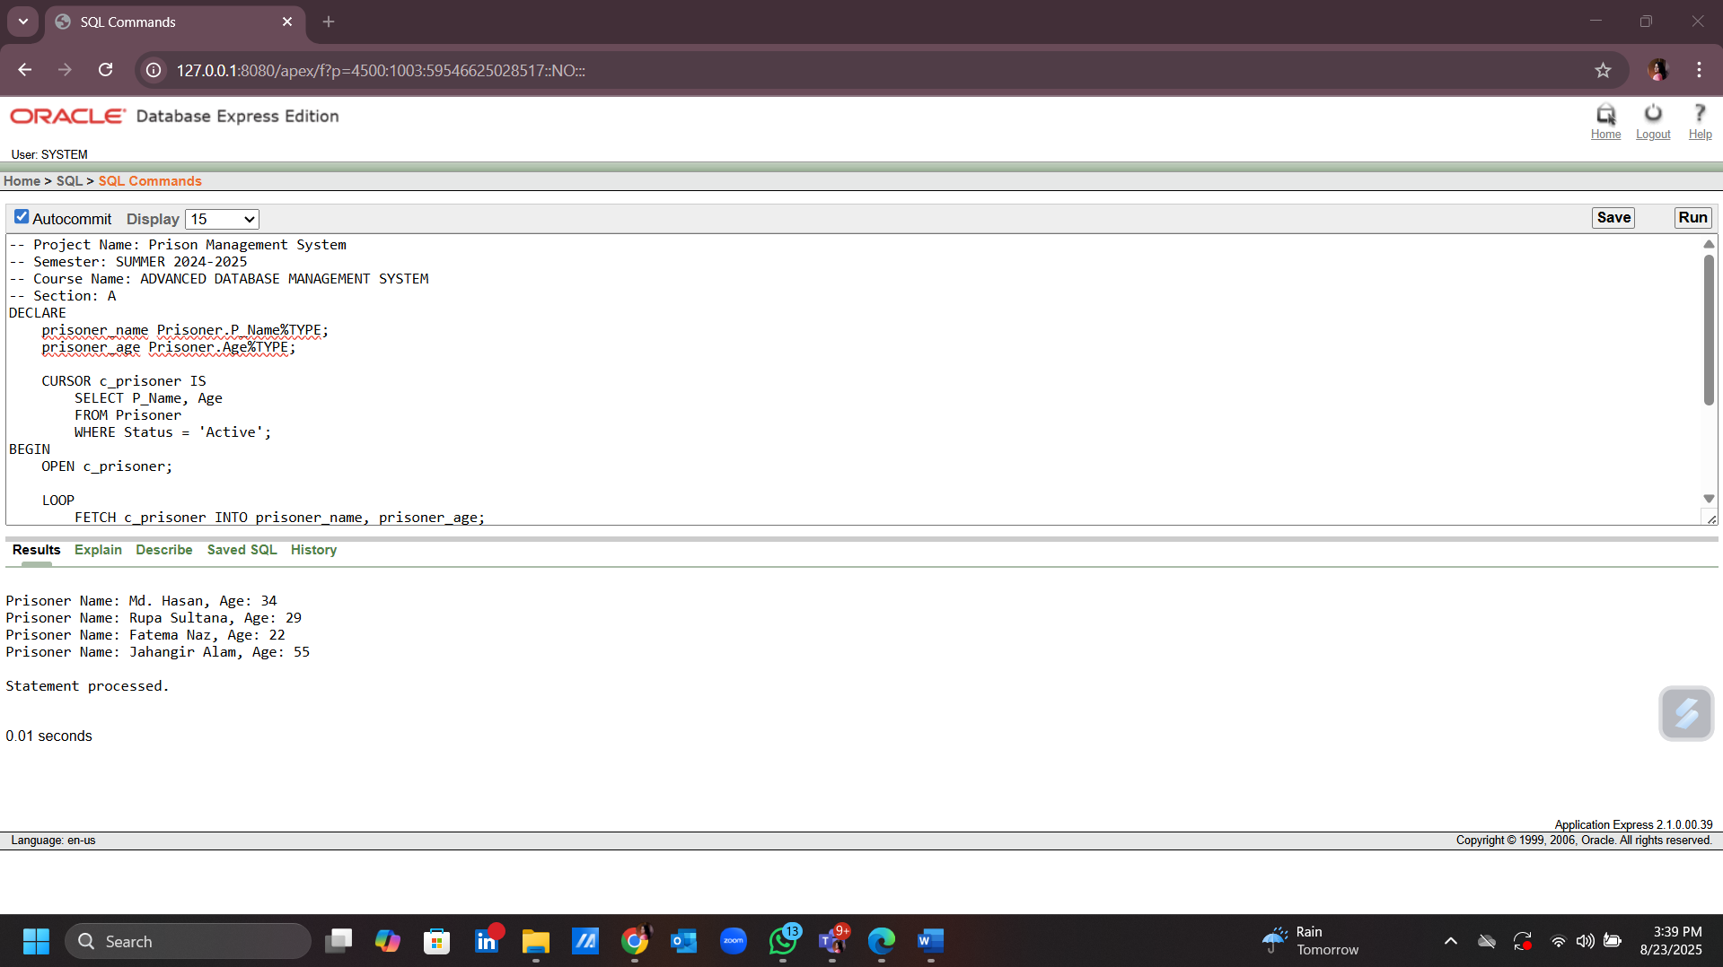

1. **To select case managers that handle 'violent criminal' cases:**

-- Project Name: Prison Management System

-- Semester: SUMMER 2024-2025

-- Course Name: ADVANCED DATABASE MANAGEMENT SYSTEM

-- Section: A

DECLARE

case_manager_name Case_Manager.C_Name%TYPE;

case_history Case_Manager.Case_History%TYPE;

CURSOR c_case_manager IS

SELECT C_Name, Case_History

FROM Case_Manager

WHERE Case_History LIKE '%violent criminal%';

BEGIN

OPEN c_case_manager;

LOOP

FETCH c_case_manager INTO case_manager_name, case_history;

EXIT WHEN c_case_manager%NOTFOUND;

DBMS_OUTPUT.PUT_LINE('Case Manager Name: ' || case_manager_name);

DBMS_OUTPUT.PUT_LINE('Case History: ' || case_history);

END LOOP;

CLOSE c_case_manager;

END;

/

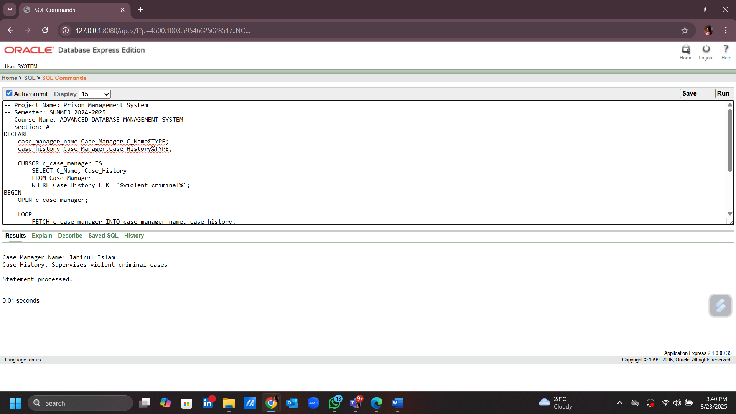

**Cursor Based Record:**

**1)Administrators want to see prisoners with upcoming releases within 30 days for release planning.**

-- Project Name: Prison Management System

-- Semester: SUMMER 2024-2025

-- Course Name: ADVANCED DATABASE MANAGEMENT SYSTEM

-- Section: A

DECLARE

v_prisoner_id Prisoner.Prisoner_ID%TYPE;

v_name Prisoner.P_Name%TYPE;

v_release_date Prisoner.Sentence_End_Date%TYPE;

CURSOR c_prisoners IS

SELECT Prisoner_ID, P_Name, Sentence_End_Date

FROM Prisoner

WHERE Sentence_End_Date <= SYSDATE + 30

AND Status = 'Active';

BEGIN

OPEN c_prisoners;

LOOP

FETCH c_prisoners INTO v_prisoner_id, v_name, v_release_date;

EXIT WHEN c_prisoners%NOTFOUND;

DBMS_OUTPUT.PUT_LINE(v_prisoner_id || ' ' || v_name || ' ' || TO_CHAR(v_release_date, 'YYYY-MM-DD'));

END LOOP;

CLOSE c_prisoners;

END;

/

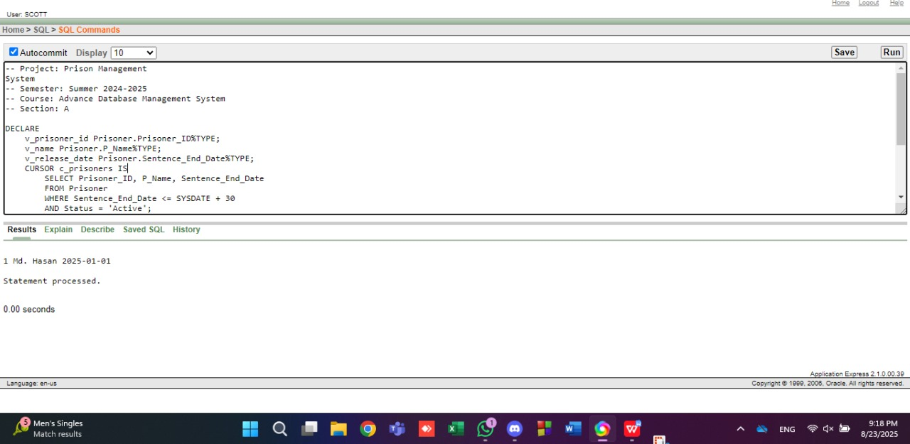

**2) Medical workers want to see prisoners with specific medical conditions like Asthma for check-ups.**

-- Project Name: Prison Management System

-- Semester: SUMMER 2024-2025

-- Course Name: ADVANCED DATABASE MANAGEMENT SYSTEM

-- Section: A

DECLARE

v_prisoner_id Prisoner.Prisoner_ID%TYPE;

v_name Prisoner.P_Name%TYPE;

v_history Prisoner.Medical_History%TYPE;

CURSOR c_medical(p_condition VARCHAR2) IS

SELECT Prisoner_ID, P_Name, Medical_History

FROM Prisoner

WHERE Medical_History LIKE '%' || p_condition || '%'

AND Status = 'Active';

BEGIN

OPEN c_medical('Asthma');

LOOP

FETCH c_medical INTO v_prisoner_id, v_name, v_history;

EXIT WHEN c_medical%NOTFOUND;

DBMS_OUTPUT.PUT_LINE(v_prisoner_id || ' ' || v_name || ' ' || v_history);

END LOOP;

CLOSE c_medical;

END;

/

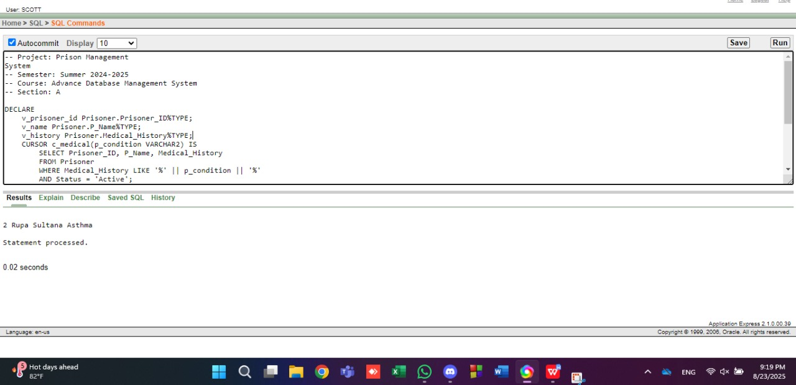

**Row Level Trigger:**

**1) Administrators want to log staff role changes during updates for auditing.**

-- Project Name: Prison Management System

-- Semester: SUMMER 2024-2025

-- Course Name: ADVANCED DATABASE MANAGEMENT SYSTEM

-- Section: A

CREATE OR REPLACE TRIGGER trg_log_role_change

BEFORE UPDATE ON Staff

FOR EACH ROW

BEGIN

DBMS_OUTPUT.PUT_LINE('Old role: ' || :OLD.Ch_Role);

DBMS_OUTPUT.PUT_LINE('New role: ' || :NEW.Ch_Role);

DBMS_OUTPUT.PUT_LINE('Role changed for Staff_ID: ' || :OLD.Staff_ID);

END;

/

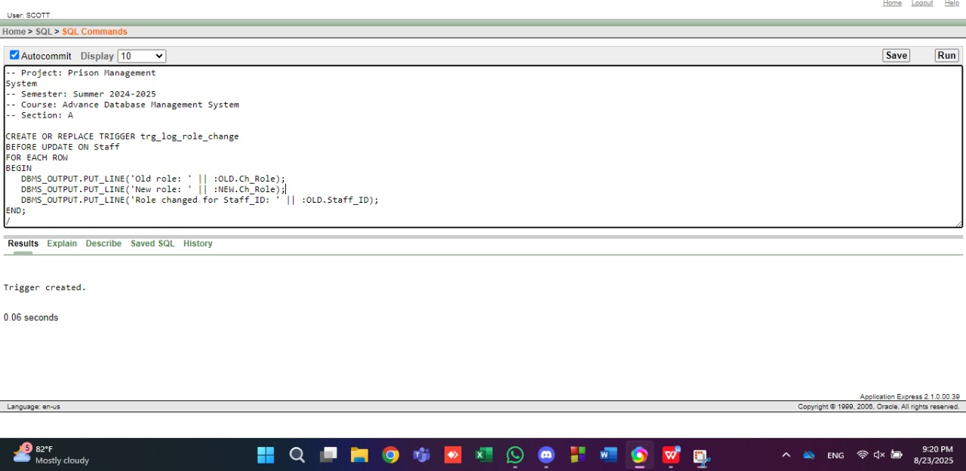

**2) Administrators want to notify when a new visitor is added for security tracking.**

-- Project Name: Prison Management System

-- Semester: SUMMER 2024-2025

-- Course Name: ADVANCED DATABASE MANAGEMENT SYSTEM

-- Section: A

CREATE OR REPLACE TRIGGER trg_new_visitor

AFTER INSERT ON Visitor

FOR EACH ROW

WHEN (NEW.Visitor_ID > 0)

BEGIN

DBMS_OUTPUT.PUT_LINE('New Visitor Added: ' || :NEW.V_Name);

END;

/

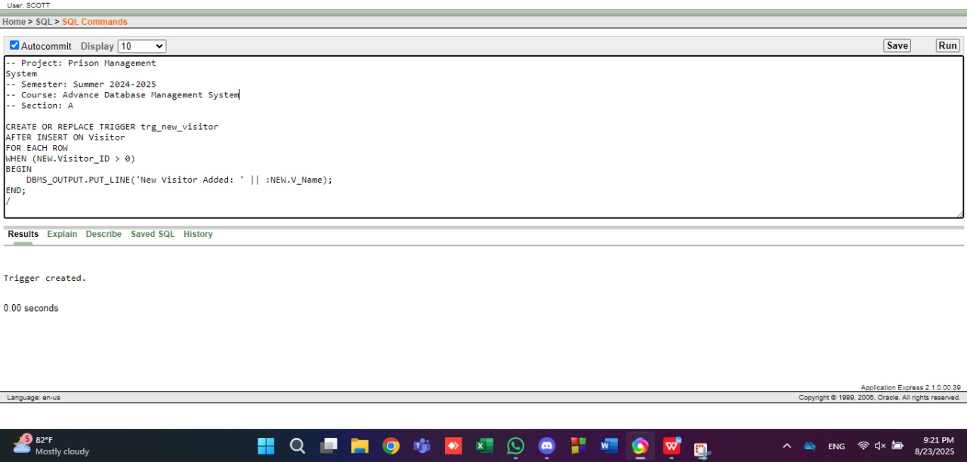

**Statement Level Trigger:**

1. **Keep Prison.Total_Inmates updated after insert/delete in Prisoner.**

-- Project Name : Prison Management System

-- Semester : SUMMER 2024-2025

-- Course Name : ADVANCED DATABASE MANAGEMENT SYSTEM

-- Section : A

CREATE OR REPLACE TRIGGER trg_update_inmates

AFTER INSERT OR DELETE ON Prisoner

BEGIN

UPDATE Prison p

SET Total_Inmates = (SELECT COUNT(*)

FROM Prisoner pr

WHERE pr.Prison_ID = p.Prison_ID);

END;

/

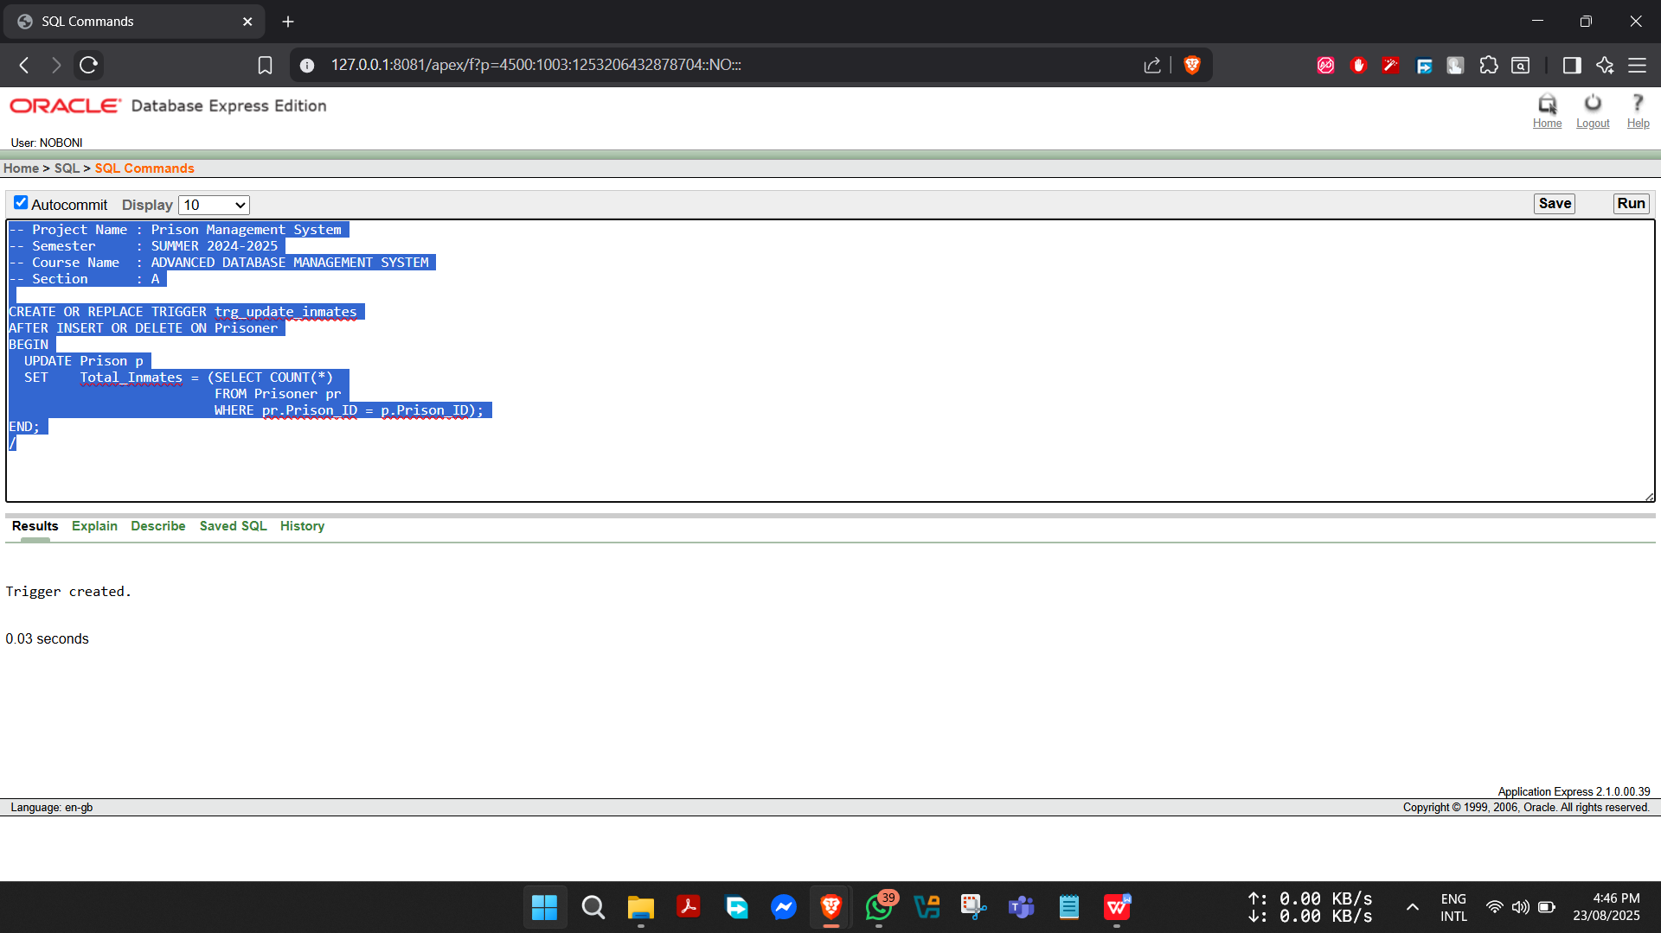

1. **Show message whenever a new visitor is added.**

-- Project Name : Prison Management System

-- Semester : SUMMER 2024-2025

-- Course Name : ADVANCED DATABASE MANAGEMENT SYSTEM

-- Section : A

CREATE OR REPLACE TRIGGER trg_new_visitor

AFTER INSERT ON Visitor

BEGIN

DBMS_OUTPUT.PUT_LINE('A new visitor has been registered.');

END;

/

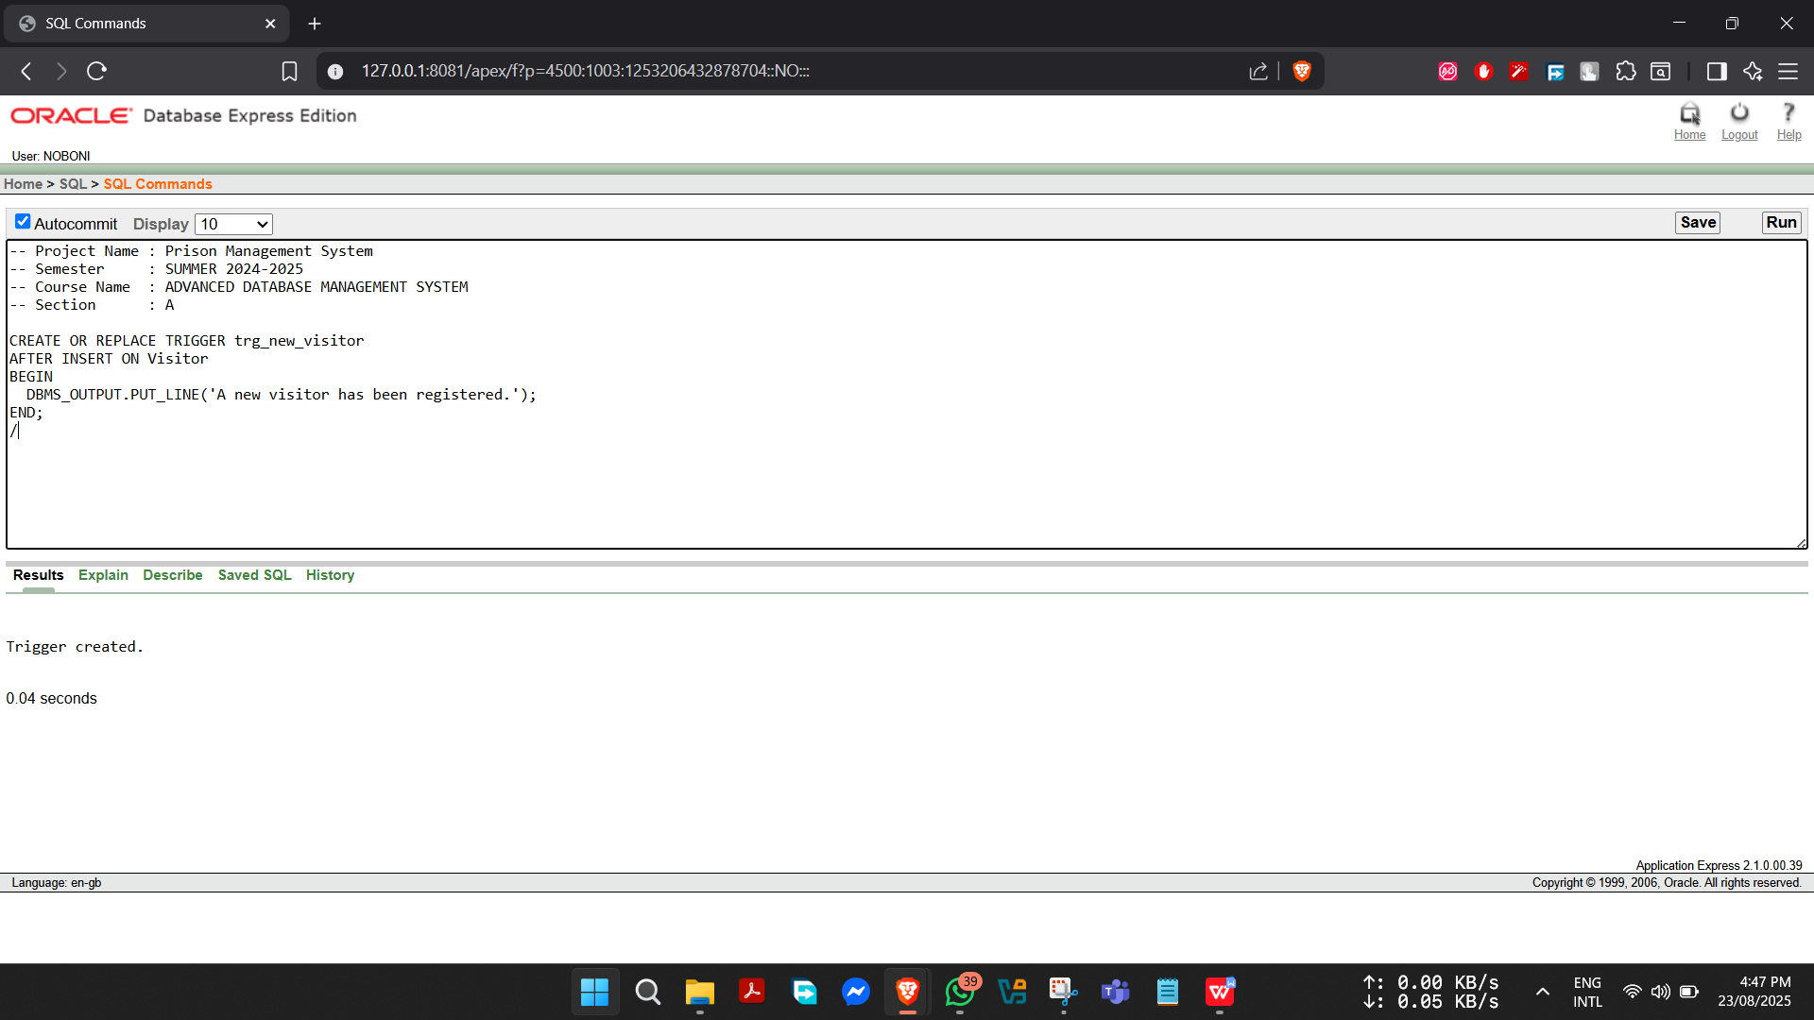

**Package:**

1. **Package to calculate utilization % of a prison.**

-- Project Name : Prison Management System

-- Semester : SUMMER 2024-2025

-- Course Name : ADVANCED DATABASE MANAGEMENT SYSTEM

-- Section : A

CREATE OR REPLACE PACKAGE prison_pkg AS

FUNCTION utilization(p_pid IN Prison.Prison_ID%TYPE) RETURN NUMBER;

END prison_pkg;

/

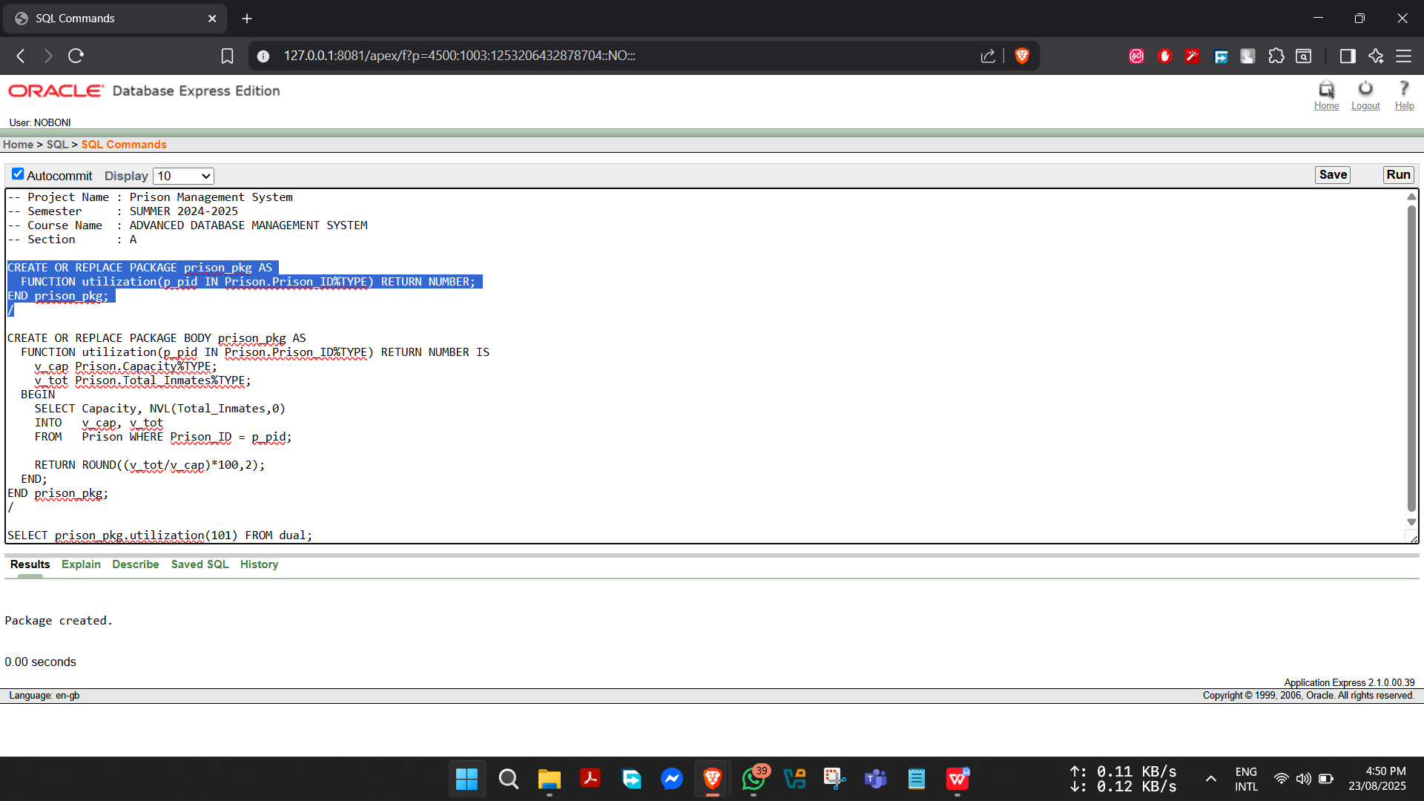

CREATE OR REPLACE PACKAGE BODY prison_pkg AS

FUNCTION utilization(p_pid IN Prison.Prison_ID%TYPE) RETURN NUMBER IS

v_cap Prison.Capacity%TYPE;

v_tot Prison.Total_Inmates%TYPE;

BEGIN

SELECT Capacity, NVL(Total_Inmates,0)

INTO v_cap, v_tot

FROM Prison WHERE Prison_ID = p_pid;

RETURN ROUND((v_tot/v_cap)*100,2);

END;

END prison_pkg;

/

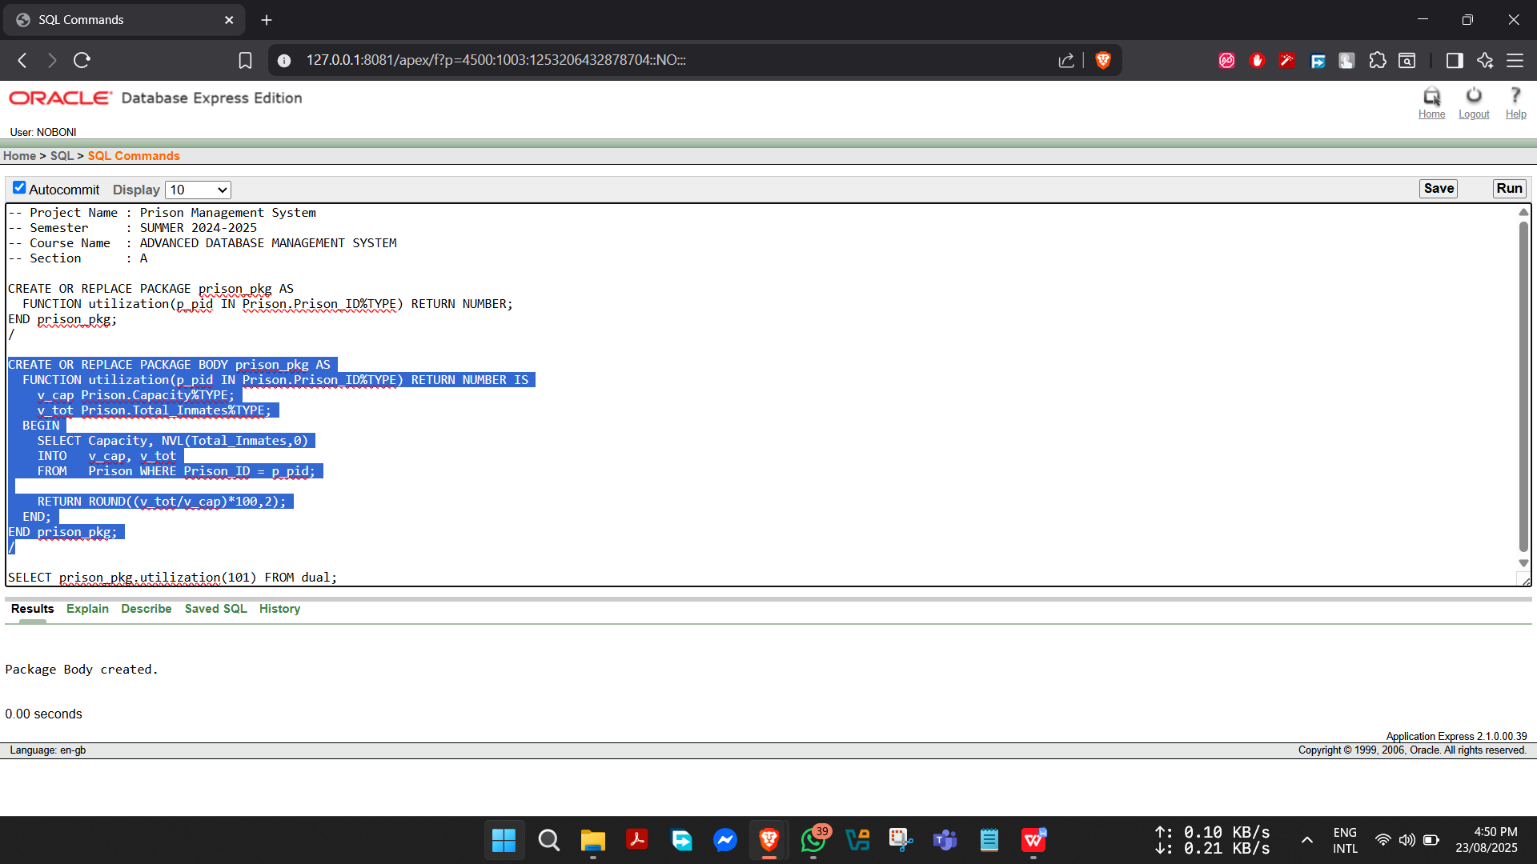

SELECT prison_pkg.utilization(101) FROM dual;

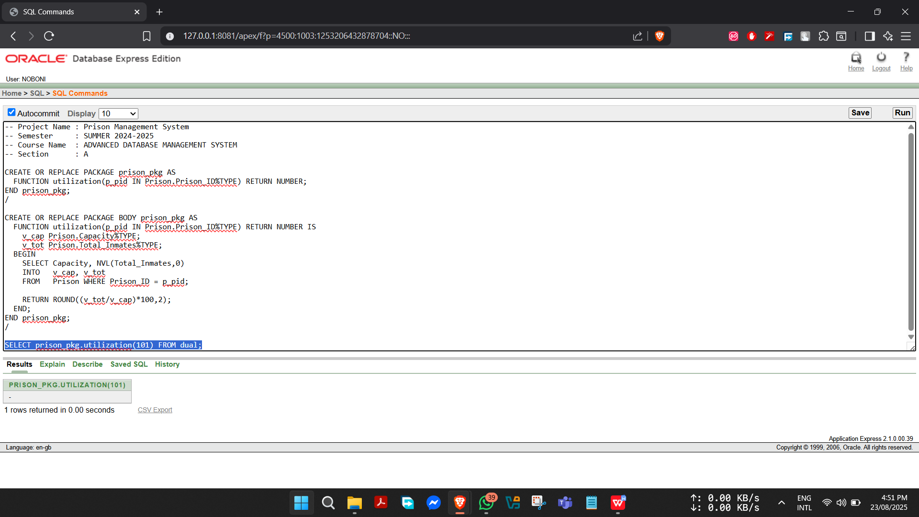

1. **Package to safely move a prisoner to a new cell.**

-- Project Name : Prison Management System

-- Semester : SUMMER 2024-2025

-- Course Name : ADVANCED DATABASE MANAGEMENT SYSTEM

-- Section : A

CREATE OR REPLACE PACKAGE prisoner_pkg AS

PROCEDURE move_prisoner(p_pid IN Prisoner.Prisoner_ID%TYPE,

p_cell IN Cell.Cell_ID%TYPE);

END prisoner_pkg;

/

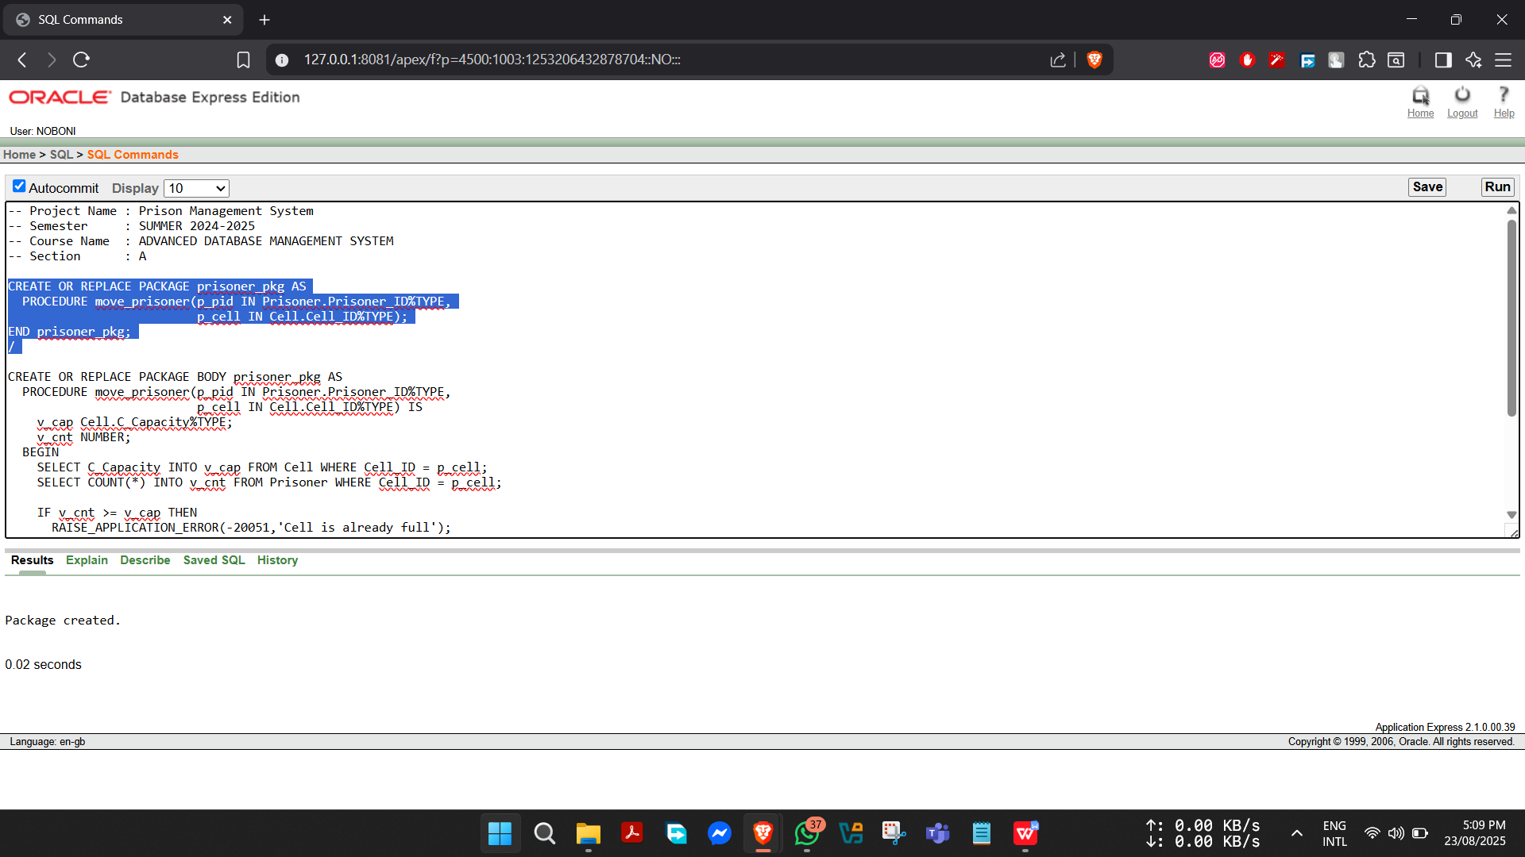

CREATE OR REPLACE PACKAGE BODY prisoner_pkg AS

PROCEDURE move_prisoner(p_pid IN Prisoner.Prisoner_ID%TYPE,

p_cell IN Cell.Cell_ID%TYPE) IS

v_cap Cell.C_Capacity%TYPE;

v_cnt NUMBER;

BEGIN

SELECT C_Capacity INTO v_cap FROM Cell WHERE Cell_ID = p_cell;

SELECT COUNT(*) INTO v_cnt FROM Prisoner WHERE Cell_ID = p_cell;

IF v_cnt >= v_cap THEN

RAISE_APPLICATION_ERROR(-20051,'Cell is already full');

END IF;

UPDATE Prisoner

SET Cell_ID = p_cell

WHERE Prisoner_ID = p_pid;

DBMS_OUTPUT.PUT_LINE('Prisoner '||p_pid||' moved to cell '||p_cell);

END;

END prisoner_pkg;

/

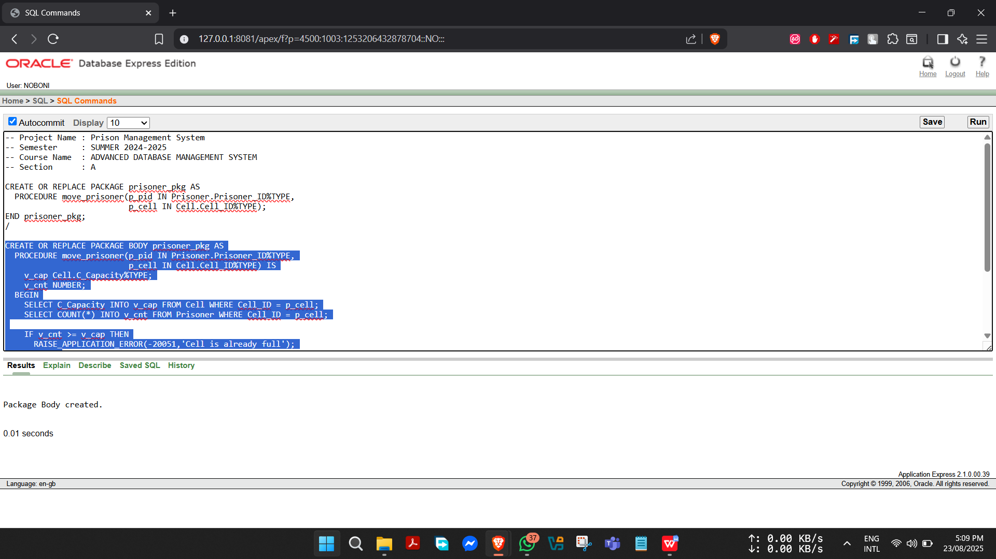

**Conclusion**

The Prison Management System has been developed to make prison operations more organized, efficient, and secure. From our project, we found that the system can successfully store and manage details of prisons, wardens, officers, prisoners, cells, and staff while also handling complex relationships between prisoners, lawyers, visitors, medical workers, and court cases. By using proper database design and normalization, the system reduces data duplication and ensures accuracy. Features like functions, procedures, triggers, and reports make it easier to track prisoner information, monitor cases, and maintain smooth prison activities. Overall, the system proves to be effective in managing large amounts of sensitive data in a structured and reliable way.

In the future, this project can be improved by adding a user-friendly web or mobile interface so that prison staff can easily access and update information. Stronger security features, such as role-based access and data encryption, can be introduced to protect sensitive records. The system can also be expanded with advanced analytics to predict prison capacity, medical needs, or case outcomes. Moreover, integration with court and police databases would create a smoother flow of information across related institutions. These improvements would transform the current system into a complete digital solution for modern prison management, ensuring better security, transparency, and efficiency.